Cloudera Setup via AWS Image

Ubuntu 14.04

12/15/2016

Shalaj Shukla

Contents

Purpose 2

AWS Console Configuration 3

Create Key Pairs 4

Convert .pem to .ppk file 6

Create EC2 Instance 8

Install Cloudera Manager 19

Add Hadoop services 31

Add Zookeeper Service 44

Add HDFS Service 49

Add YARN Service 54

Add Hive Service 58

Create Amazon Machine Image (AMI) 66

Launch Ec2 Instance via Image 70

# Purpose

This document describes how to set up and configure a single-node Hadoop installation via Cloudera distribution on AWS EC2 instance and install services like HDFS, Zookeeper, YARN and Hive on that cluster,.

Apart from this document also describe how to create Amazon Machine Image (AMI) of this EC2 instance and launch new EC2 instance and all required configuration to start all the services on new instance

# AWS Console Configuration

Login to AWS console

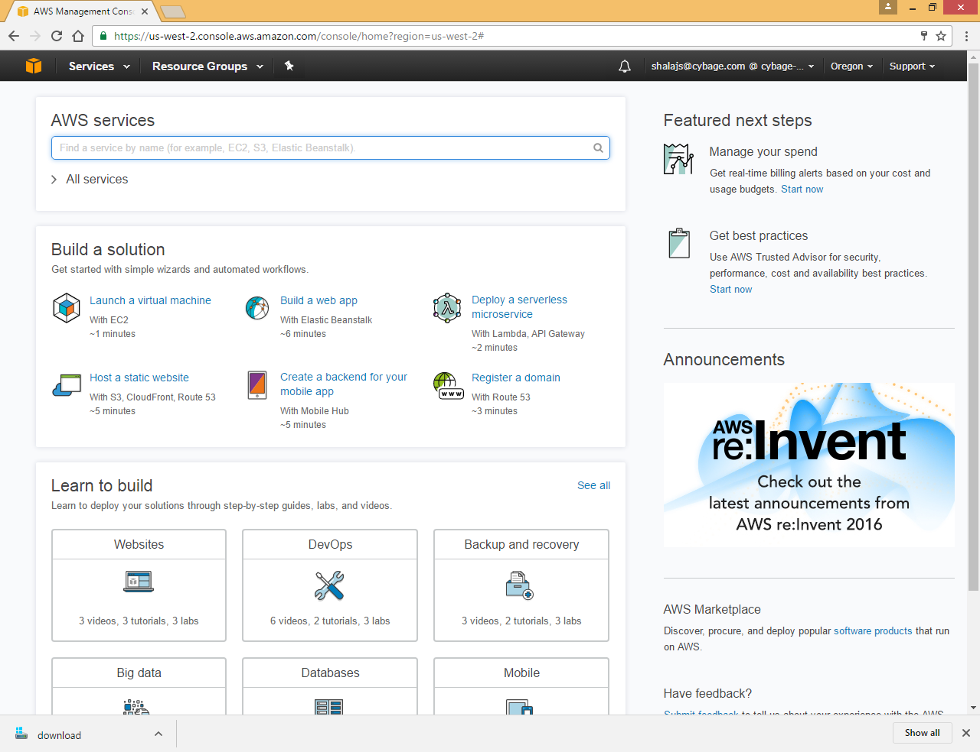

Search EC2

## Create Key Pairs

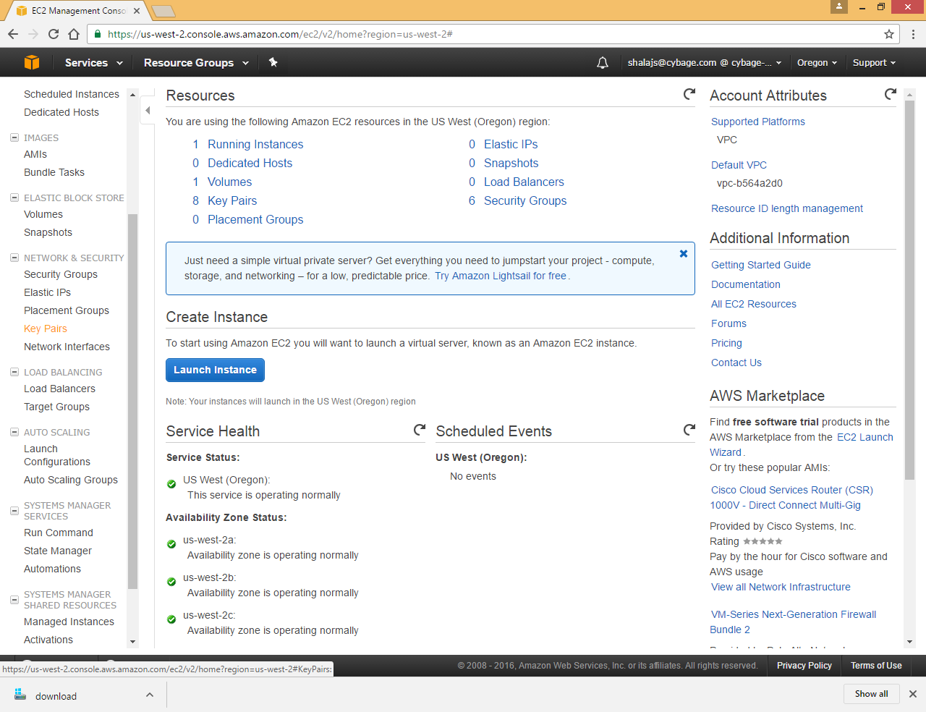

Click on Key Pairs in left frame

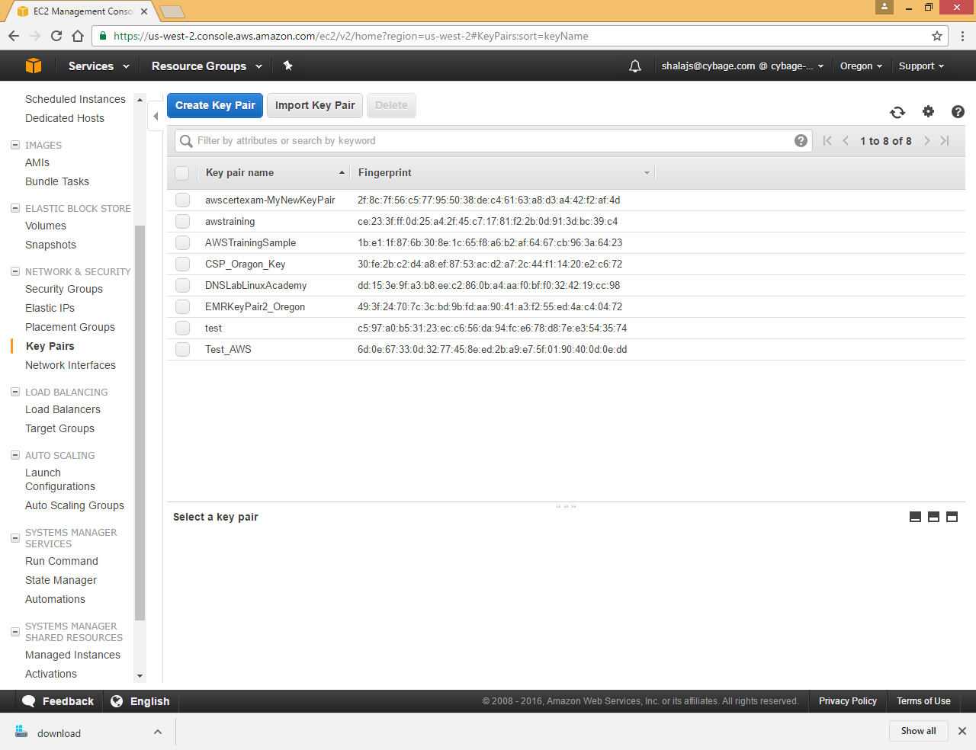

Click on Create Key Pair

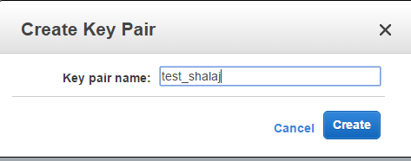

Click on Create

It will download **test_shalaj.pem** file save this file in some location

## Convert .pem to .ppk file

**Pem** – Privacy Enhanced mail

**Ppk**- putty private key

If we want to use putty to login into ec2 instance, we need to change pem file to ppk

Convert .pem to .ppk using putty gen

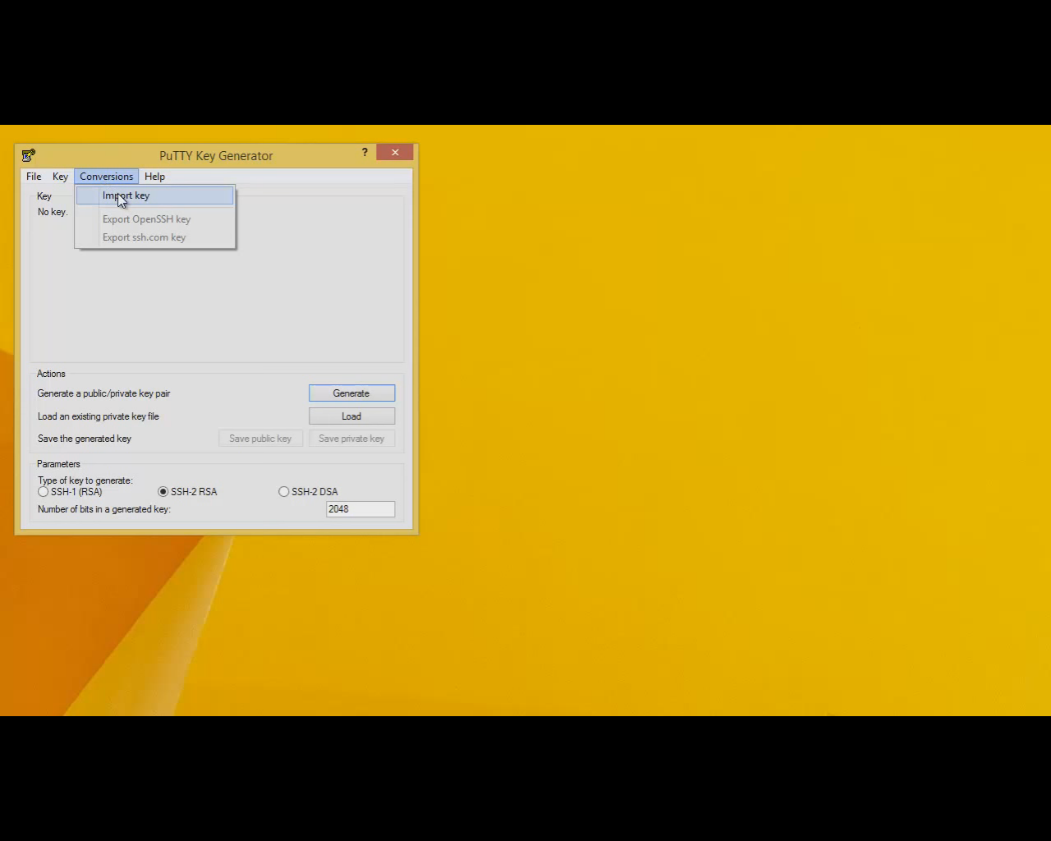

Select pem file to be converted into ppk

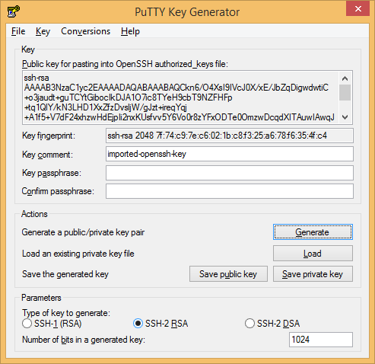

Click Save private key

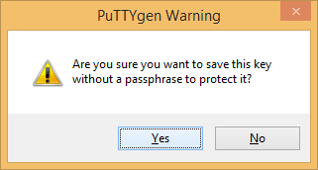

Click yes

Now ppk is saved in specified location

## Create EC2 Instance

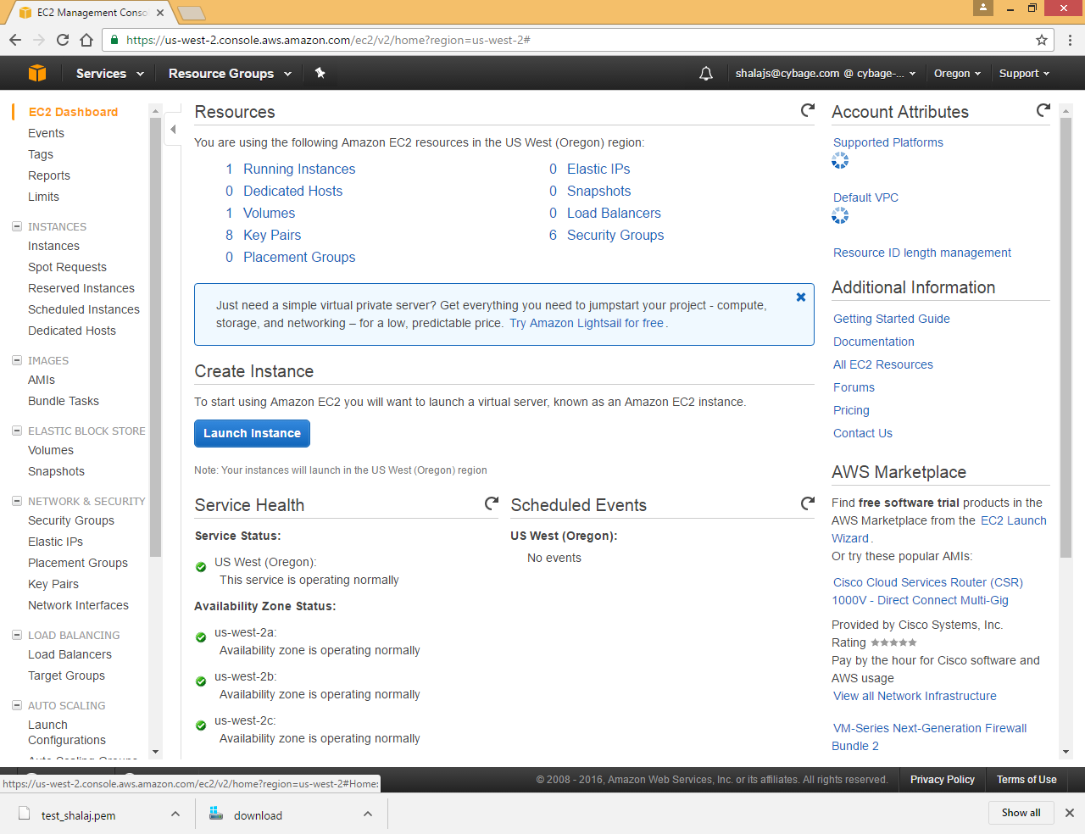

Click on Launch Instance

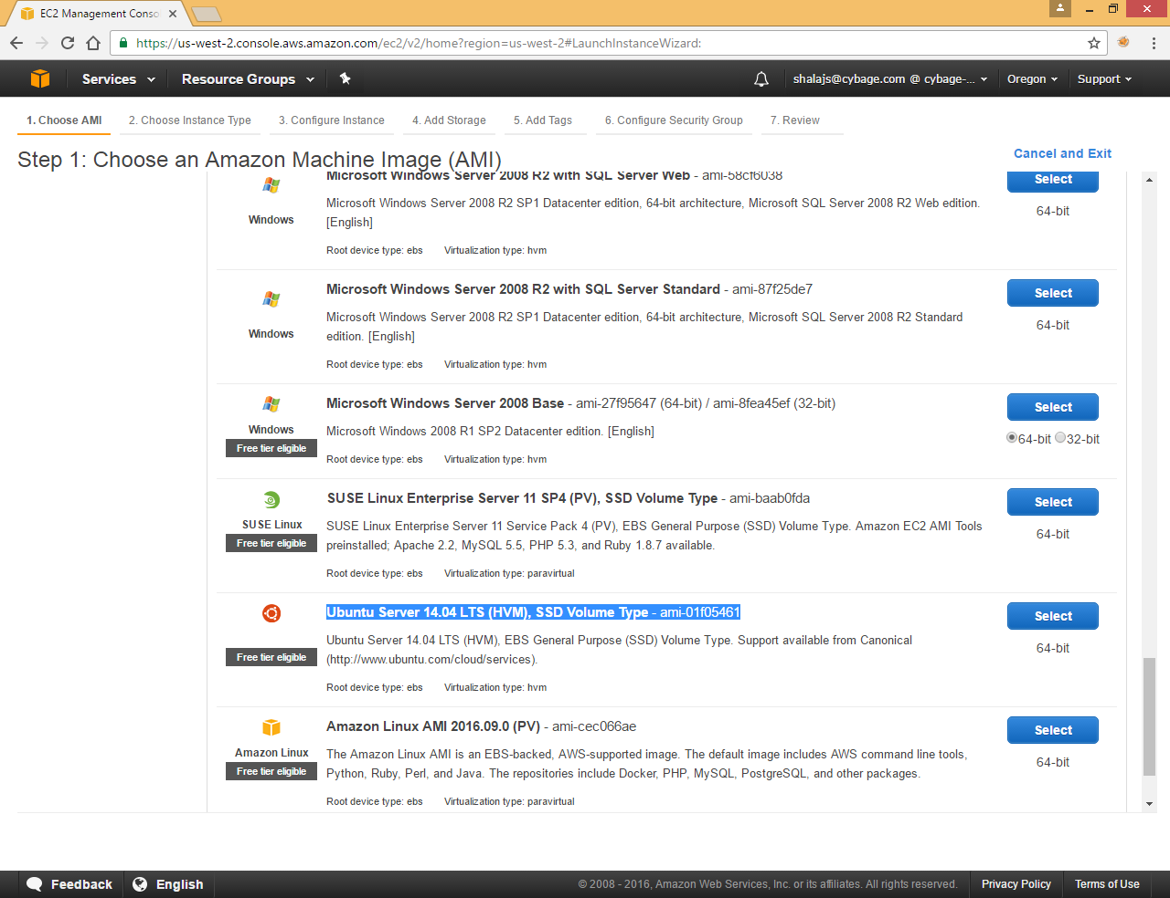

Select **Ubuntu Server 14.04 LTS (HVM), SSD Volume Type** - ami-01f05461

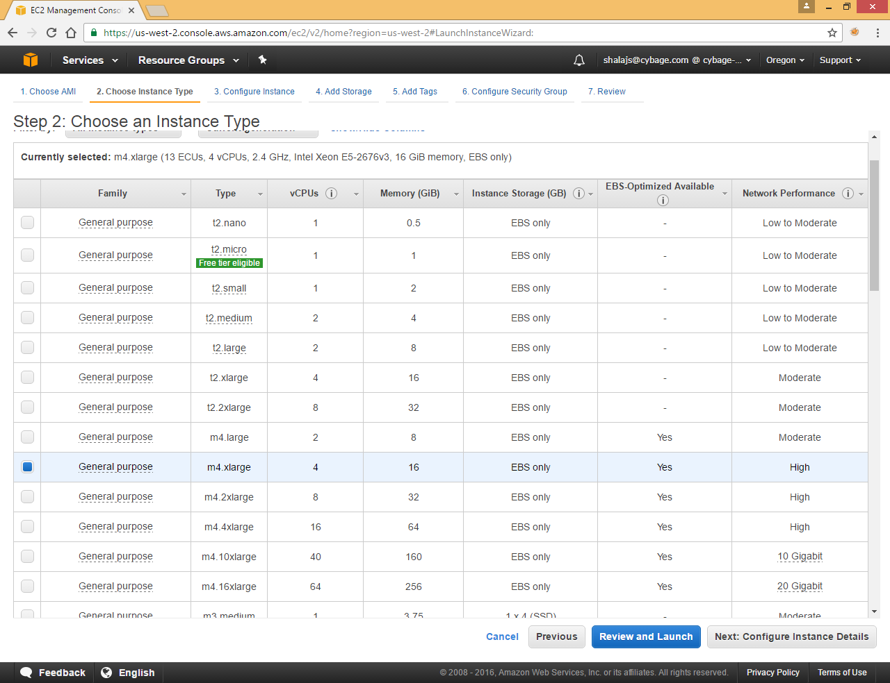

Choose an Instance Type as per your requirement

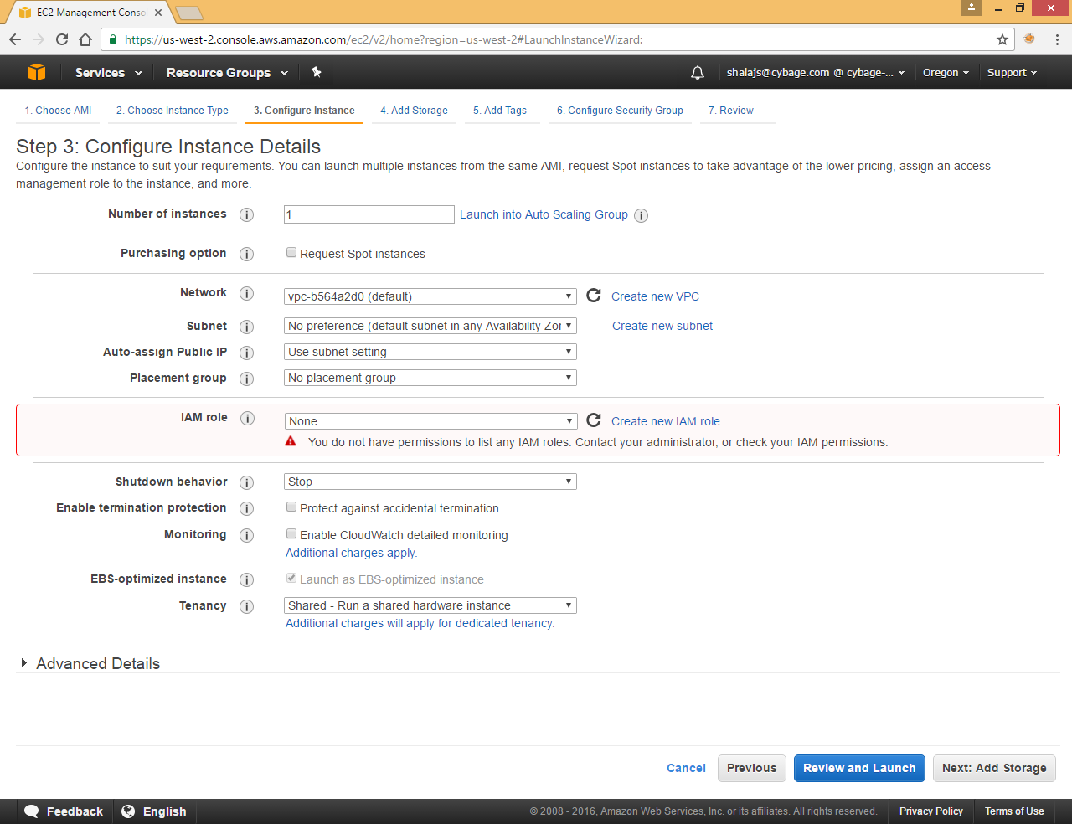

Click Next

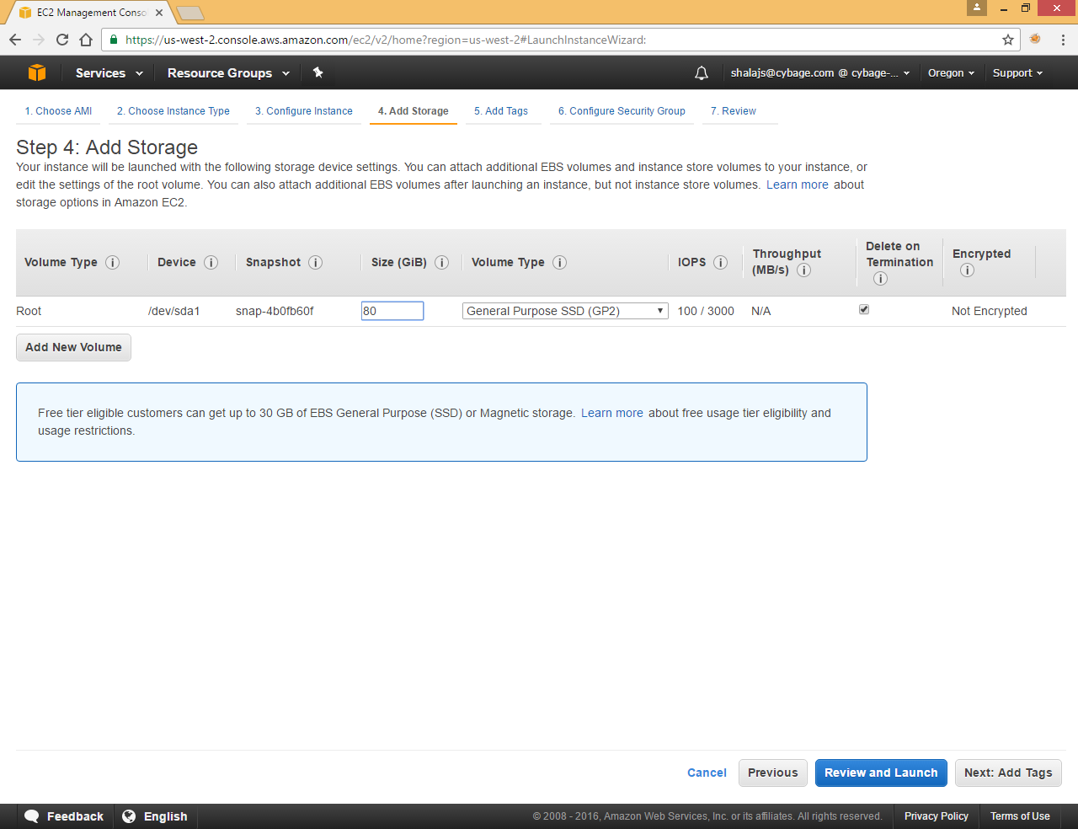

Click Next

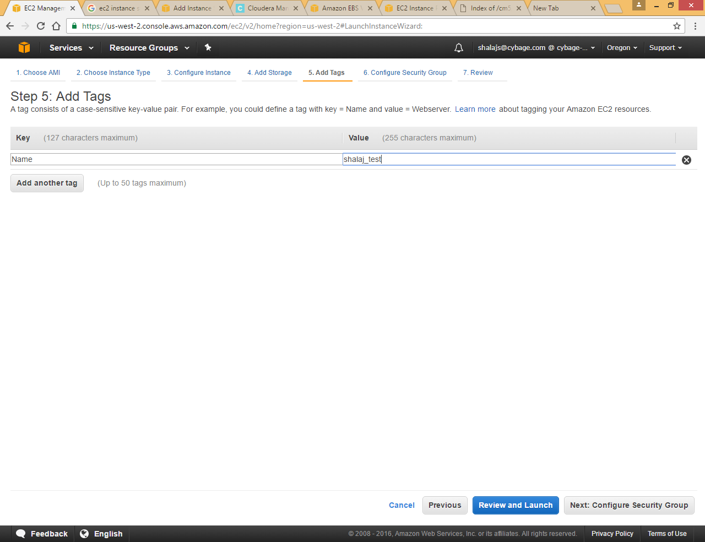

Provide some value for Name key so that you can identify your instance at dashboard page

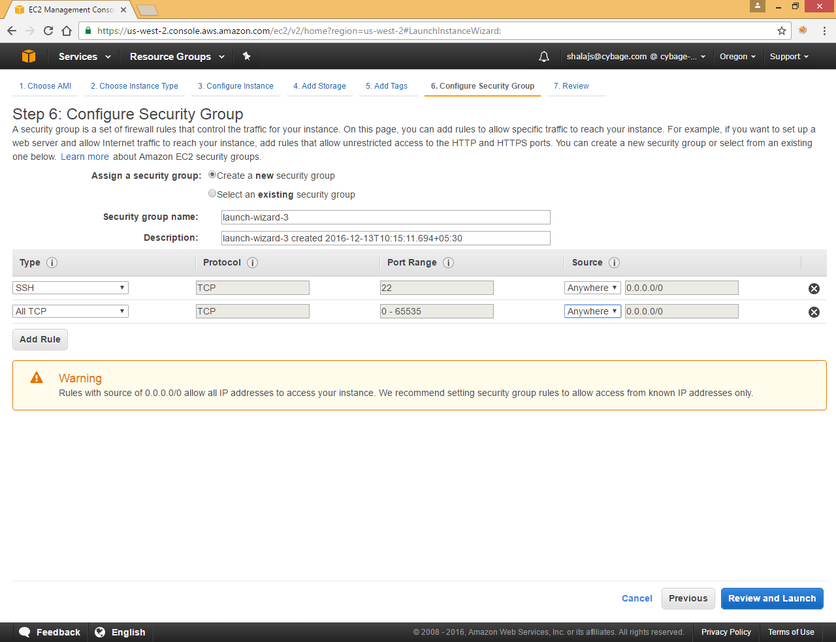

Add rule (here we are using Anywhere source for SSH and TCP, we need to be very specific in case of production environment , also we can create security group first and select existing security group)

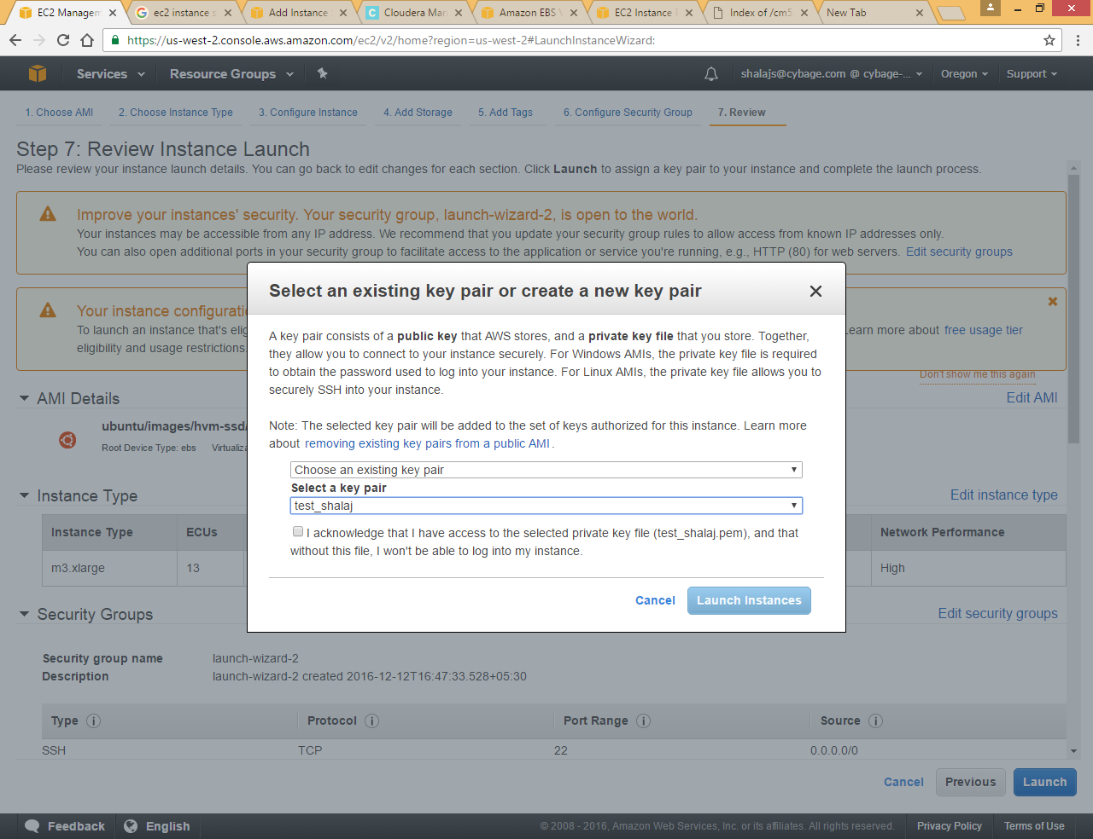

(Choose existing key that we created in Create Key section or we can create new key here, later we will use that key to connect to that instance from our local machine)

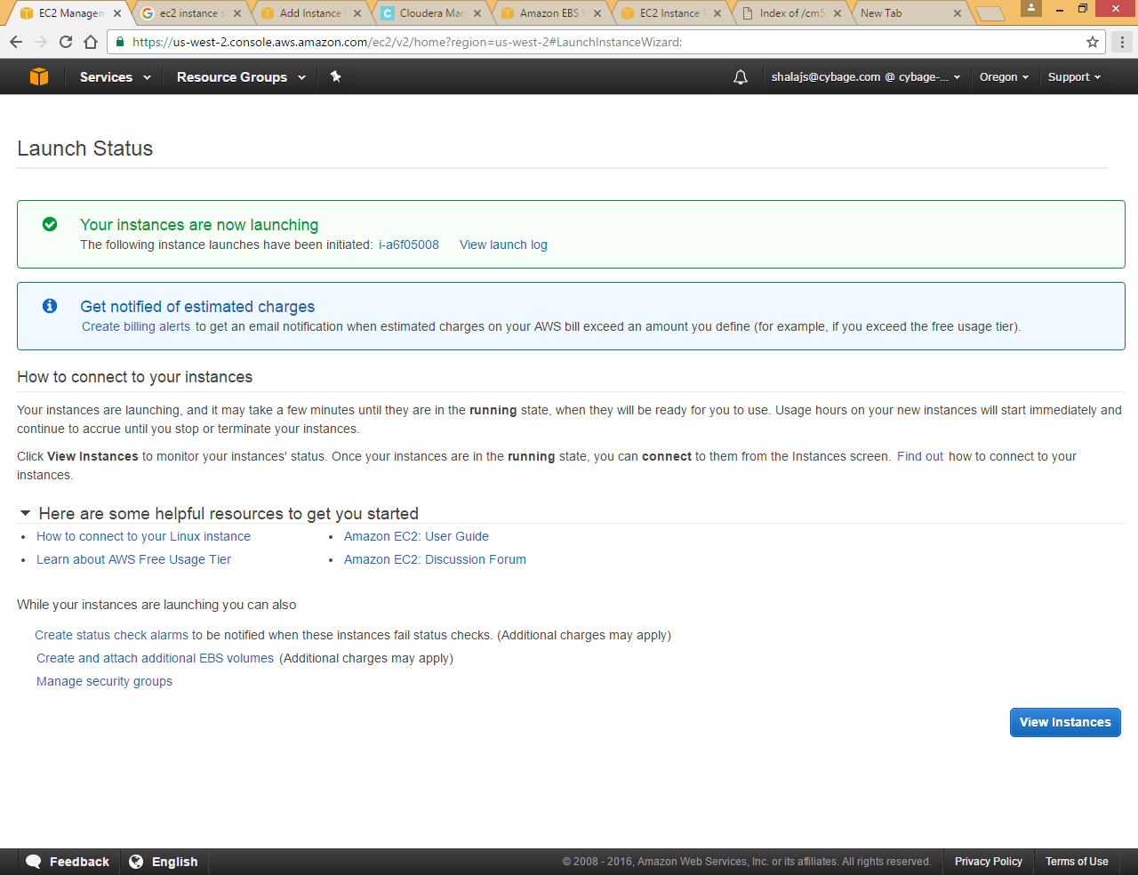

Click View Instance

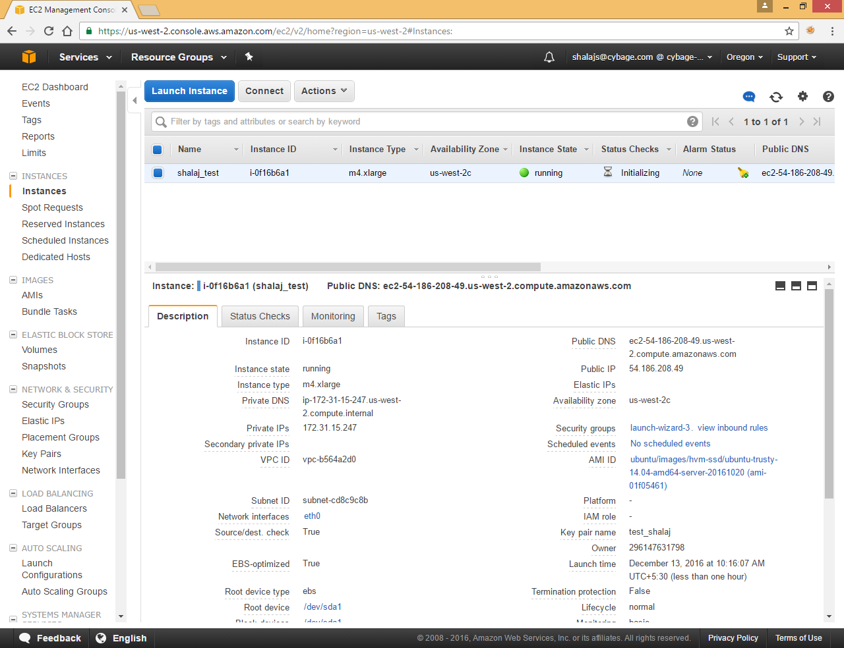

Click on Connect button to see the instruction to connect via ssh

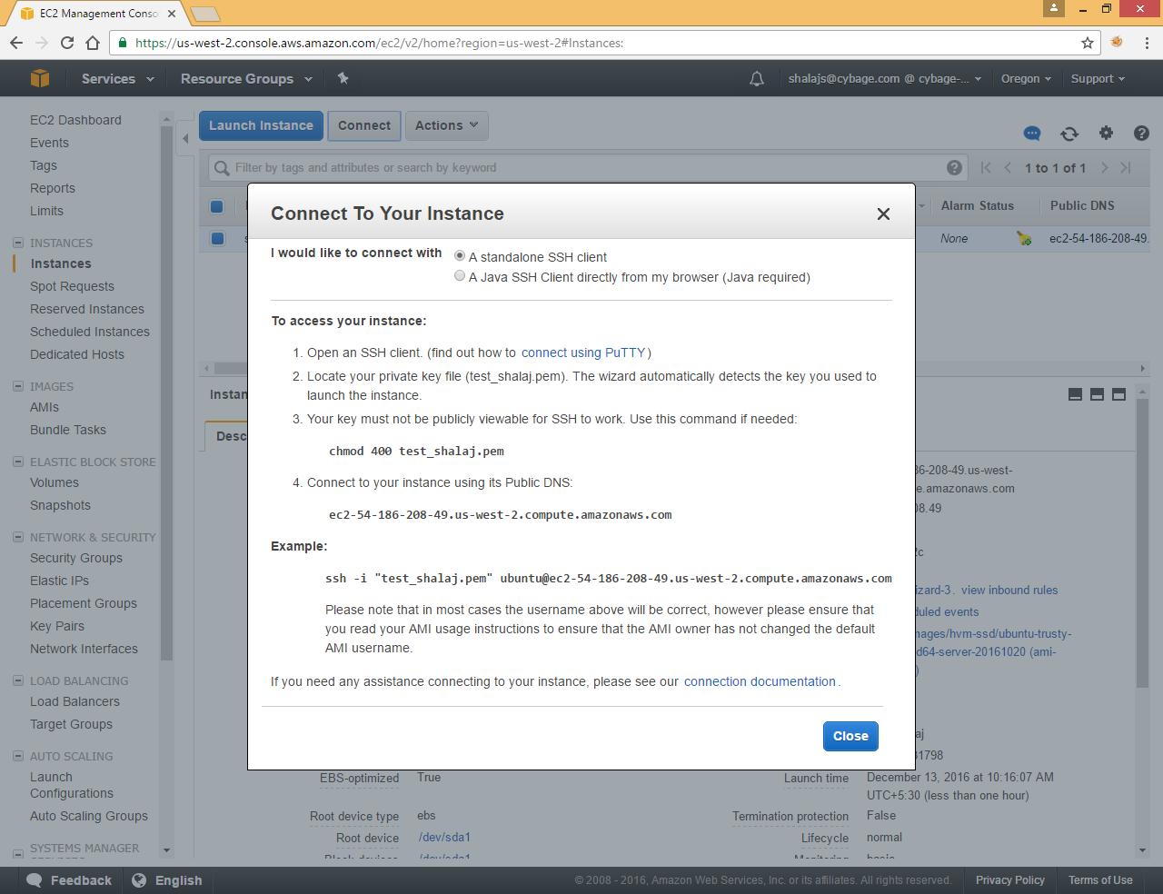

## Install Cloudera Manager

Here we are using MobaXterm instead of putty to connect to the ec2 machine in case if you are using putty we need to provide ppk file that we created in Convert pem to ppk section

(Here we have stored pem file under <Documents\MobaXterm\home\.ssh> folder, you can place it anywhere)

## Connect via Putty

Open putty go to ssh >>Auth

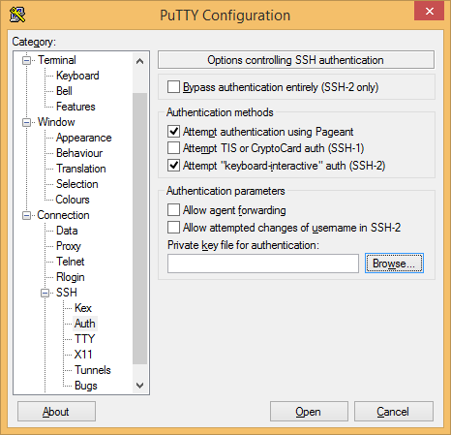

Browse private key file

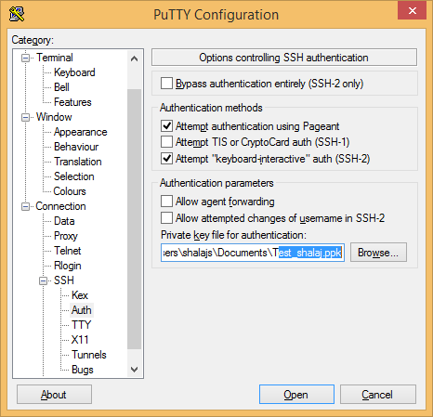

Now specify user name and port under session

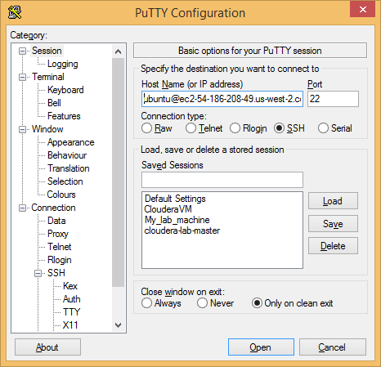

Click Open to connect it to EC2 instance

## Connect via Mobxterm

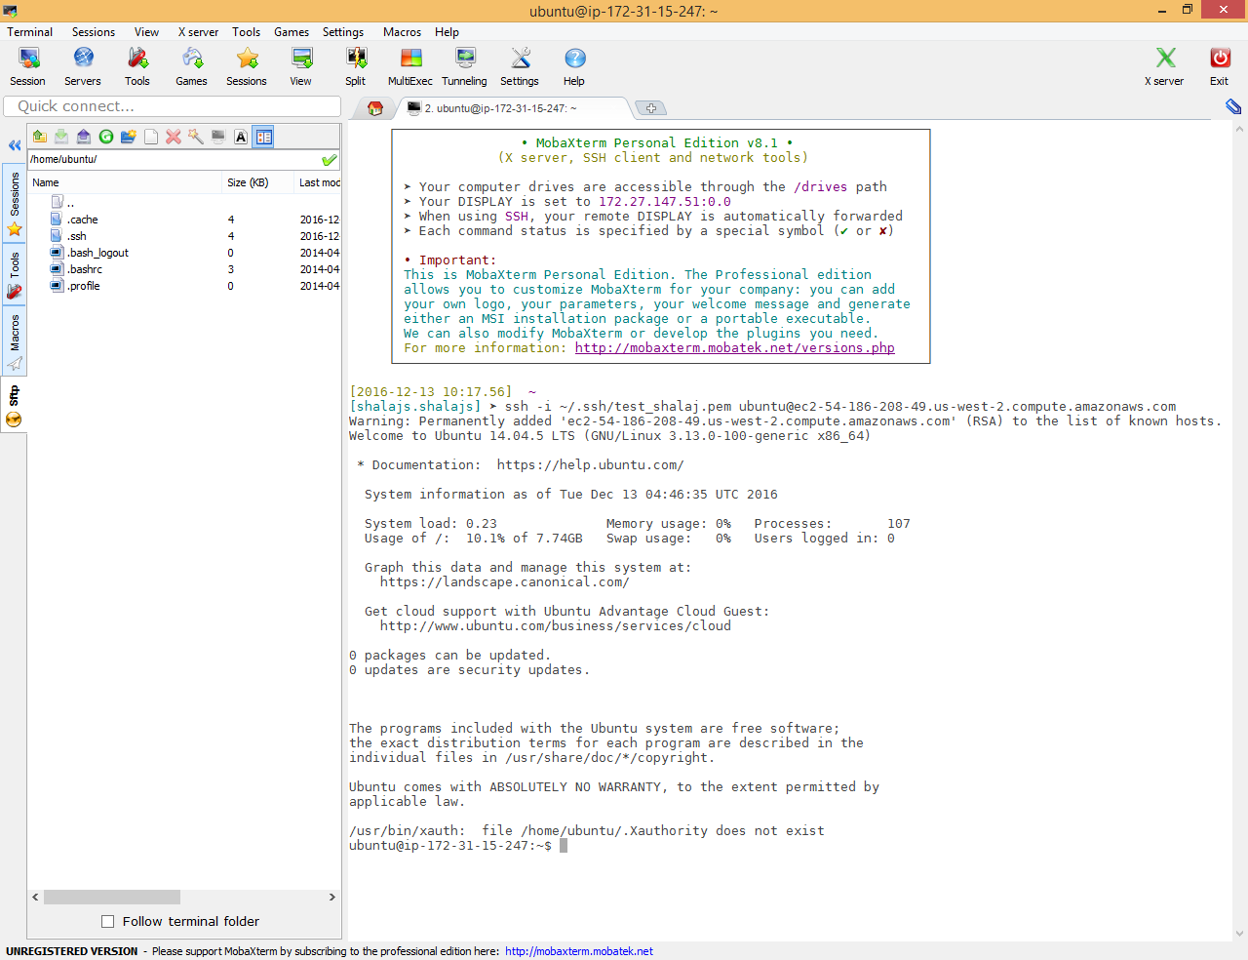

Use below command to connect to EC2 instance

|  |
| --- |
| ssh -i ~/.ssh/test_shalaj.pem ubuntu@ec2-54-186-208-49.us-west-2.compute.amazonaws.com |

Run below command to download Cloudera-manager file

|  |
| --- |
| wget https://archive.cloudera.com/cm5/installer/latest/cloudera-manager-installer.bin |
| ubuntu@ip-172-31-15-247:~$ wget https://archive.cloudera.com/cm5/installer/latest/cloudera-manager-installer.bin  --2016-12-13 04:49:54-- https://archive.cloudera.com/cm5/installer/latest/cloudera-manager-installer.bin  Resolving archive.cloudera.com (archive.cloudera.com)... 151.101.52.167  Connecting to archive.cloudera.com (archive.cloudera.com)|151.101.52.167|:443... connected.  HTTP request sent, awaiting response... 200 OK  Length: 516323 (504K) [application/octet-stream]  Saving to: ‘cloudera-manager-installer.bin’  100%[=======================================================================>] 516,323 --.-K/s in 0.1s  2016-12-13 04:49:54 (4.94 MB/s) - ‘cloudera-manager-installer.bin’ saved [516323/516323] |

Give executable permission to file using below command

|  |
| --- |
| chmod u+x cloudera-manager-installer.bin |

|  |
| --- |
| ubuntu@ip-172-31-15-247:~$ ls -l  total 508  -rw-rw-r-- 1 ubuntu ubuntu 516323 Oct 20 22:21 cloudera-manager-installer.bin  ubuntu@ip-172-31-15-247:~$ chmod u+x cloudera-manager-installer.bin  ubuntu@ip-172-31-15-247:~$ ls -l  total 508  -rwxrw-r-- 1 ubuntu ubuntu 516323 Oct 20 22:21 cloudera-manager-installer.bin  ubuntu@ip-172-31-15-247:~$ |

Run file using below command

|  |
| --- |
| sudo ./cloudera-manager-installer.bin |

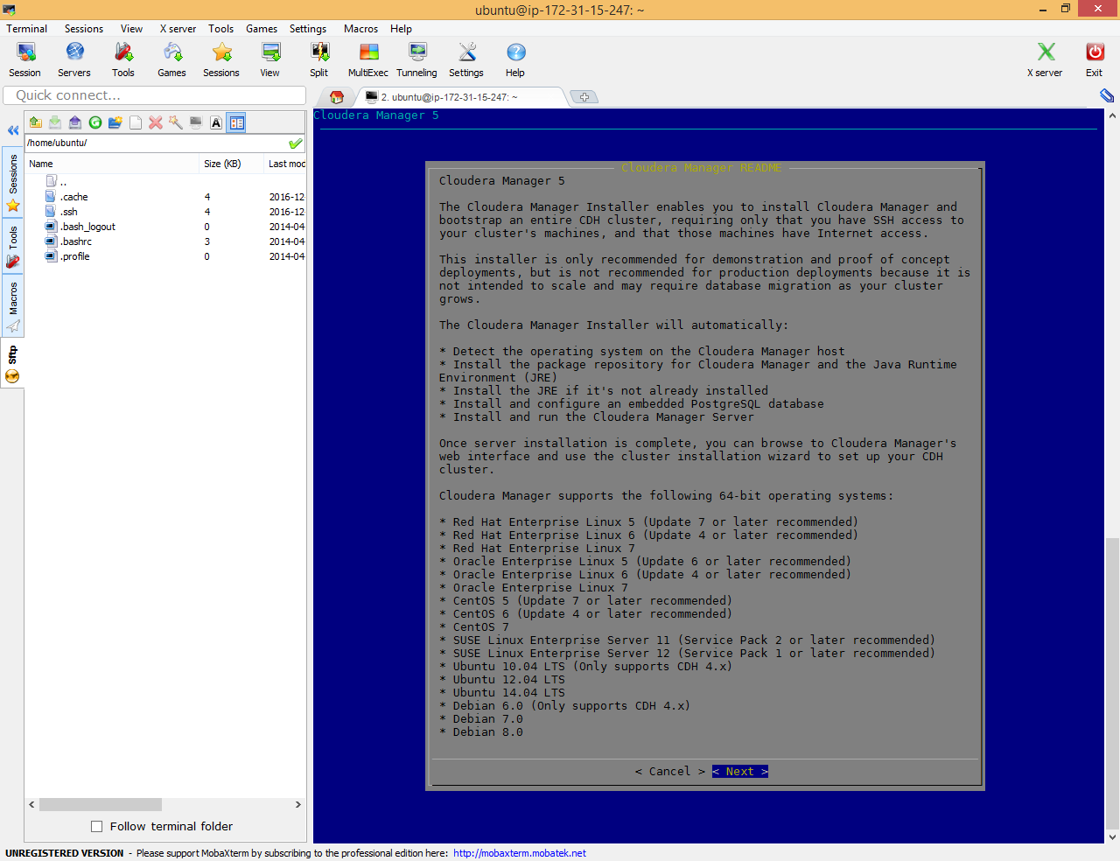

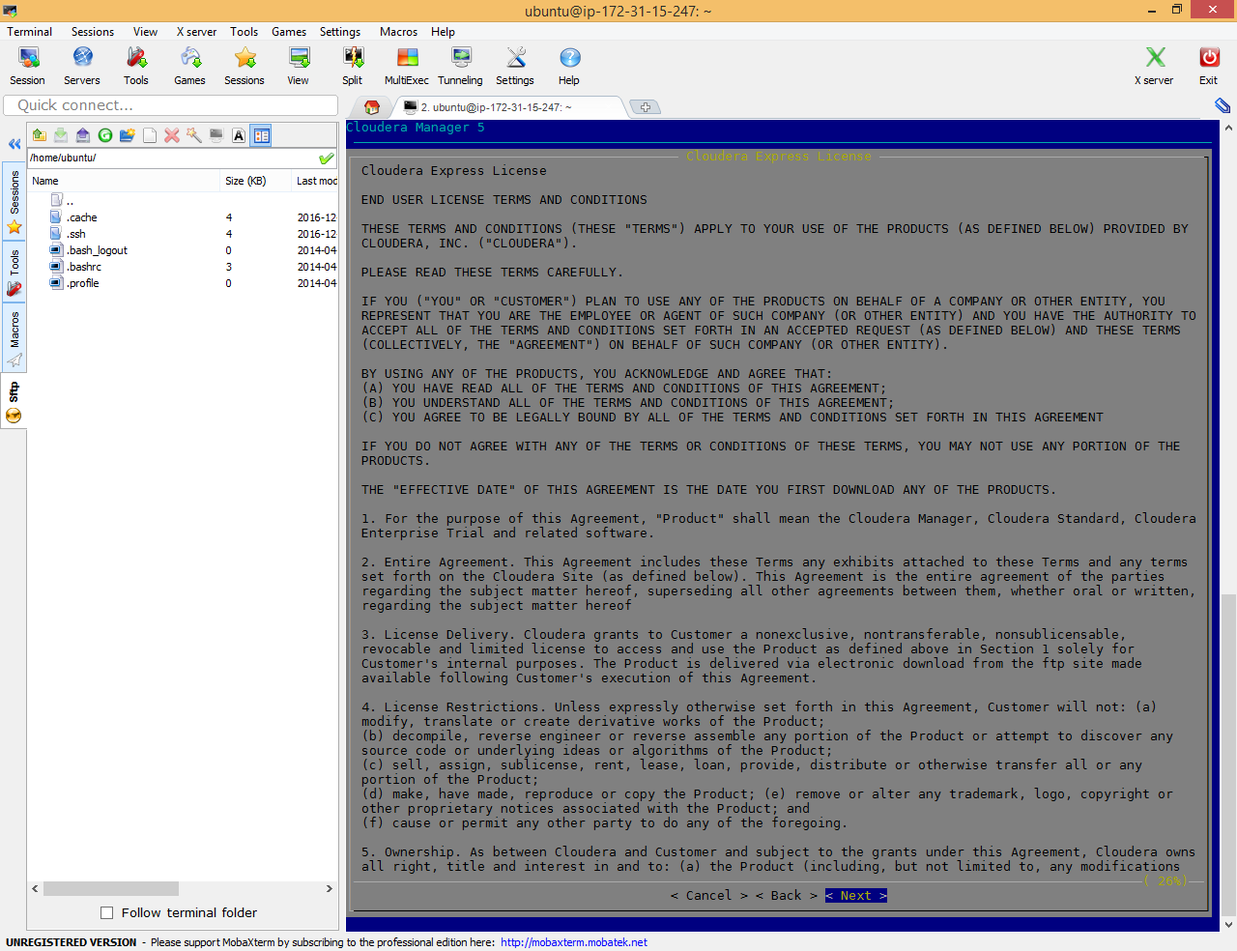

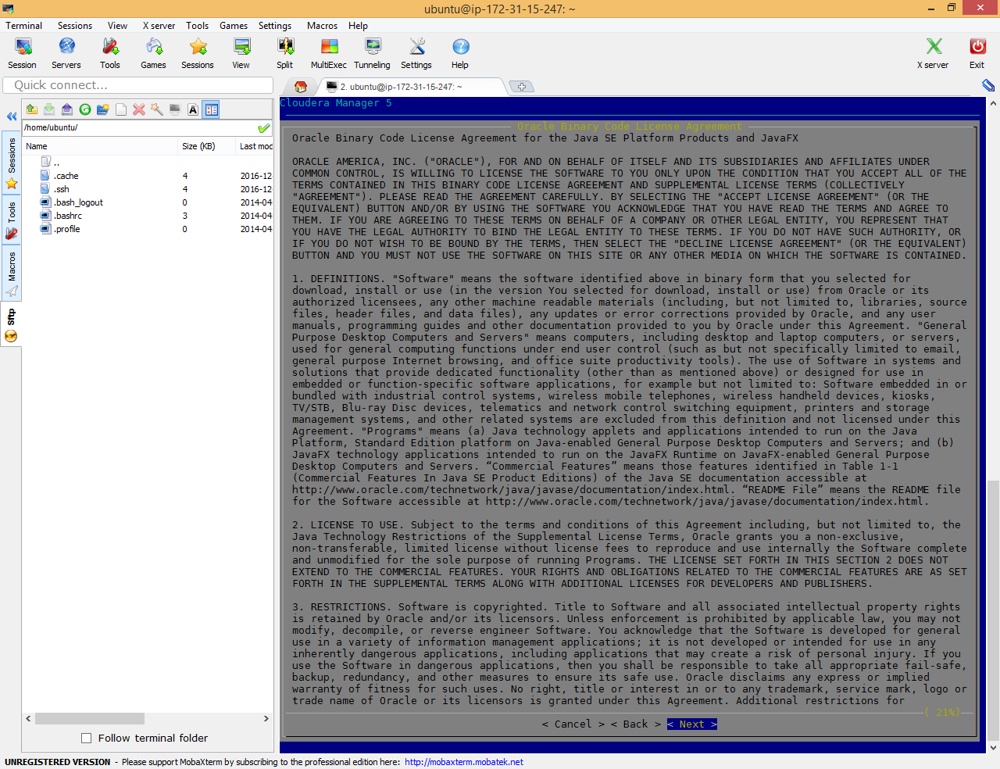

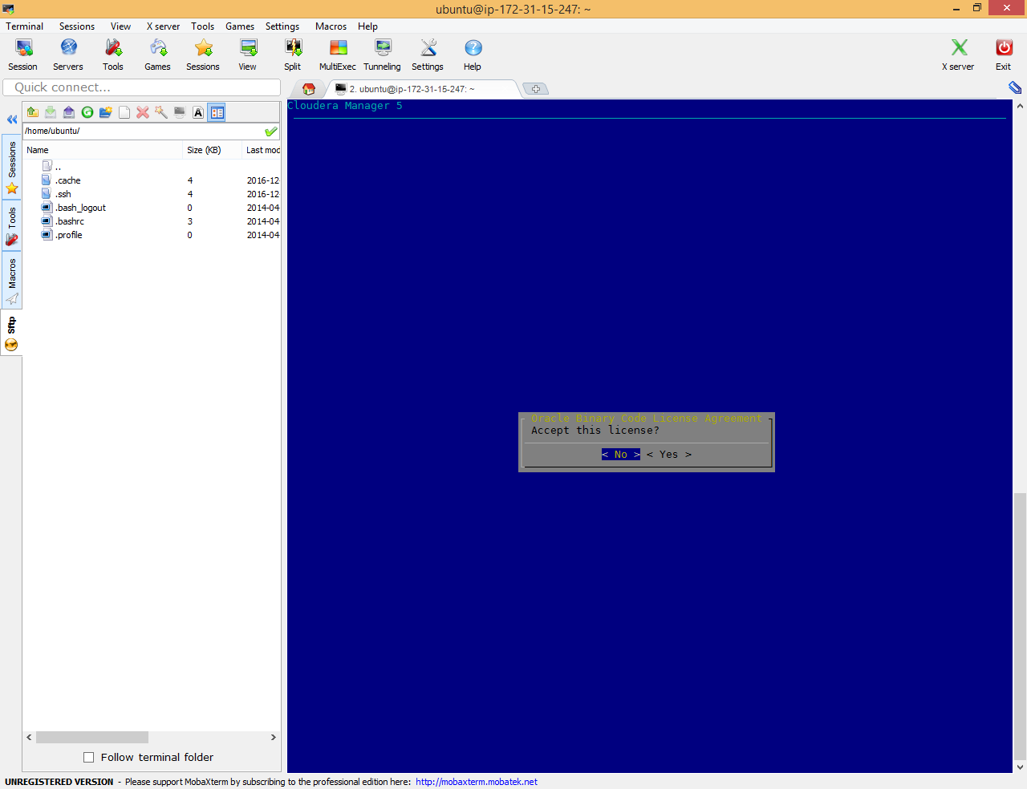

Accept licensee

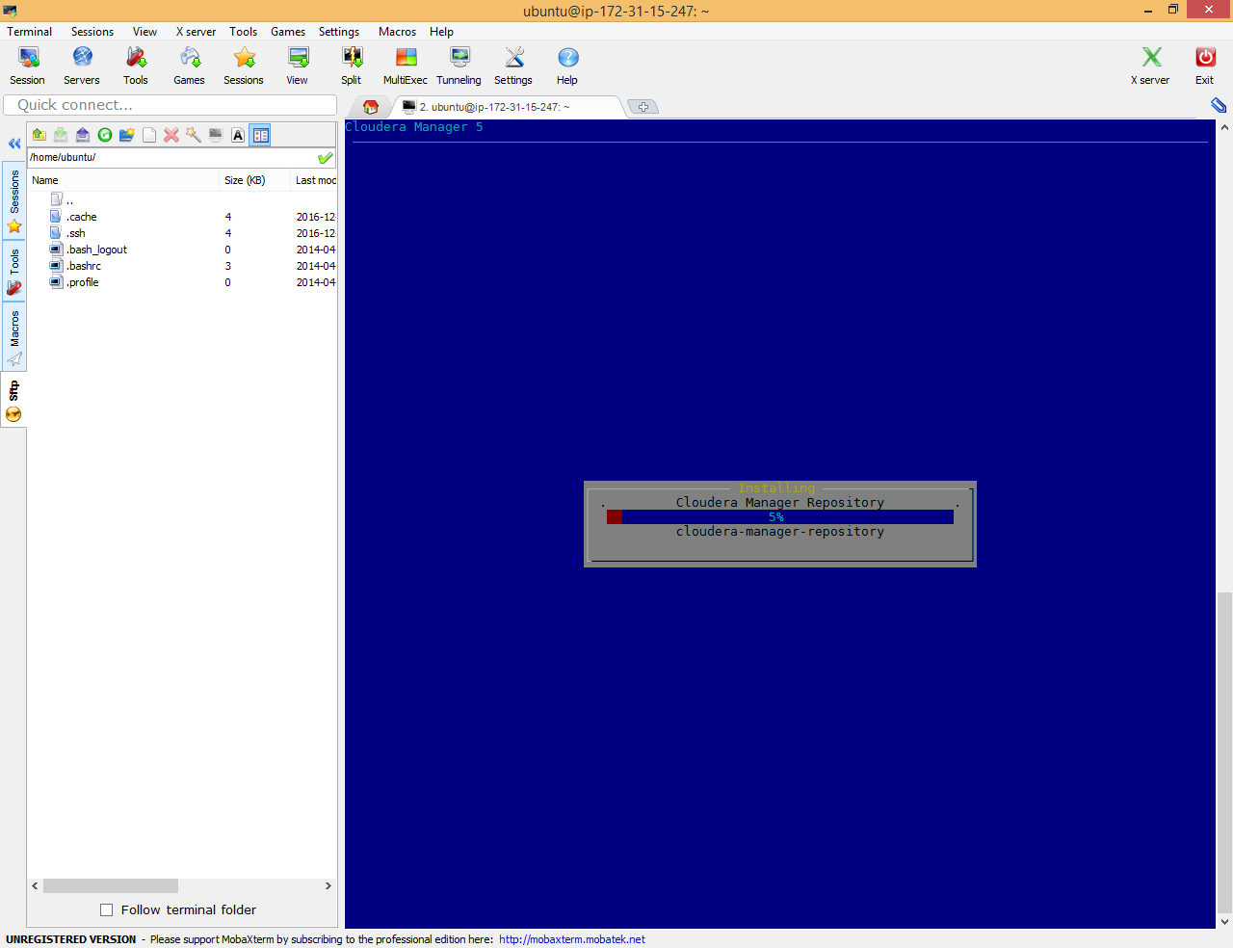

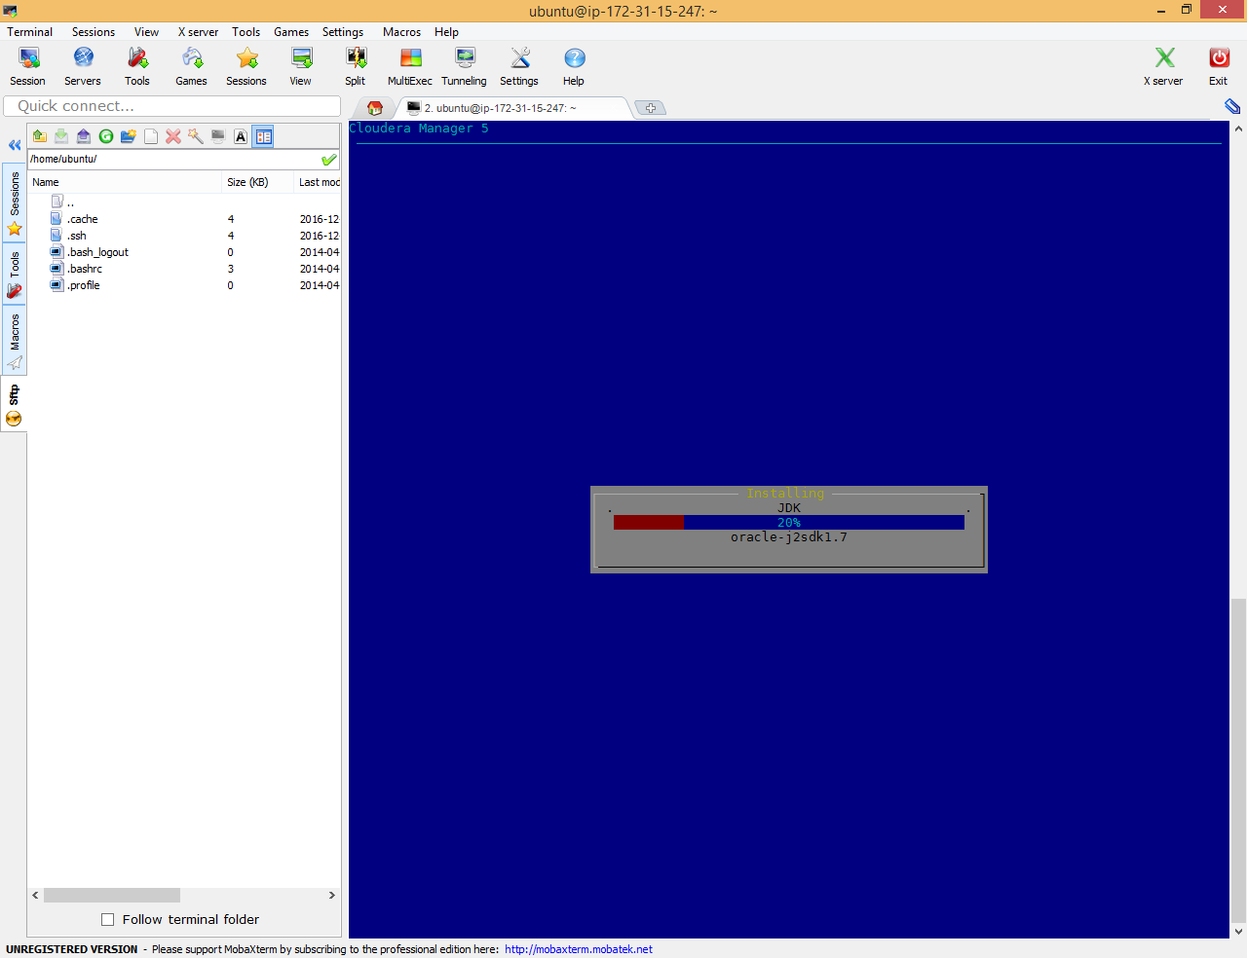

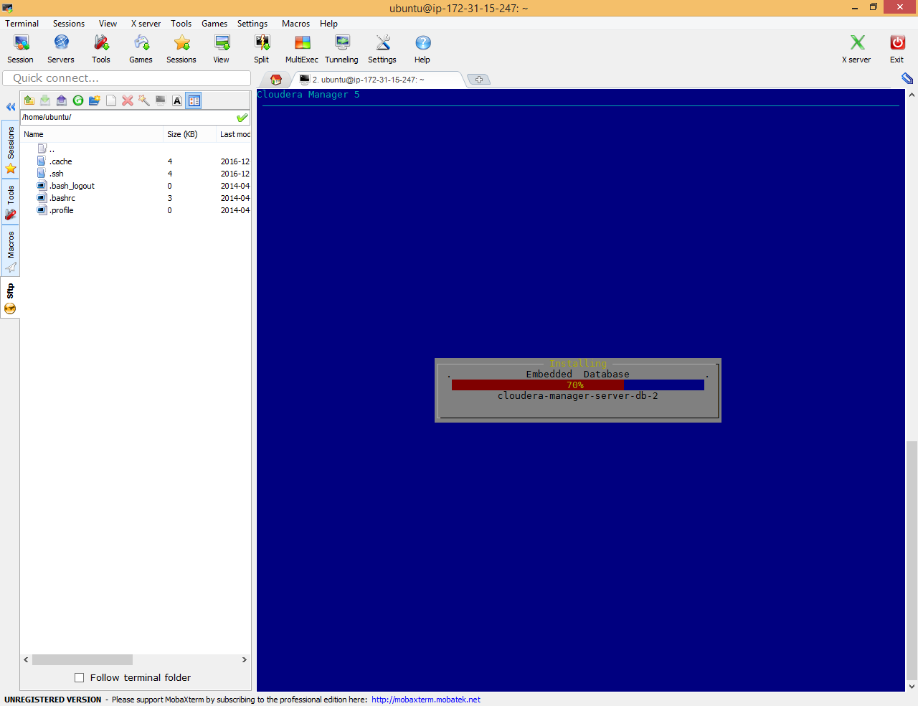

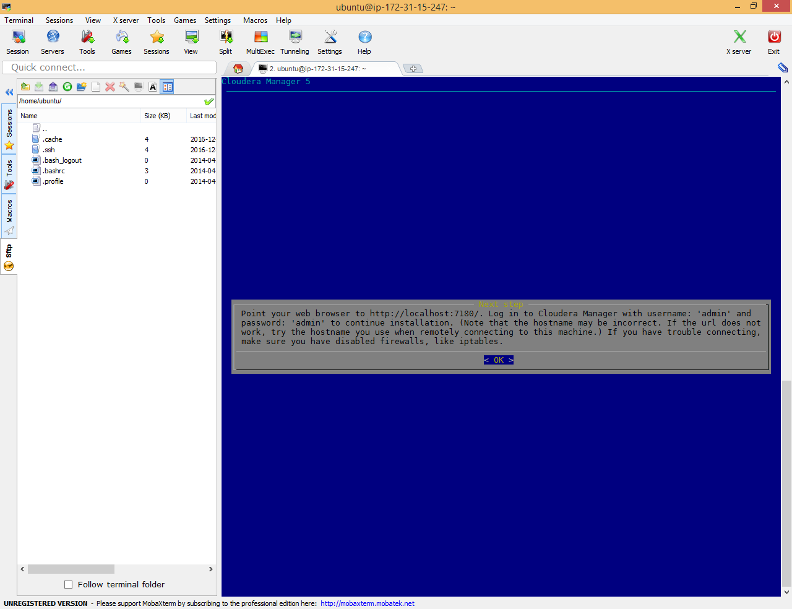

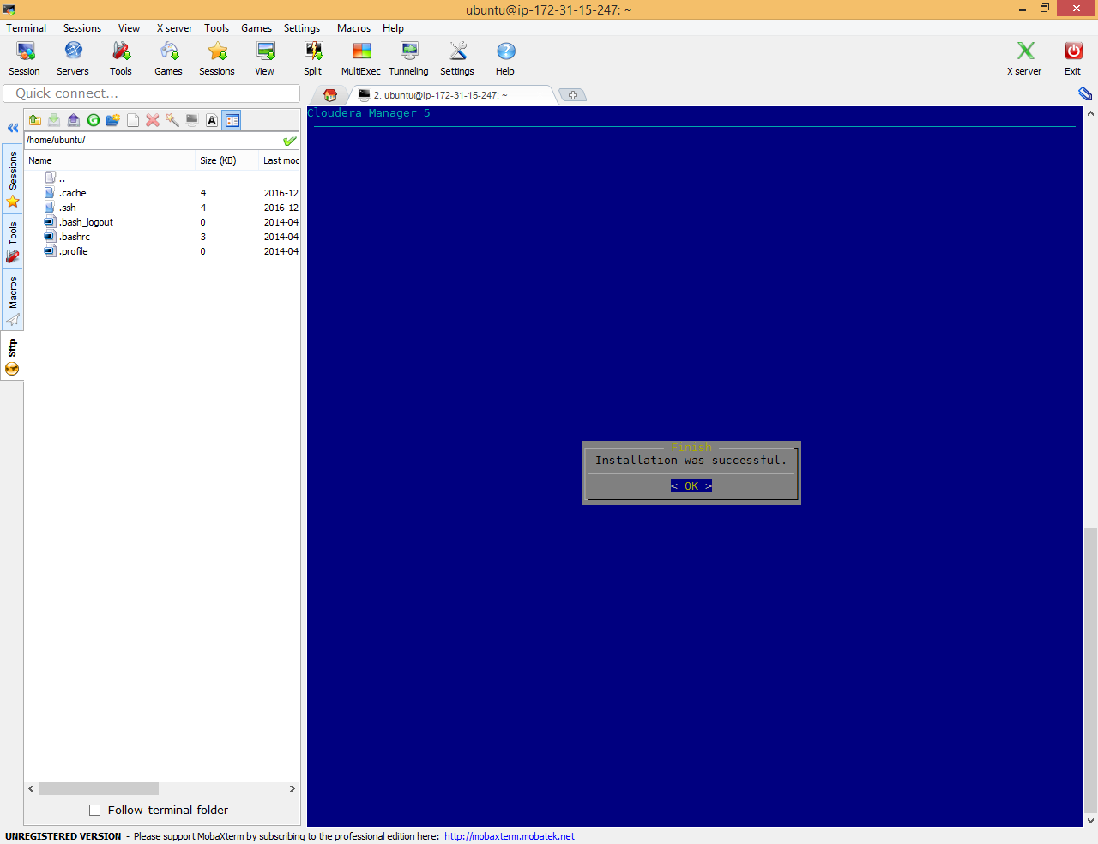

Open <http://ec2-54-186-208-49.us-west-2.compute.amazonaws.com:7180/>

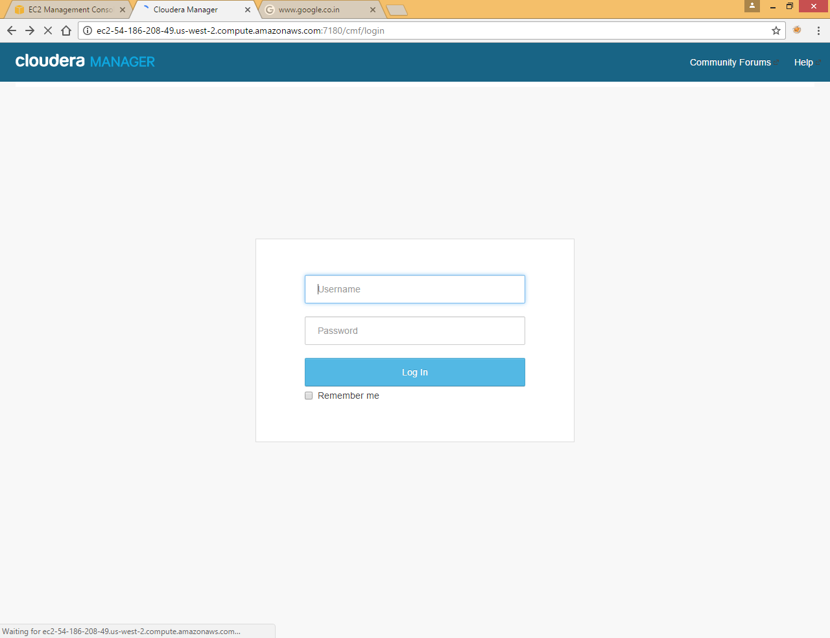

Use admin admin as username and password later you can change it from admin console

## Add Hadoop services

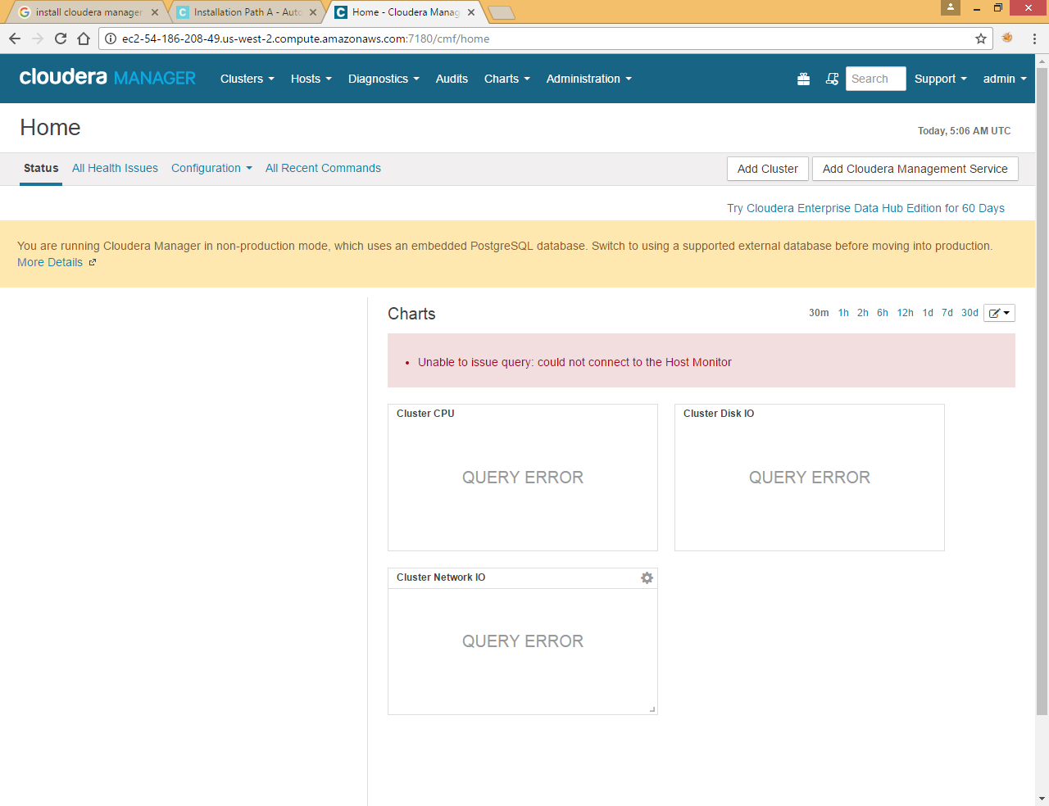

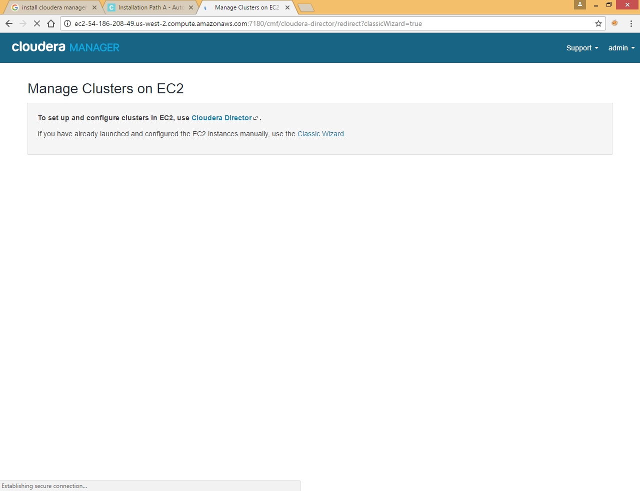

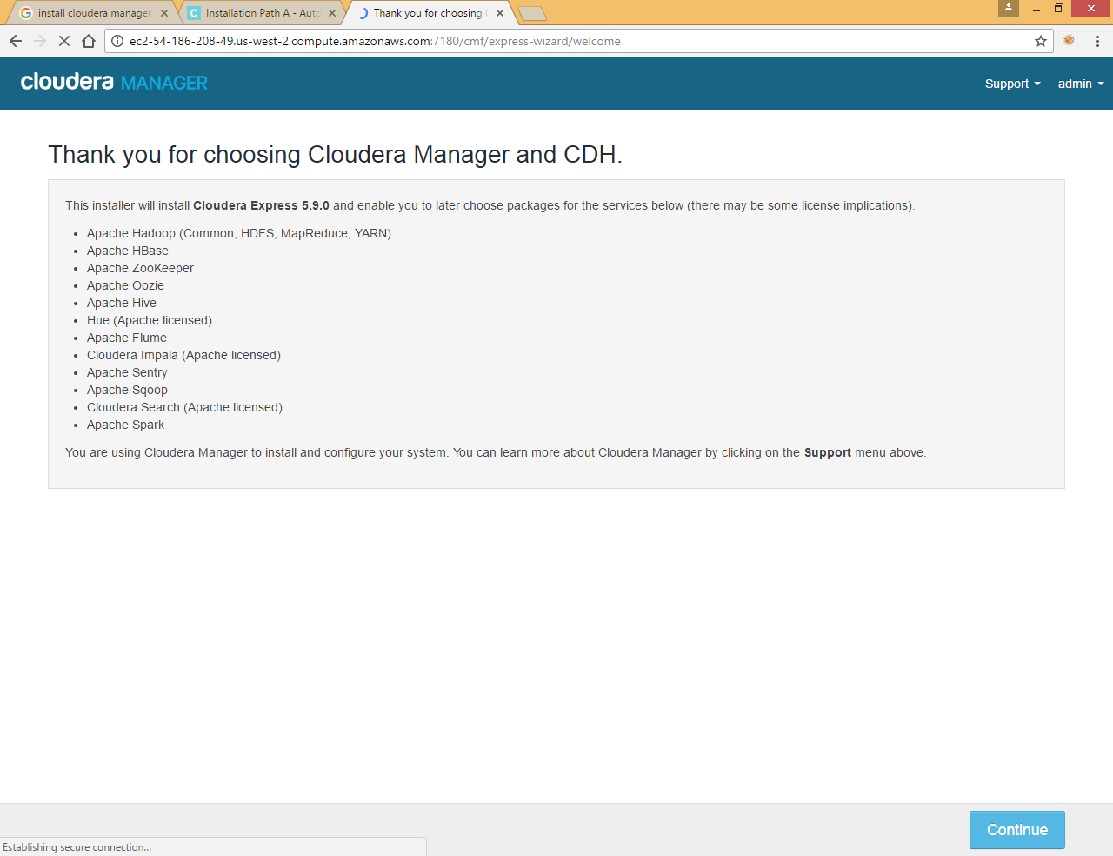

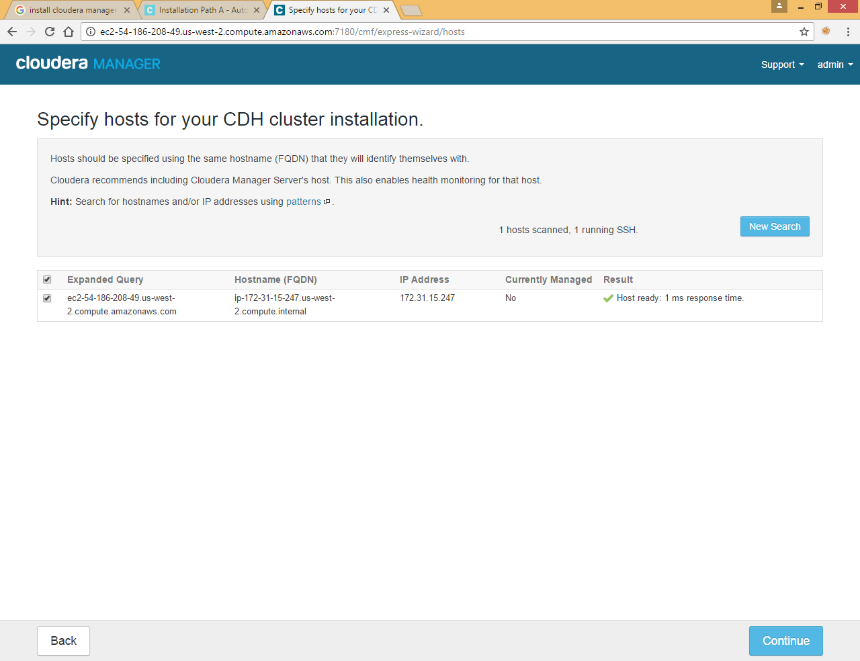

Specify host and click search and later click Continue

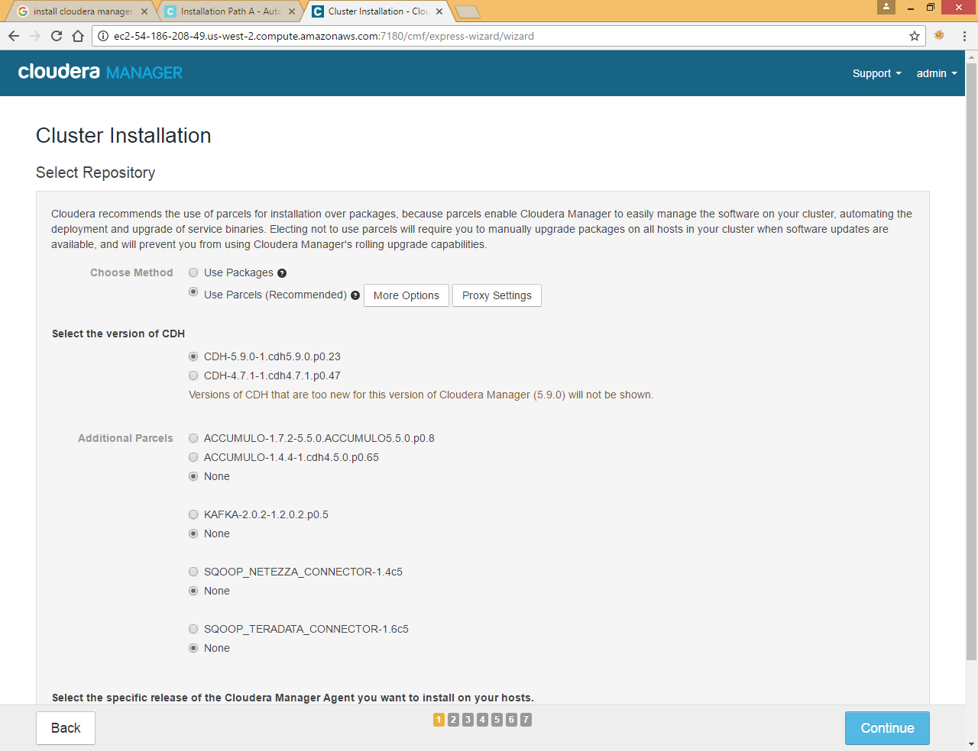

Click Continue

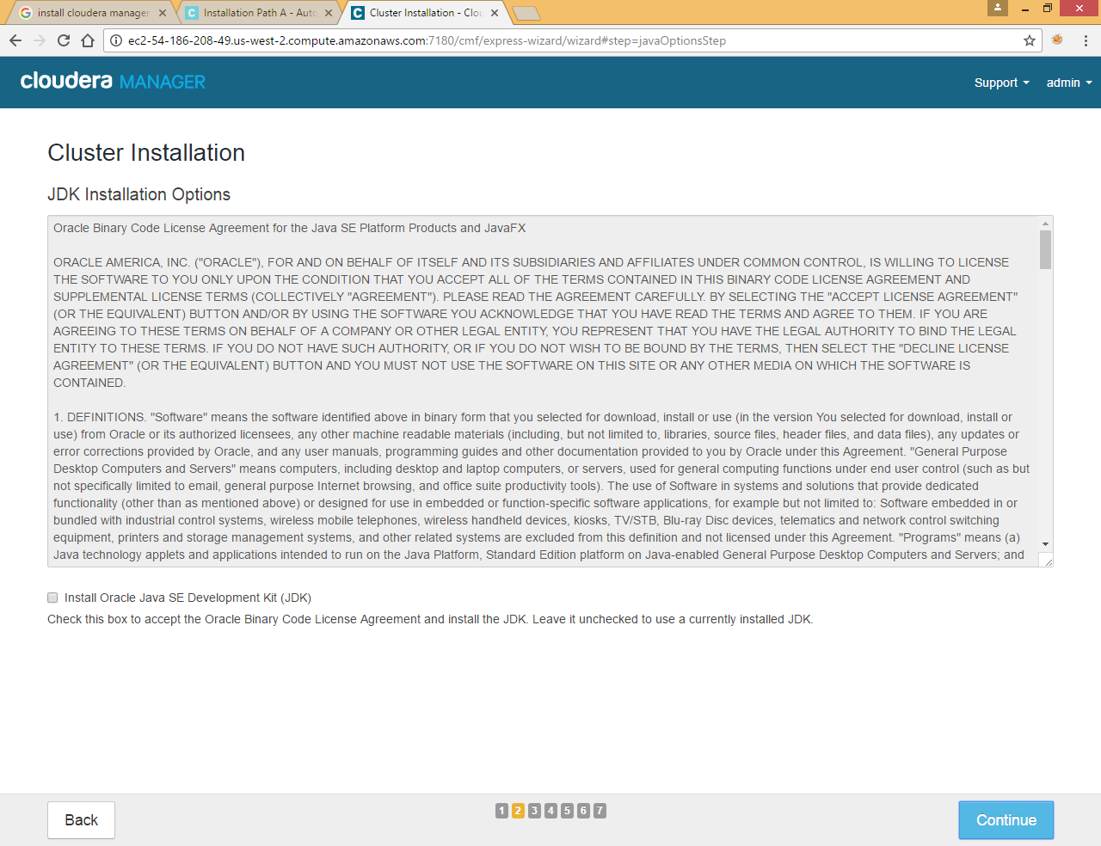

Leave jdk installation uncheck and click Continue

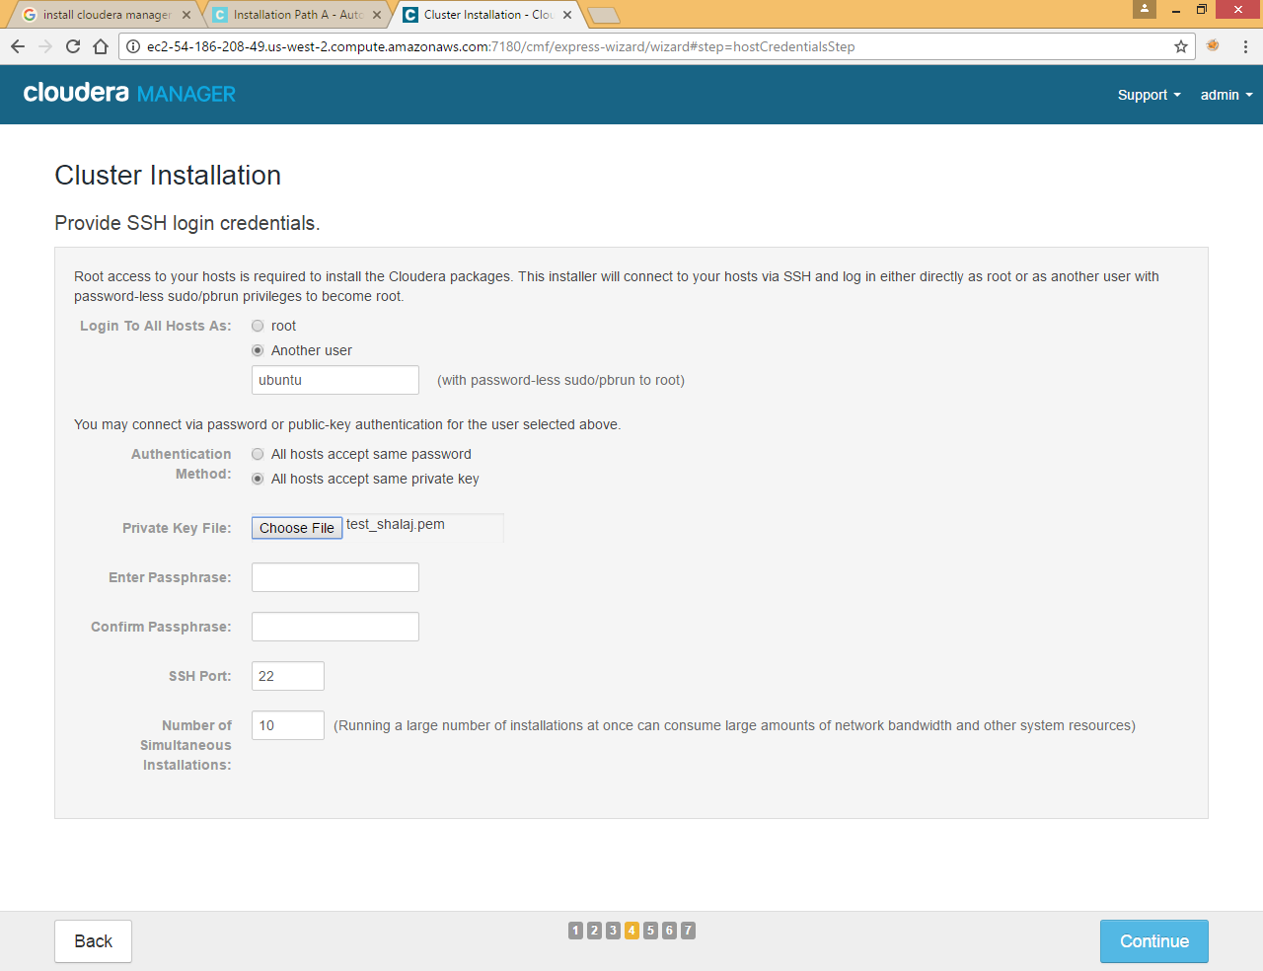

Provide user name in our case it is ubuntu

Also choose private key file that we downloaded in Create key Section

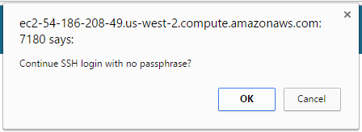

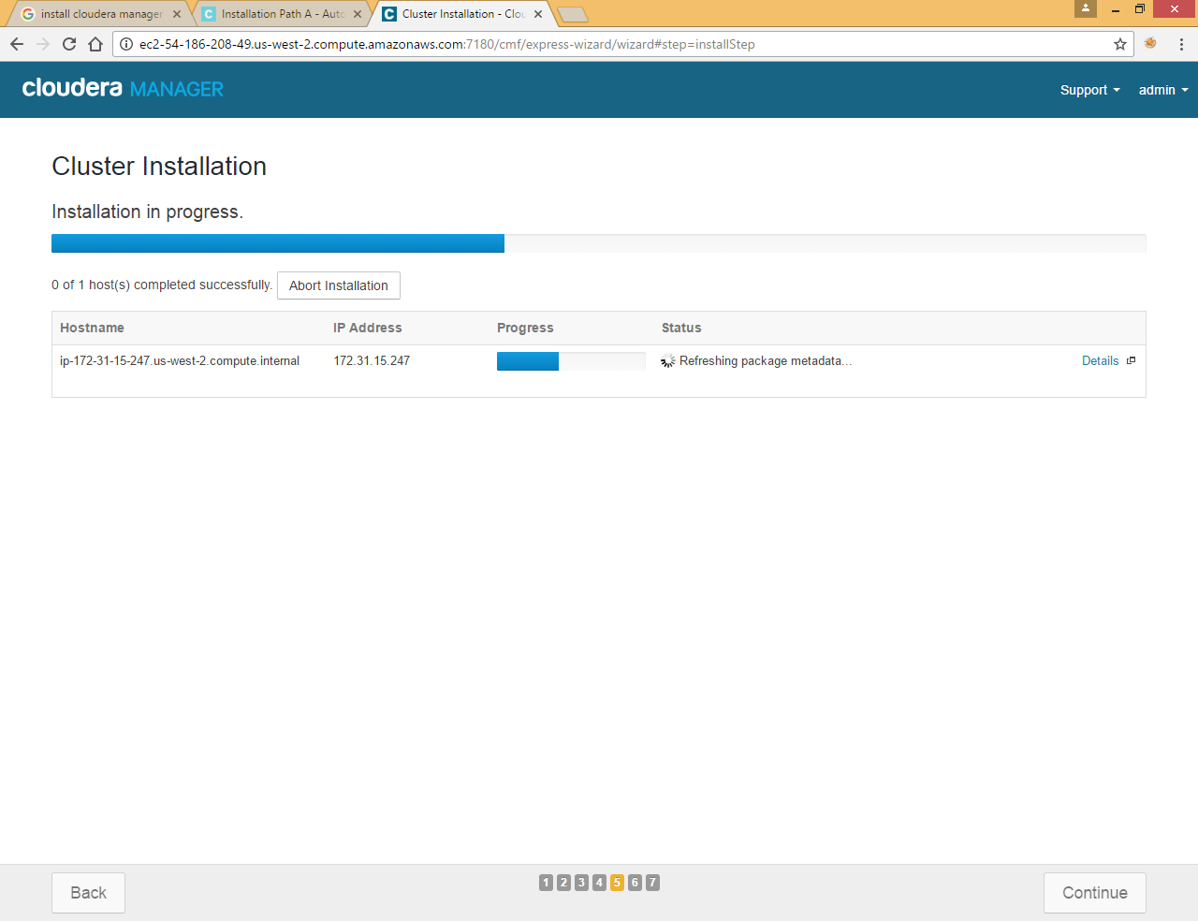

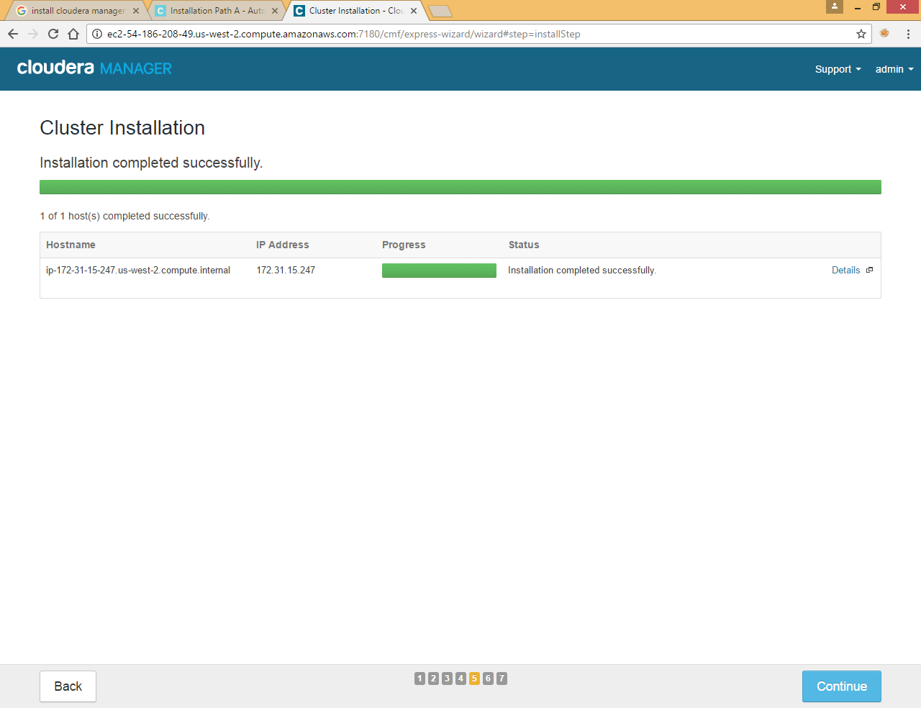

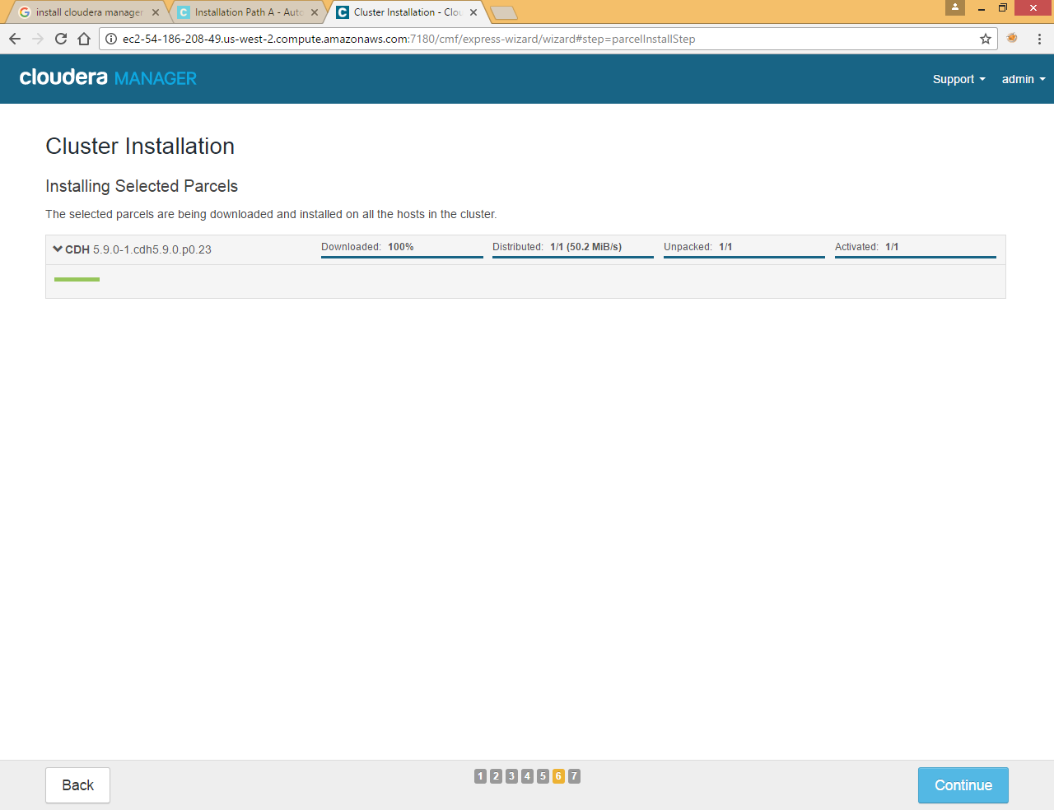

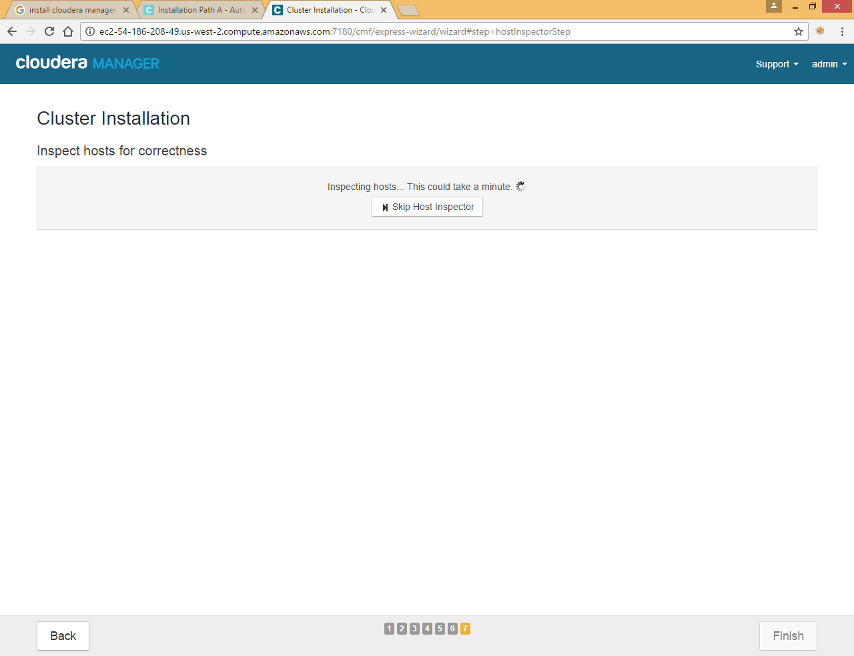

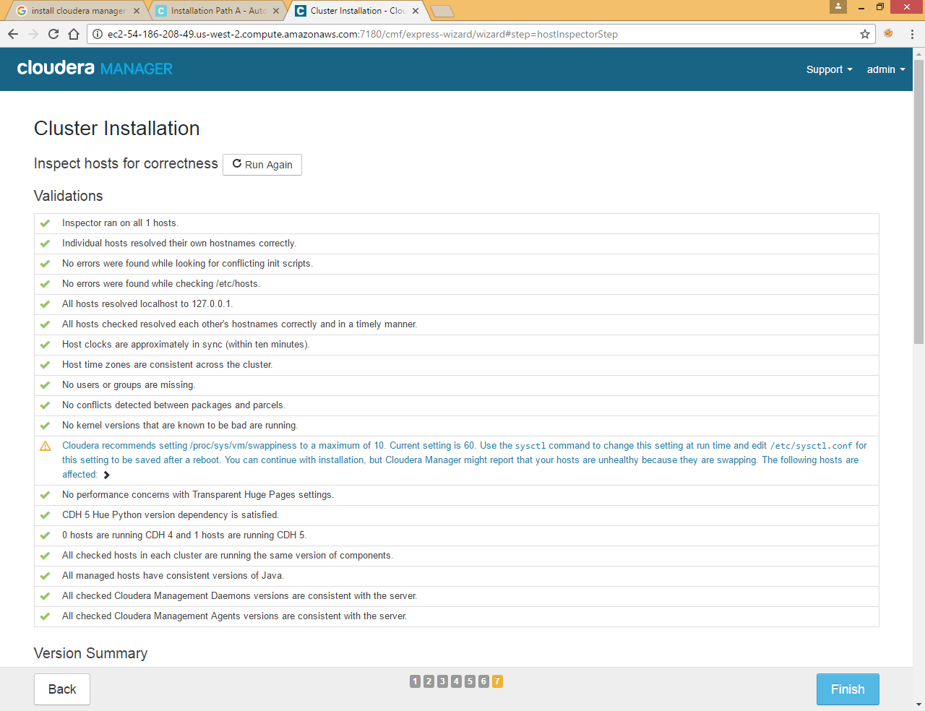

Click Finish

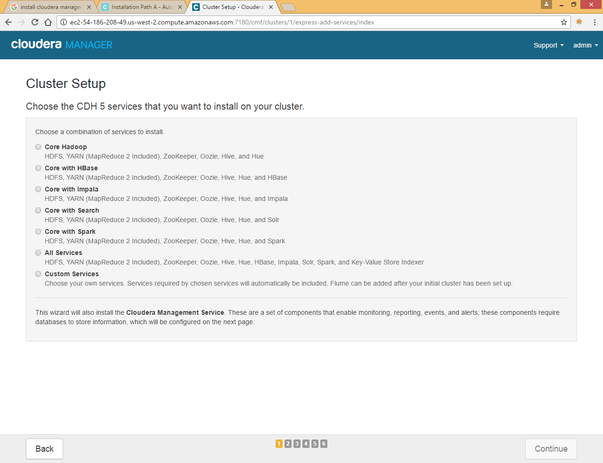

Choose Custom Services (we are going to install service one by one)

### Add Zookeeper Service

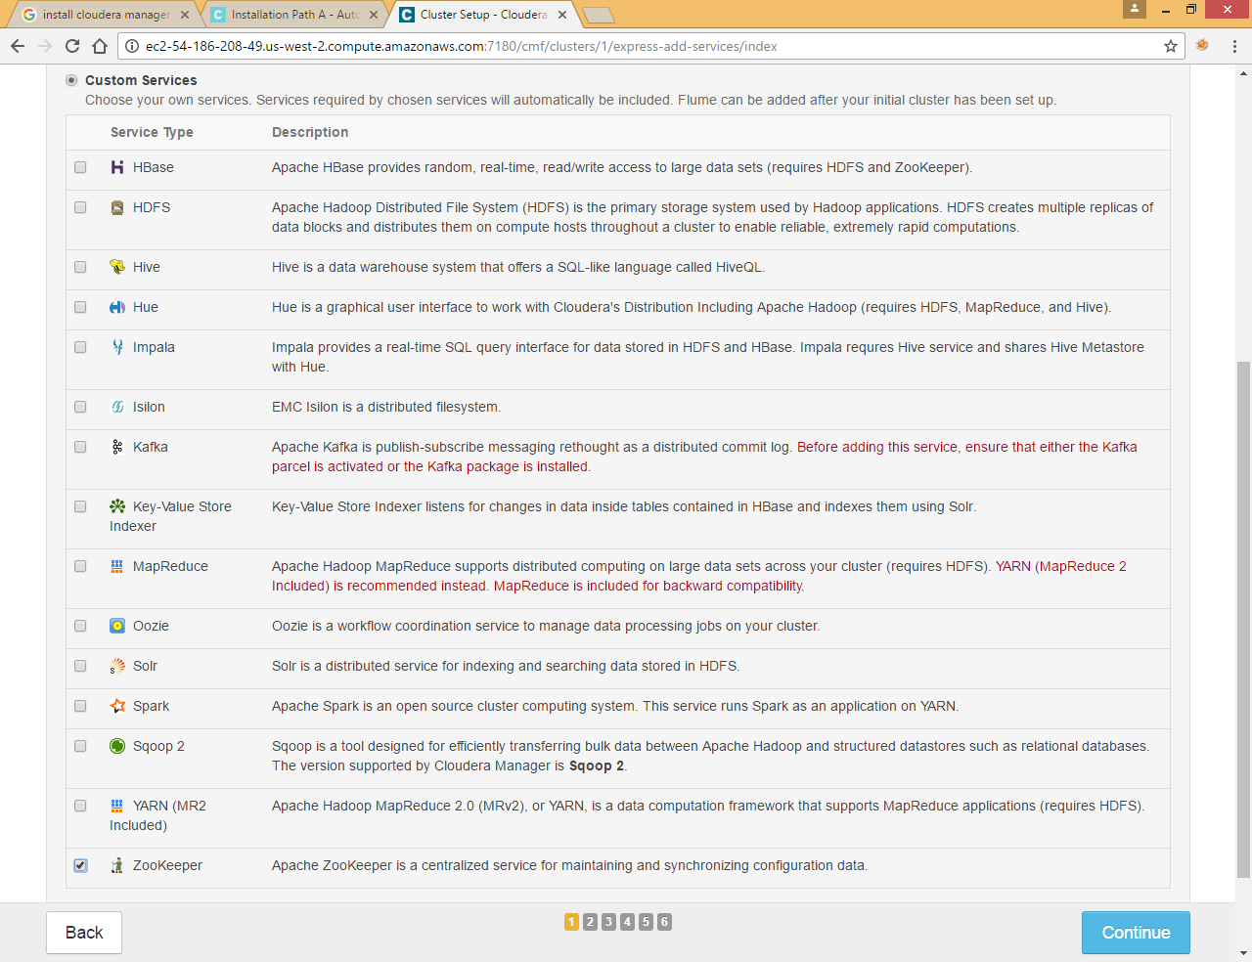

Select Zookeeper and click Continue

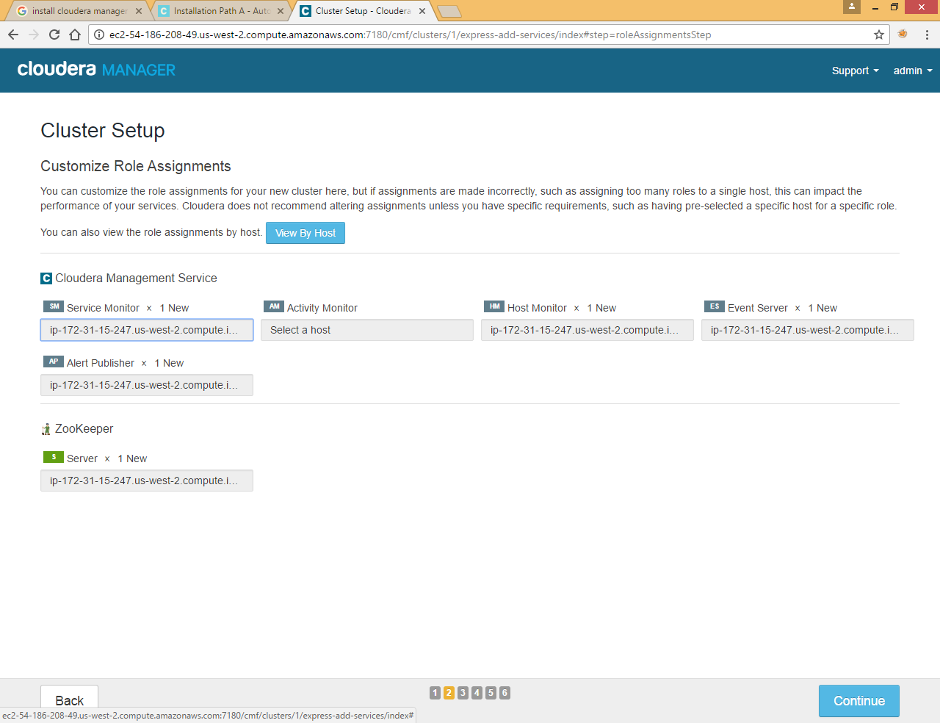

Click Continue

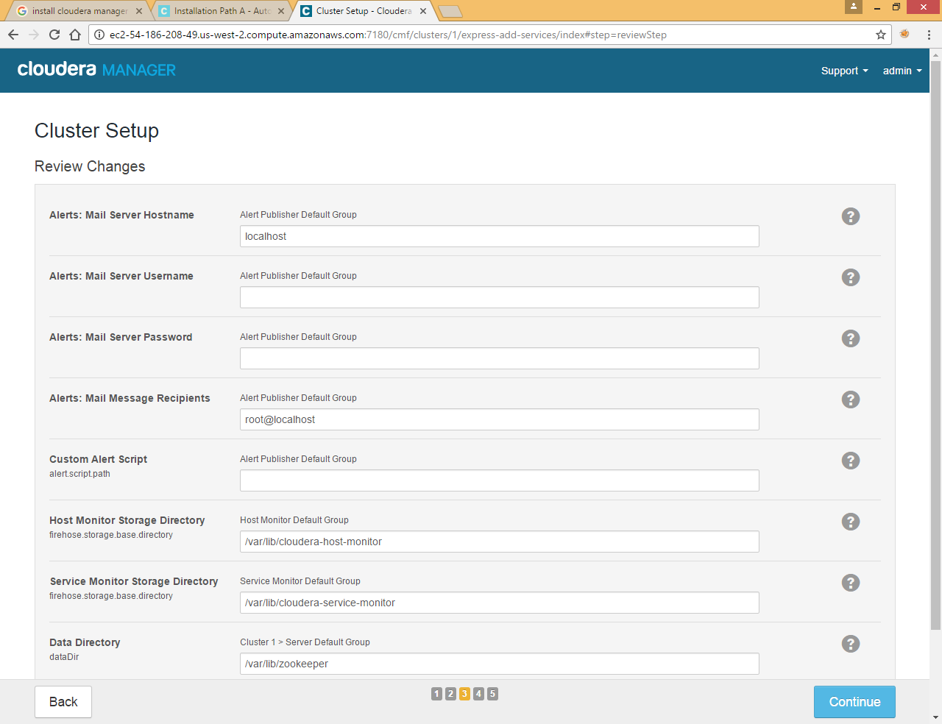

Click Continue

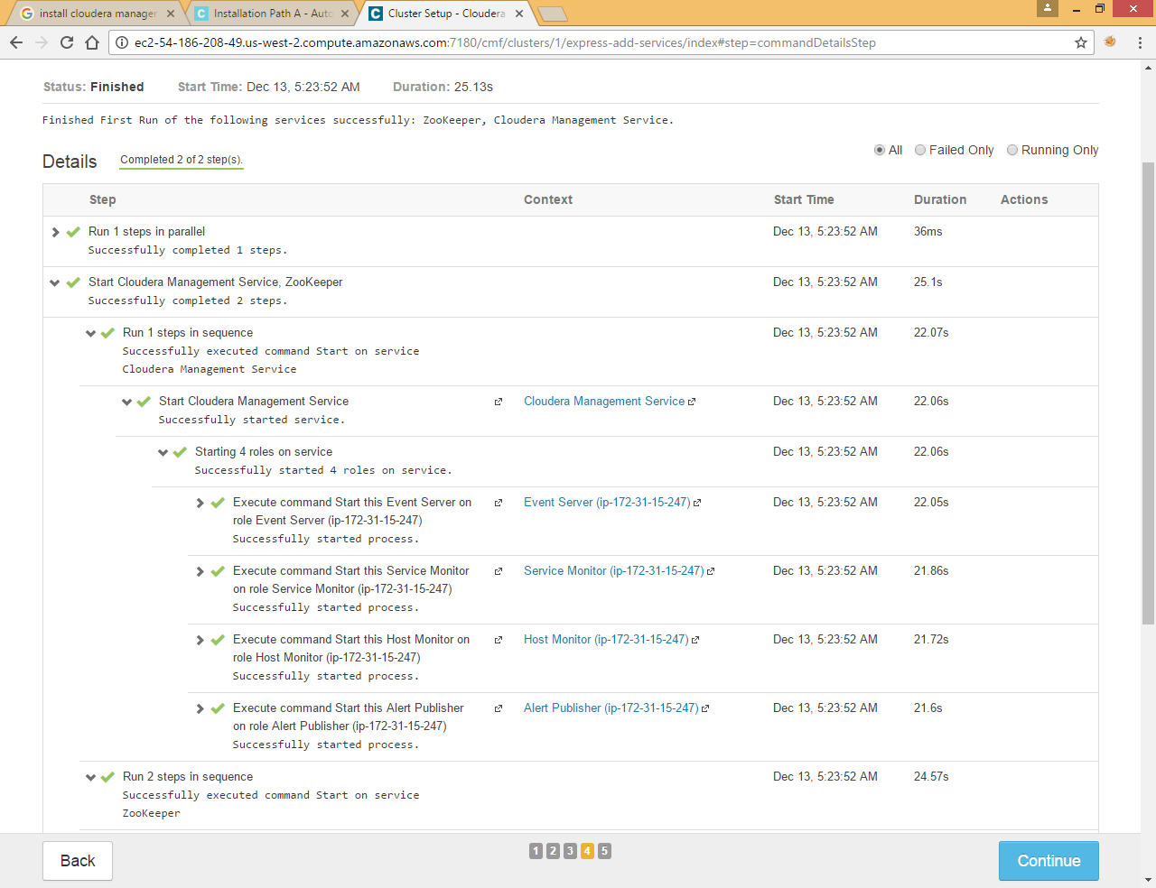

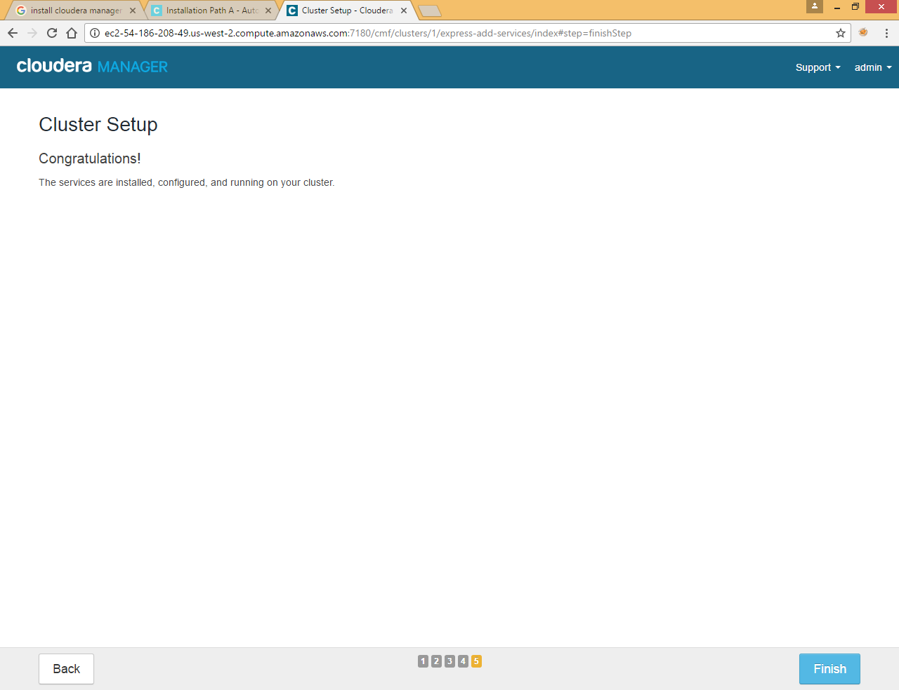

### Add HDFS Service

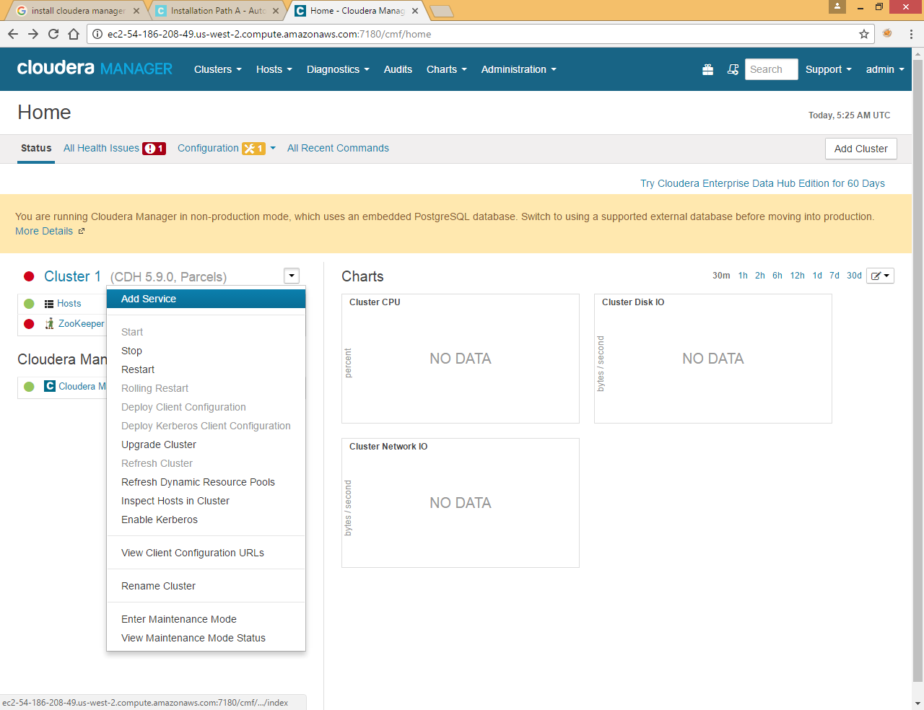

Click Add Service in cluster to add different services (HDFS, YARN and Hive)

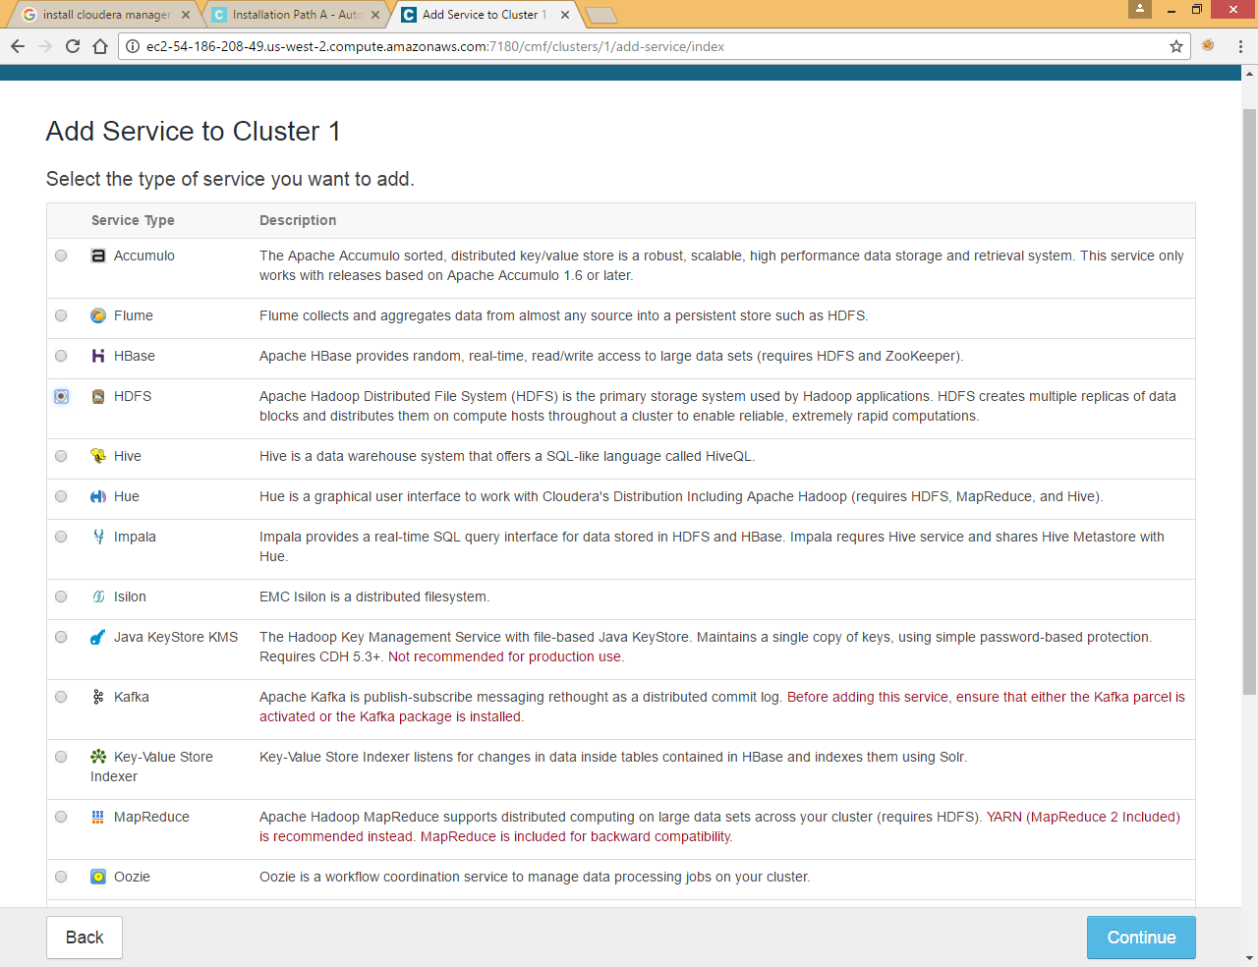

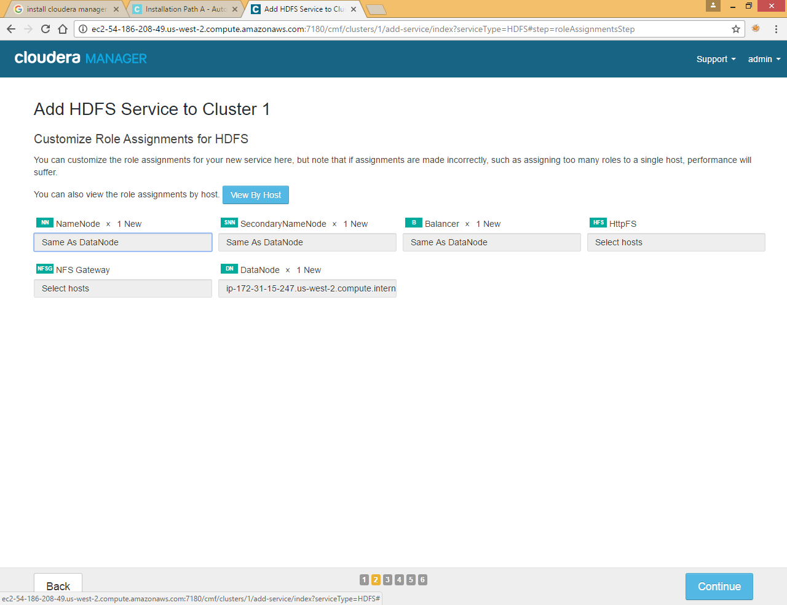

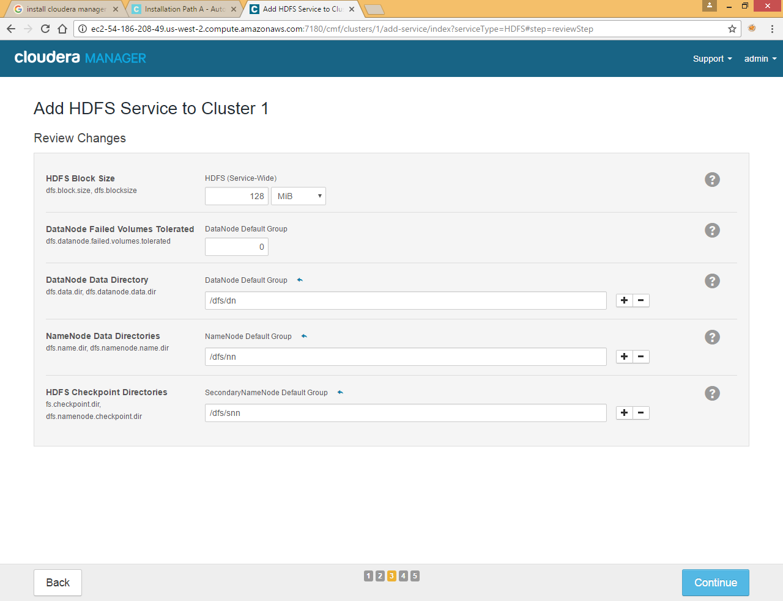

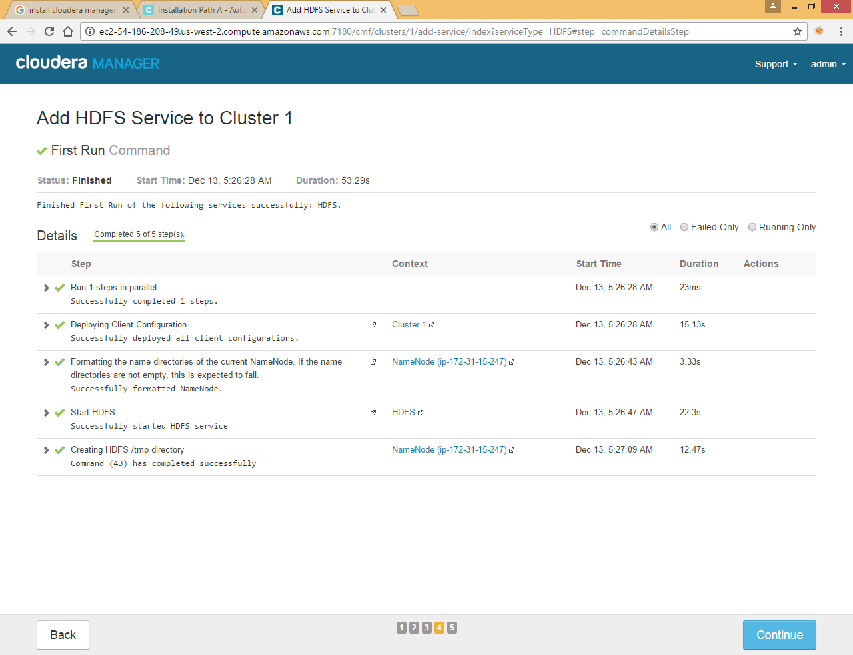

### Add YARN Service

Again Click on Cluster>>Add Service

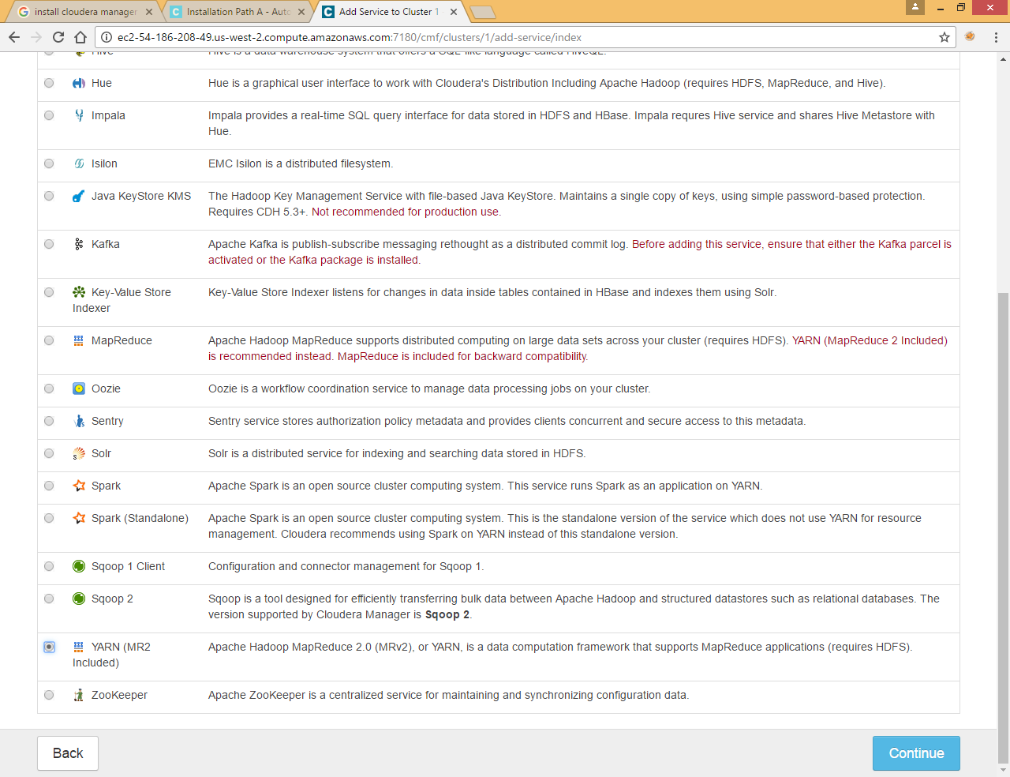

Select YARN and click Continue

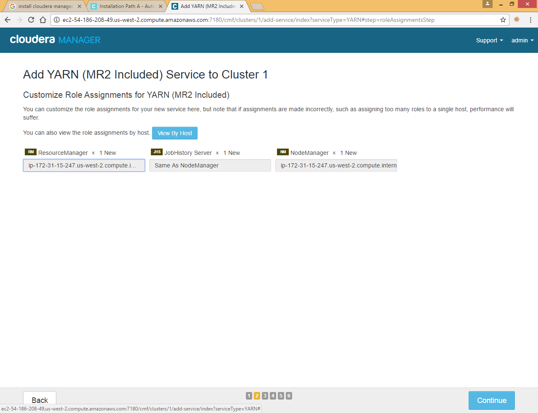

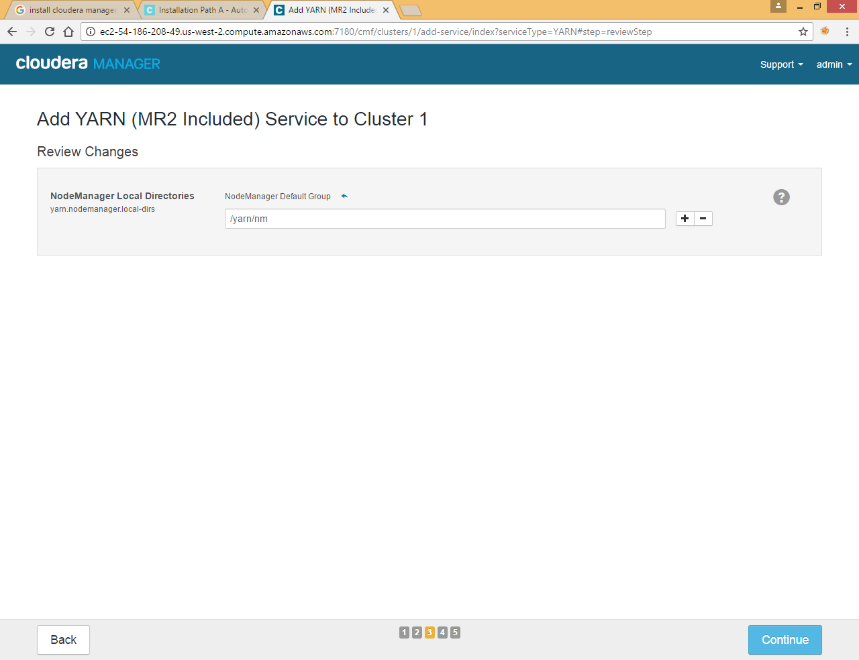

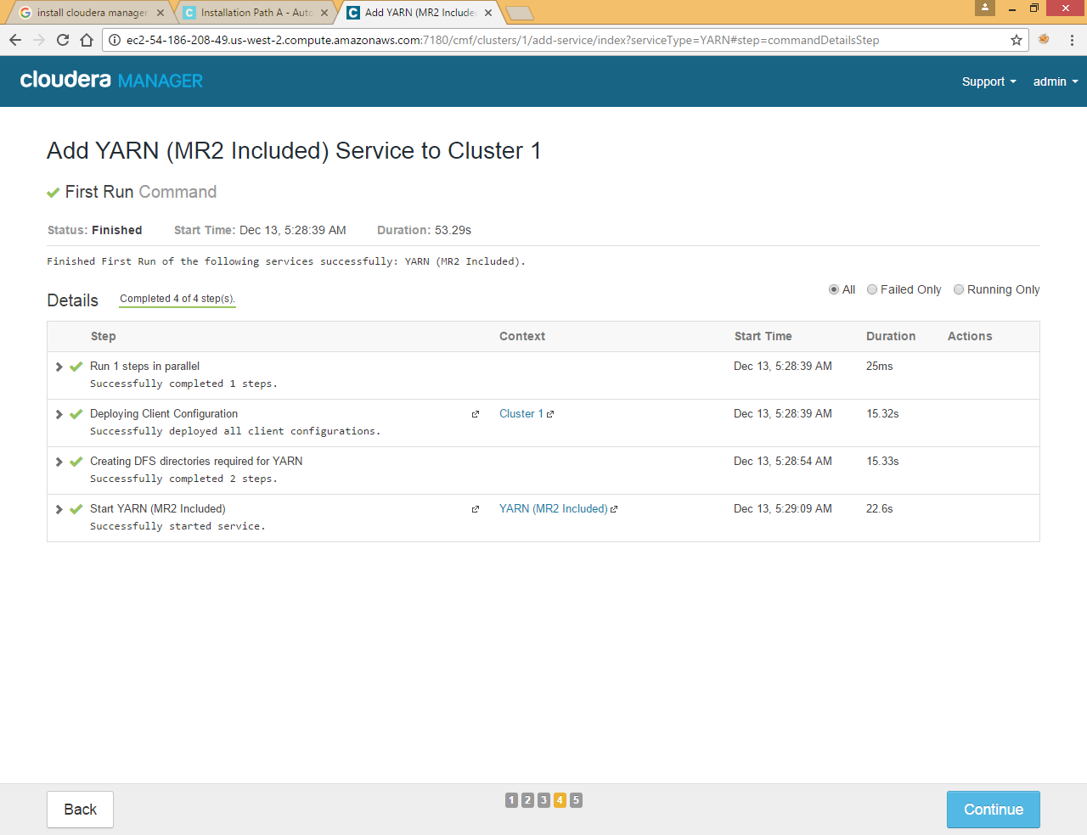

### Add Hive Service

Again Click on Cluster>>Add Service

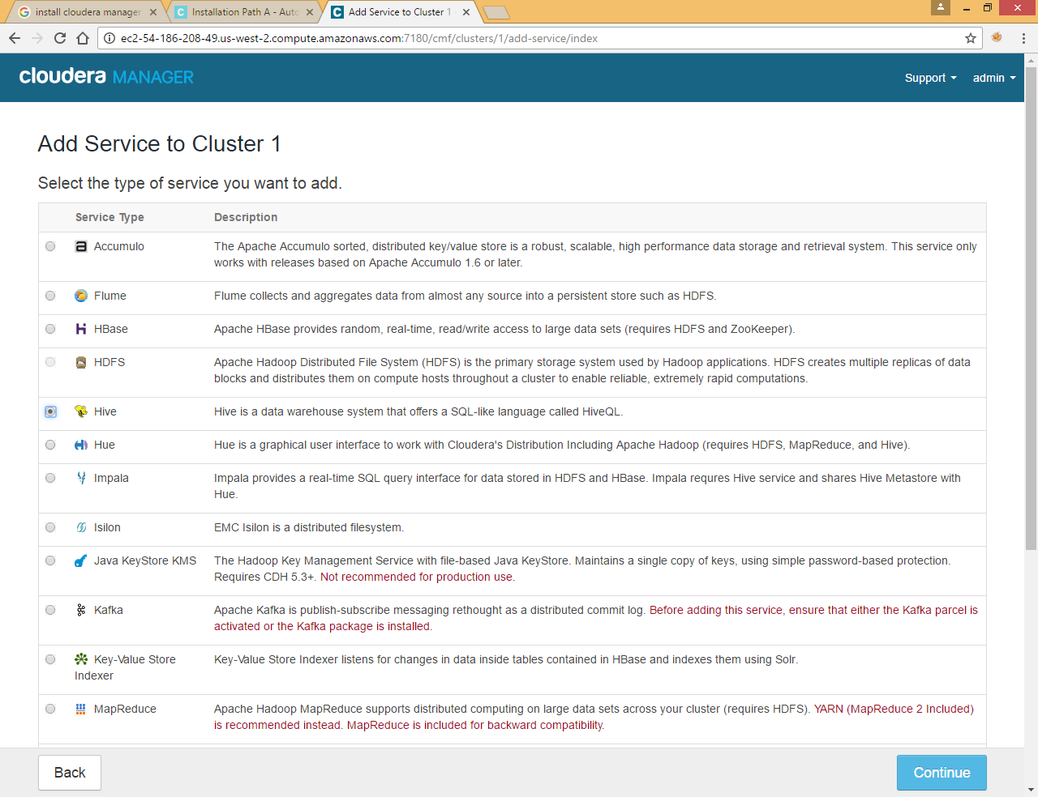

Select Hive and click continue

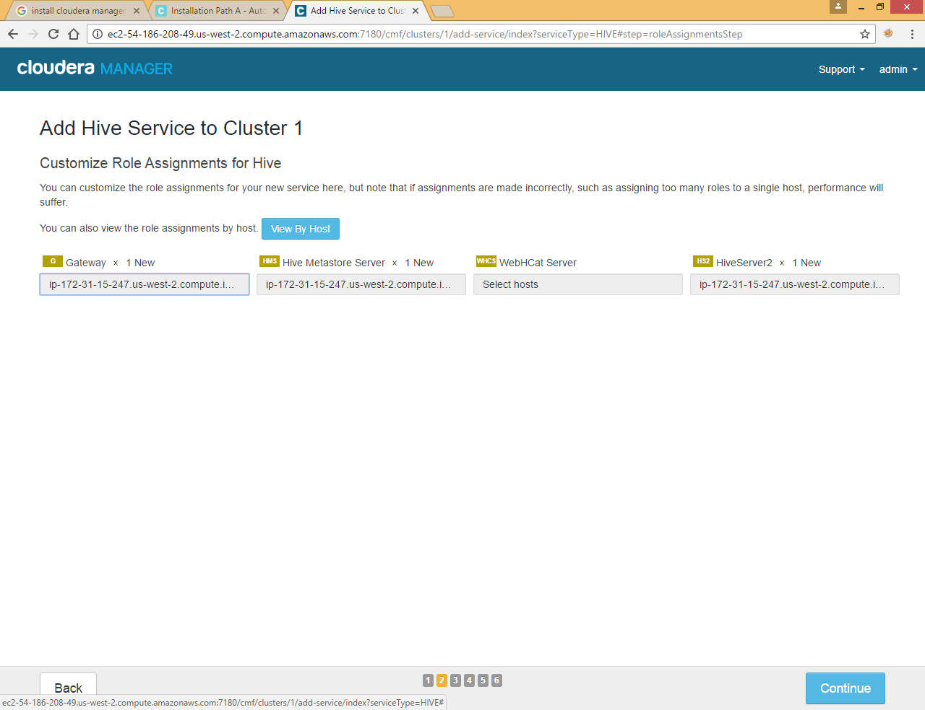

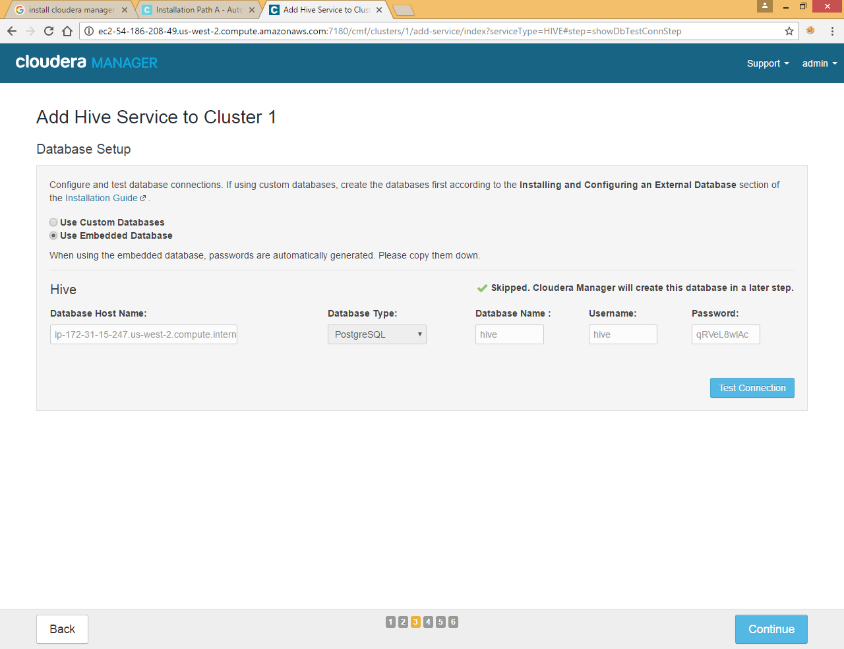

Here we are choose Embedded database you also can choose some custom DB if it is already installed on your machine, please note down metastore host name, DB Name, User Name and Password

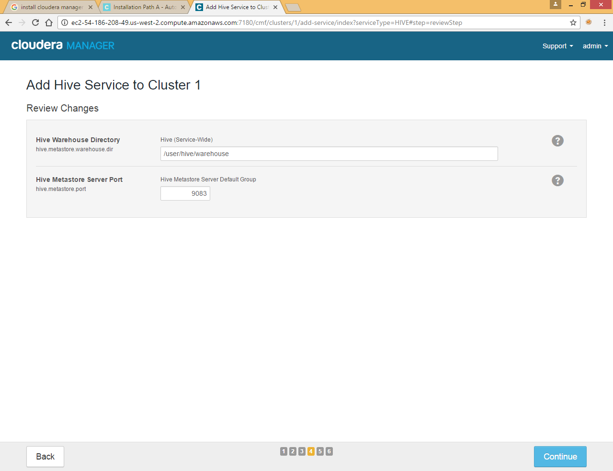

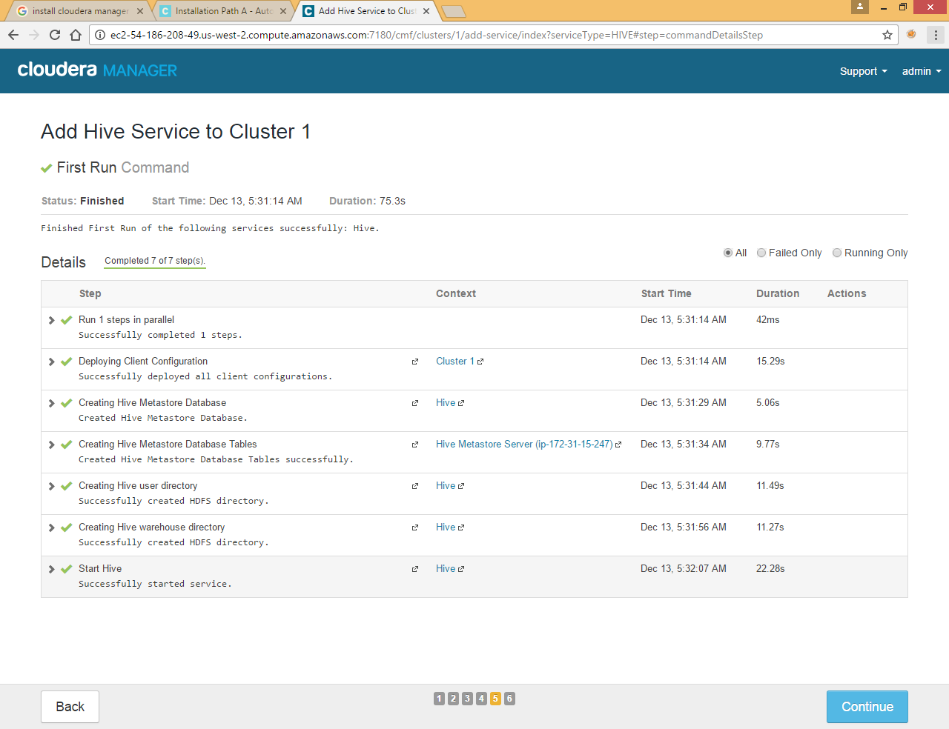

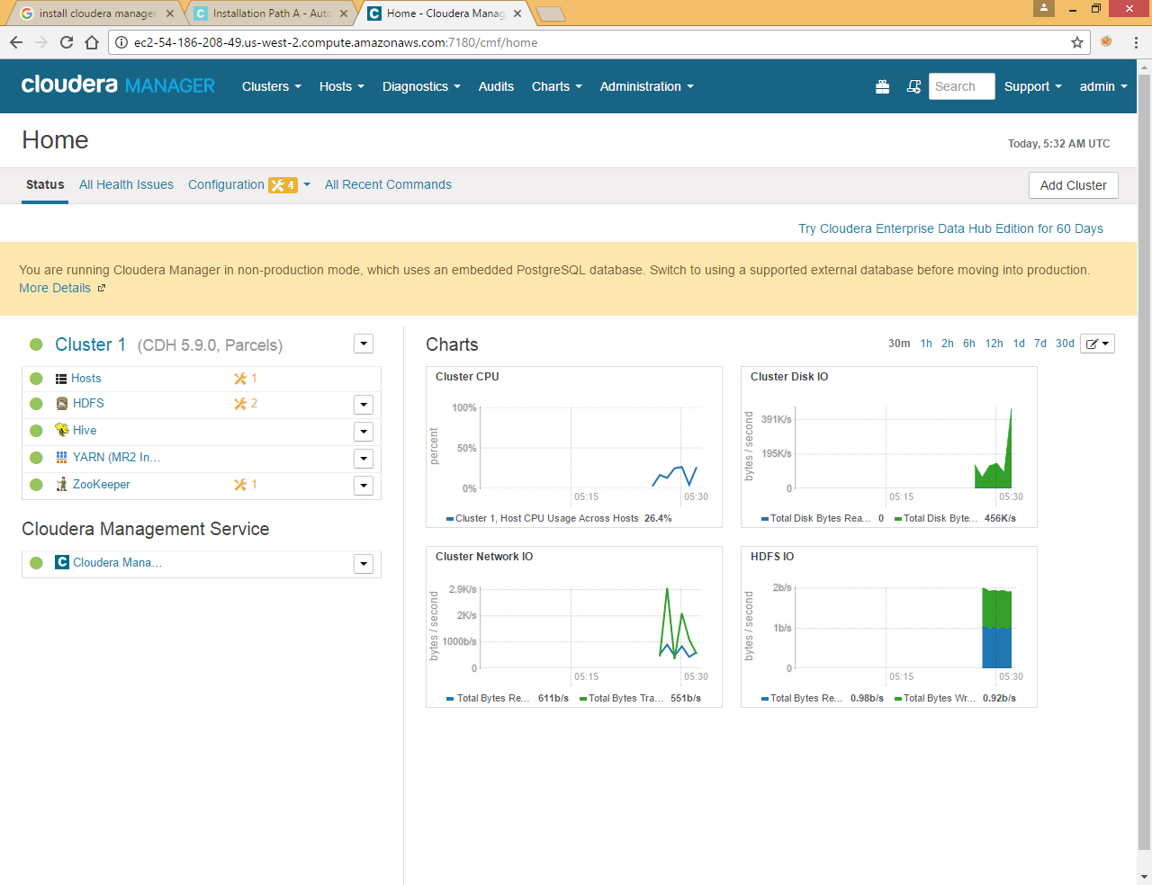

Now your cluster is up and running

Check if hdfs is working

|  |
| --- |
| ubuntu@ip-172-31-15-247:~$ hdfs dfs -ls /  Found 2 items  drwxrwxrwt - hdfs supergroup 0 2016-12-13 05:32 /tmp  drwxr-xr-x - hdfs supergroup 0 2016-12-13 05:32 /user  ubuntu@ip-172-31-15-247:~$ |

Check if hive is working

|  |
| --- |
| ubuntu@ip-172-31-15-247:~$ hive  2016-12-13 05:35:36,109 WARN [main] mapreduce.TableMapReduceUtil: The hbase-prefix-tree module jar containing PrefixTreeCodec is not present. Continuing without it.  Logging initialized using configuration in jar:file:/opt/cloudera/parcels/CDH-5.9.0-1.cdh5.9.0.p0.23/jars/hive-common-1.1.0-cdh5.9.0.jar!/hive-log4j.properties  WARNING: Hive CLI is deprecated and migration to Beeline is recommended.  hive> Create table emp( emp_id int,empname string,deptid int )ROW FORMAT DELIMITED FIELDS TERMINATED BY ',';  OK  Time taken: 0.681 seconds  hive> load data local inpath '/home/ubuntu/emp.data' into table emp;  Loading data to table default.emp  Table default.emp stats: [numFiles=1, totalSize=104]  OK  Time taken: 0.476 seconds  hive> Create table dept( deptid int,deptname string )ROW FORMAT DELIMITED FIELDS TERMINATED BY ',';  OK  Time taken: 0.062 seconds  hive> load data local inpath '/home/ubuntu/dept.data' into table dept;  Loading data to table default.dept  Table default.dept stats: [numFiles=1, totalSize=46]  OK  Time taken: 0.224 seconds  hive> select * from emp;  OK  1 Raju 2  2 Nimish 1  3 Ruma 2  4 Subrata 1  5 Gargi 2  6 Siddharth 2  7 Anil 3  8 Ashis 3  9 Palas 2  10 Mr X 5  Time taken: 0.281 seconds, Fetched: 10 row(s)  hive> select * from dept;  OK  1 Sales  2 Marketing  3 HR  4 Engineer  5 Finance  Time taken: |

*(Here we created two tables emp and dept and loaded some dummy data, later we will access these two tables from new image machie)*

# Create Amazon Machine Image (AMI)

Select EC2 Instance

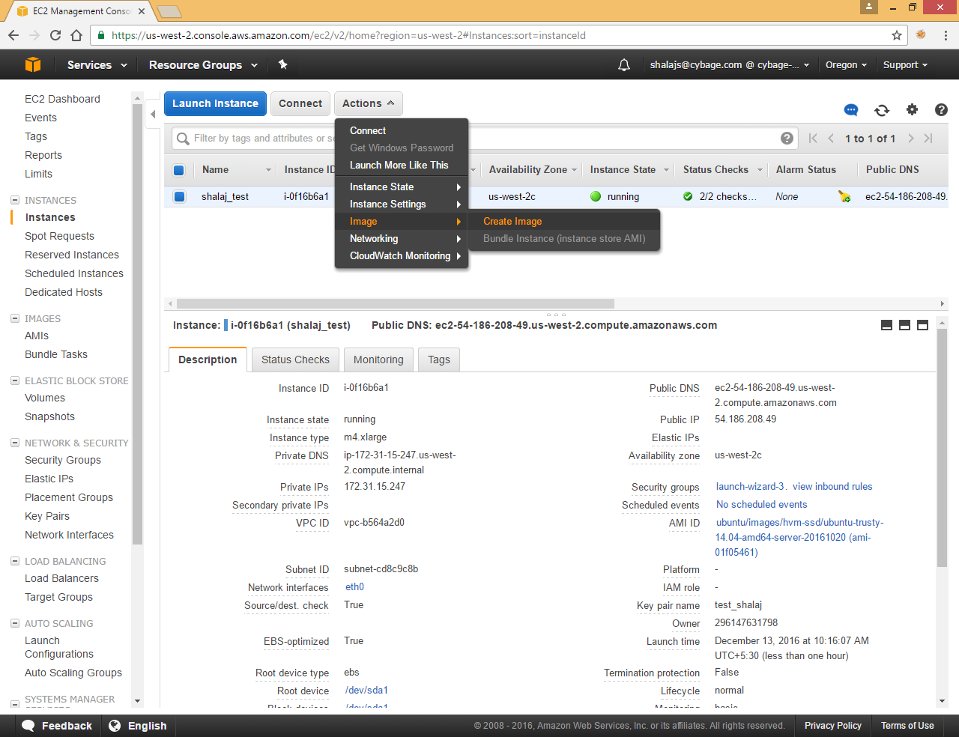

Click Actions >> Image >> Create Image

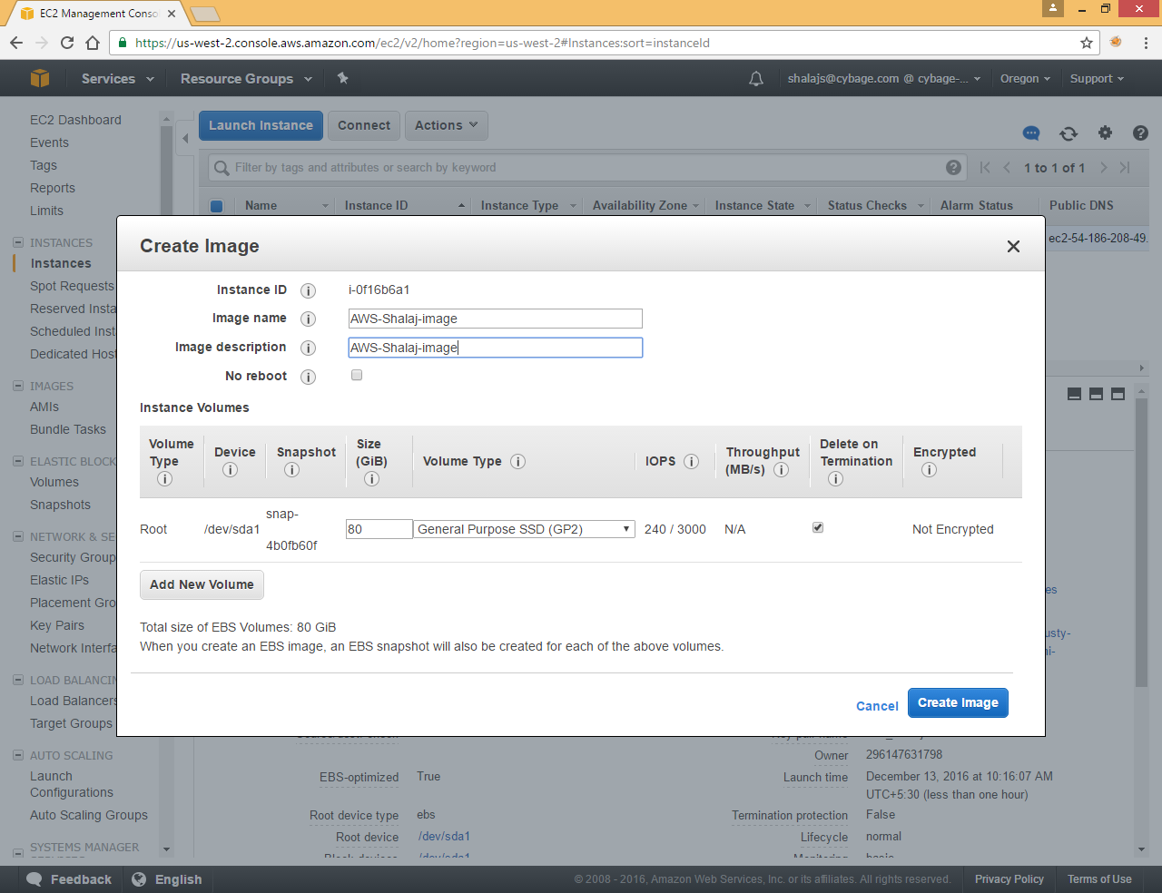

Enter some image name and description and click on Create Image

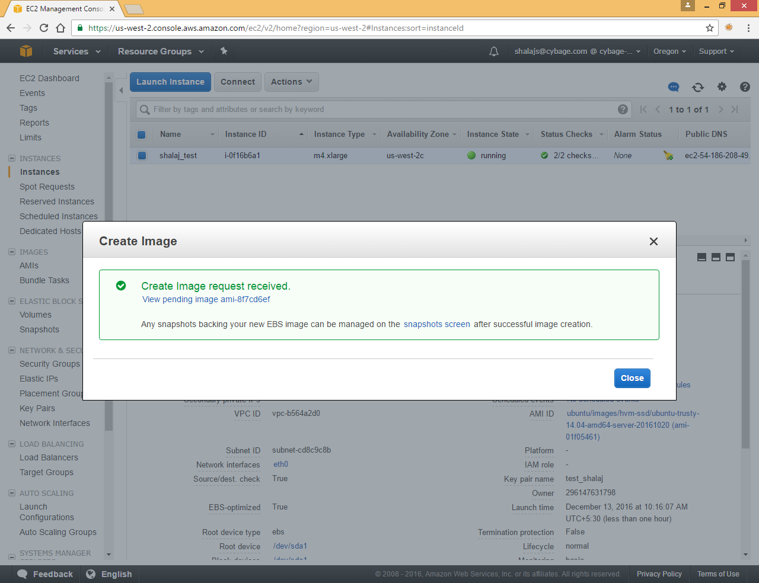

It will take some time to create

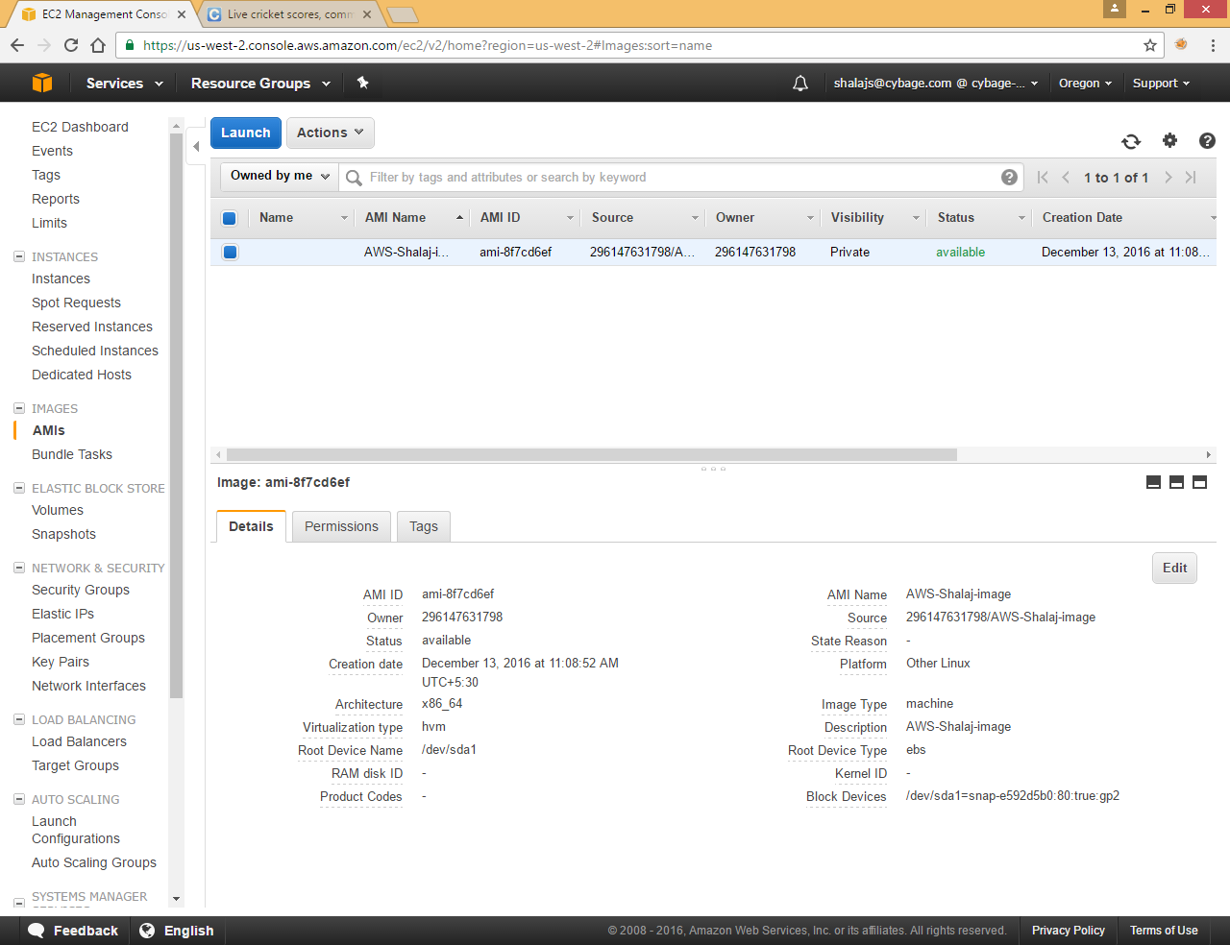

## Launch Ec2 Instance via Image

Click on AMIs at left frame and select Image



Click on Launch

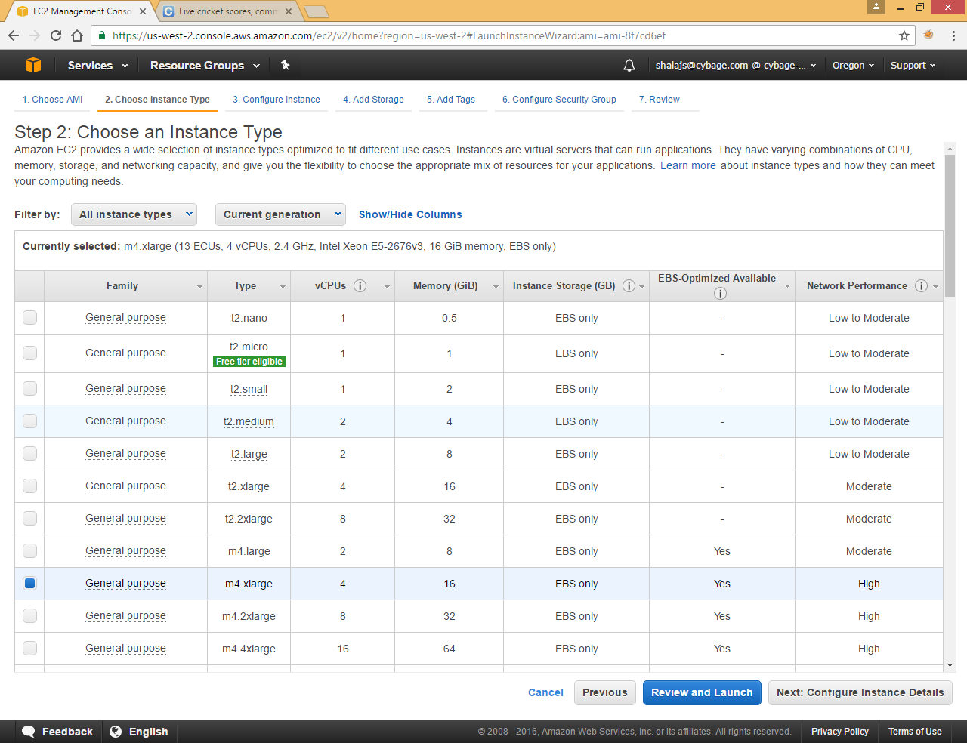

Select Instance type and click Next

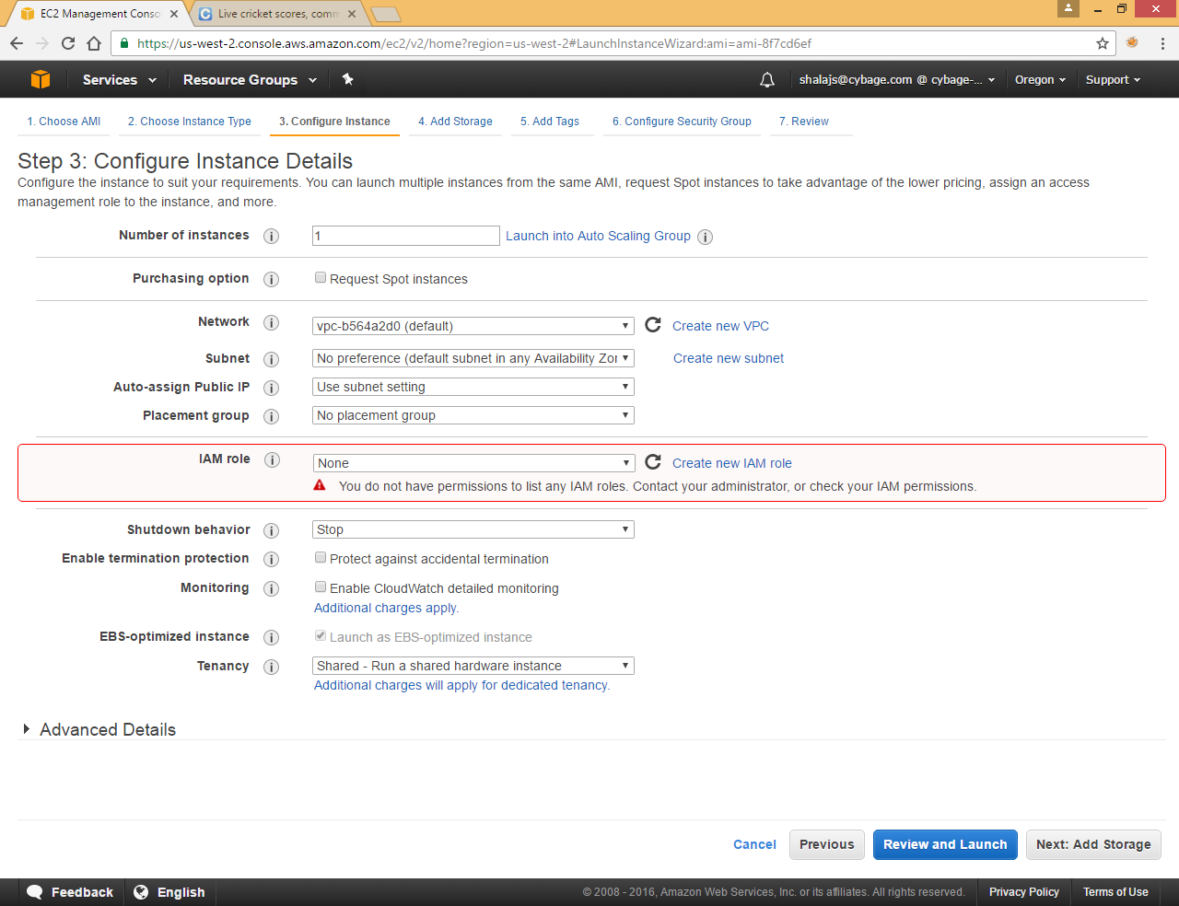

Click Next

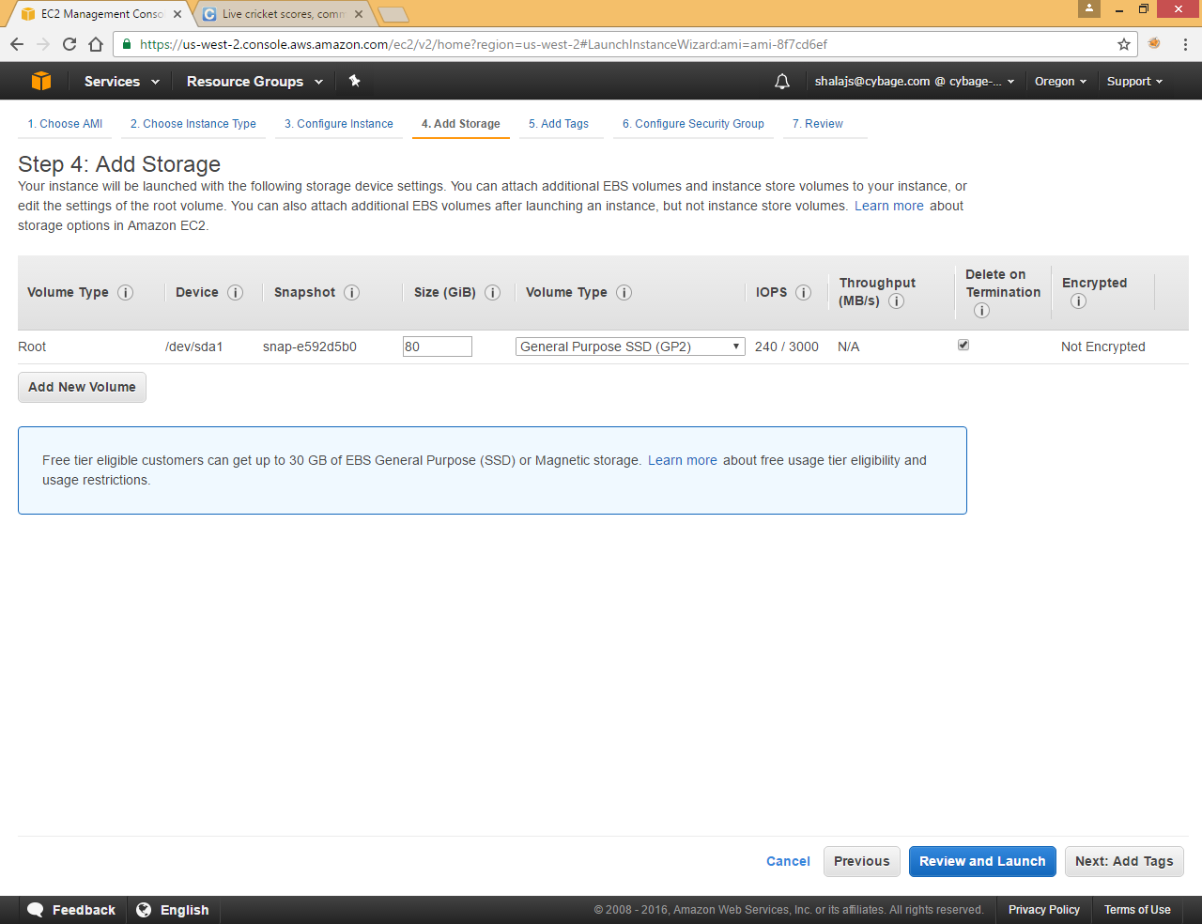

Click Next

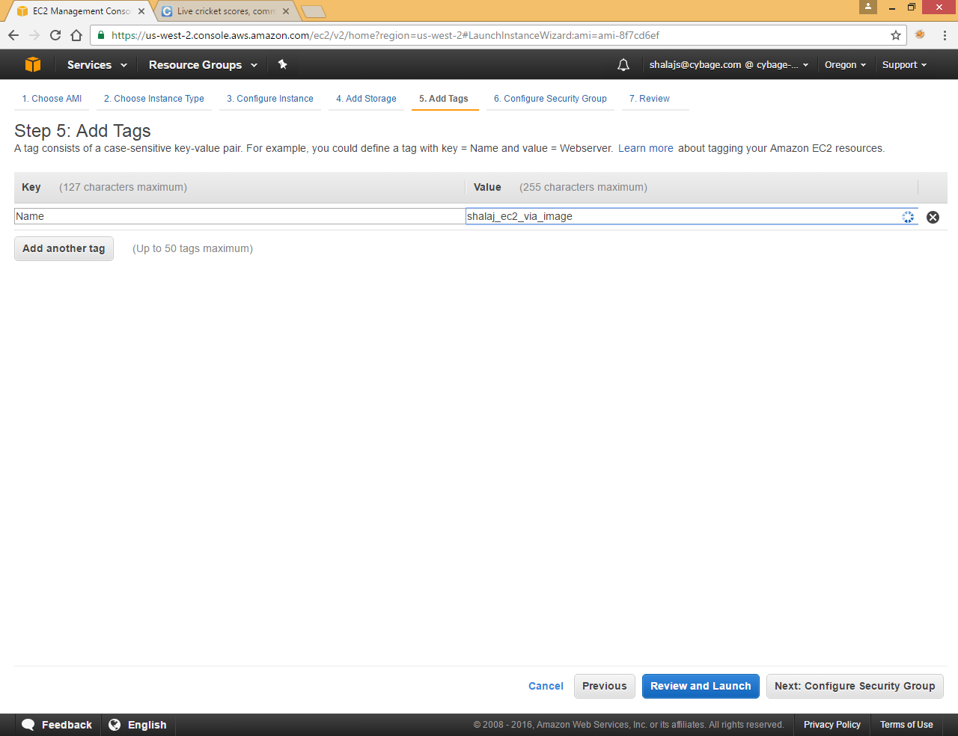

Enter some Name to identify Ec2 instance

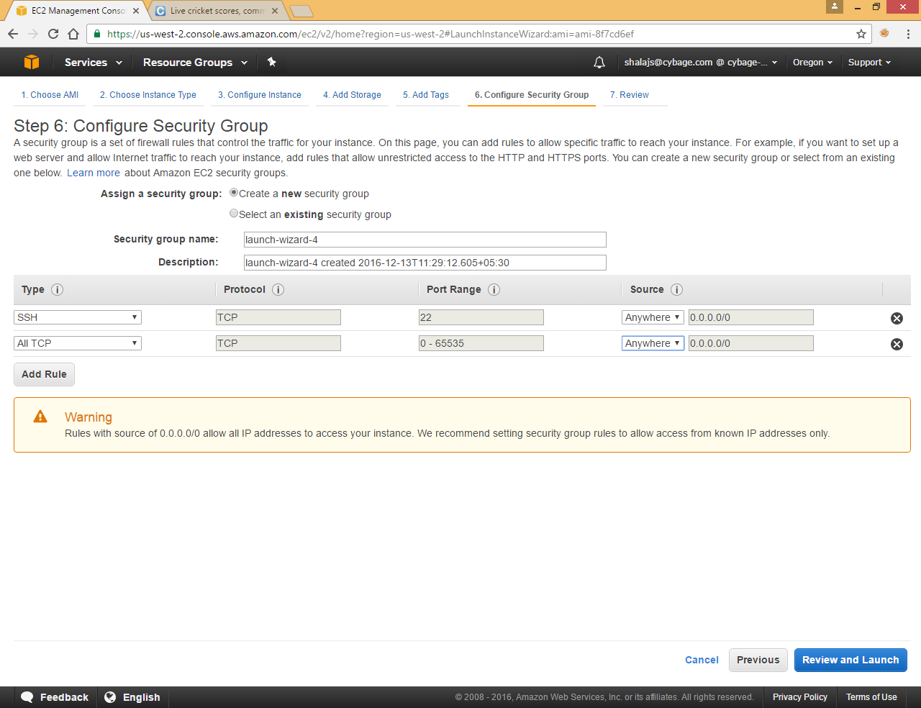

Add Rules and click Review and Launch

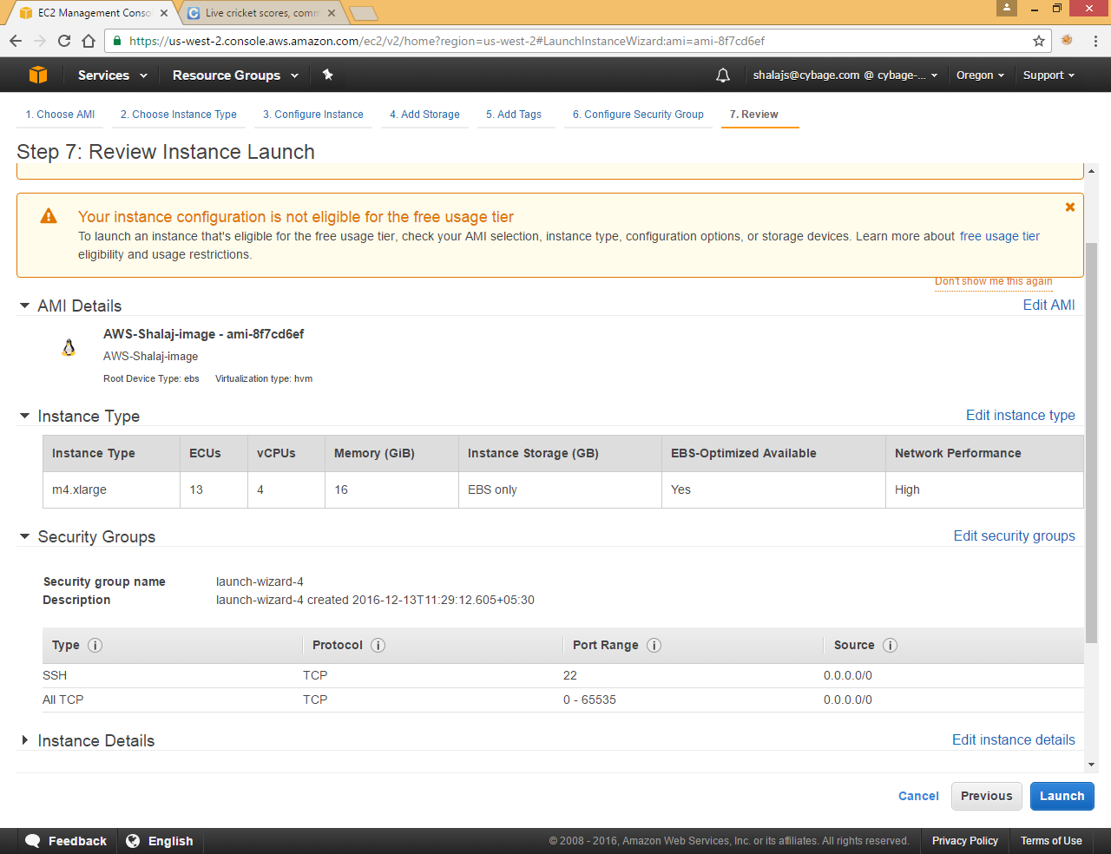

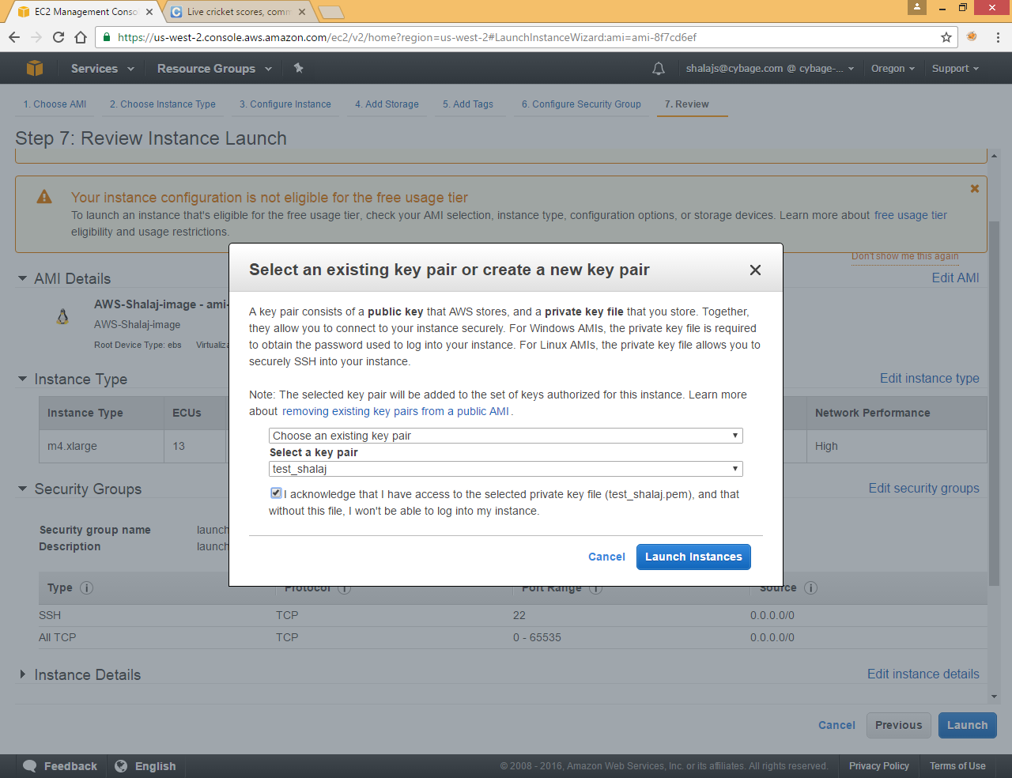

Select Existing key pair that we created in Create Key Section

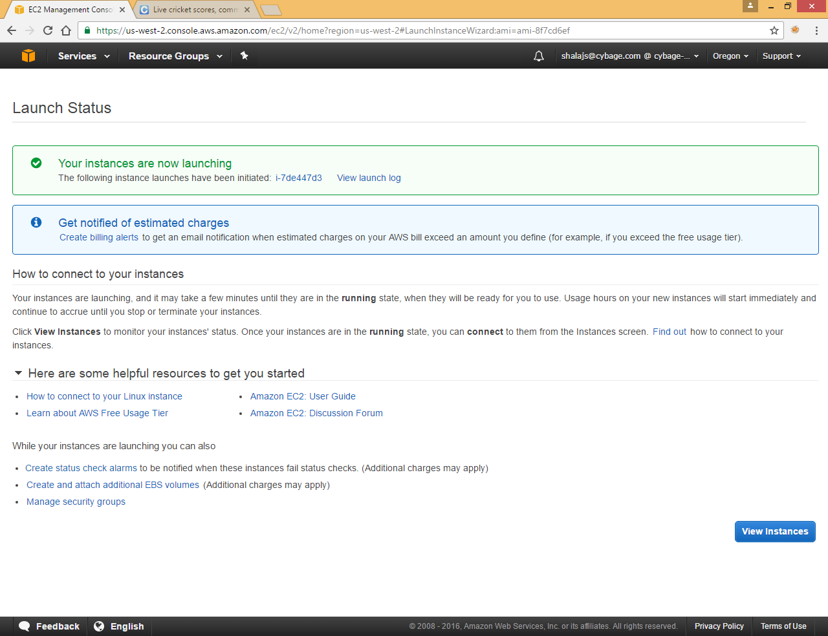

Click View Instance

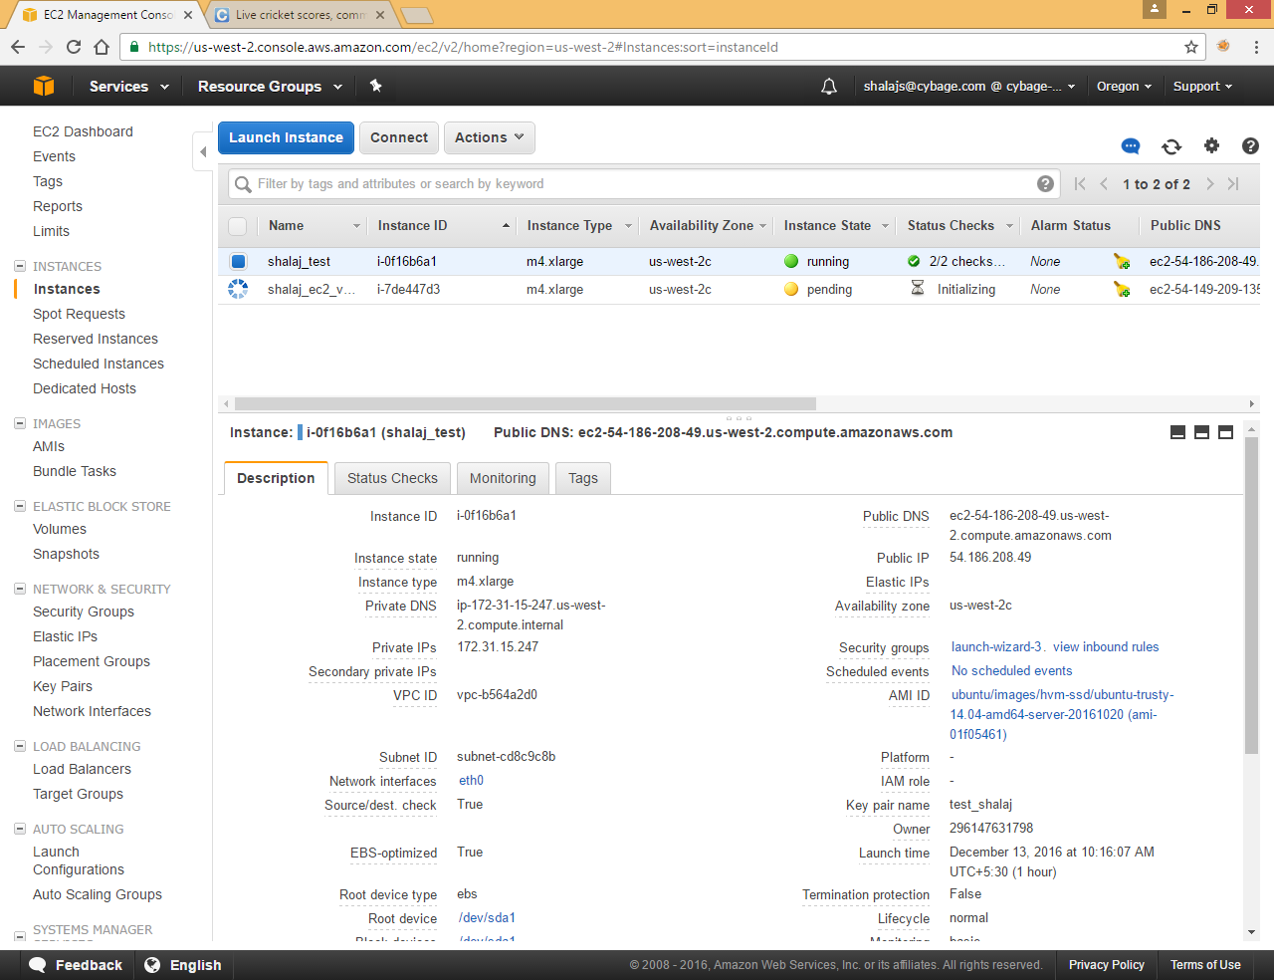

Once instance is up and running do login using public DNS

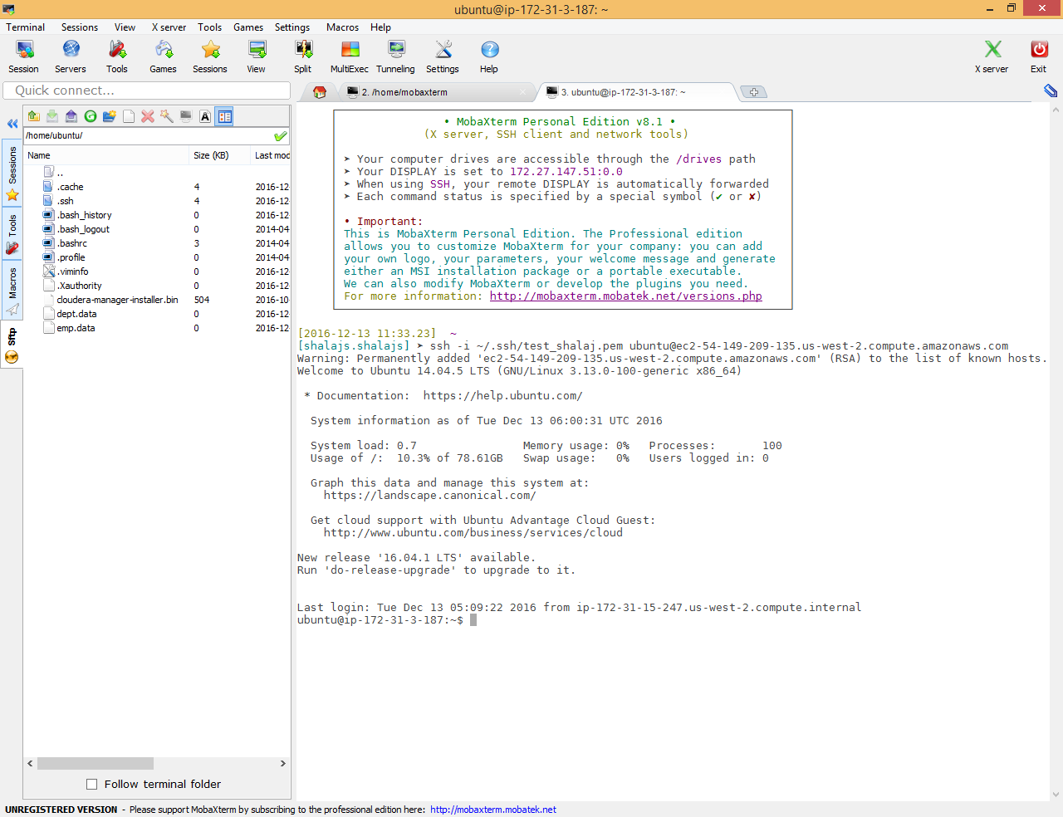

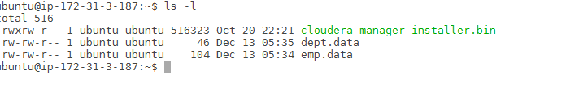

Check some files to check if files are preserved

Now open new Cloudera manager

<http://ec2-54-149-209-135.us-west-2.compute.amazonaws.com:7180>

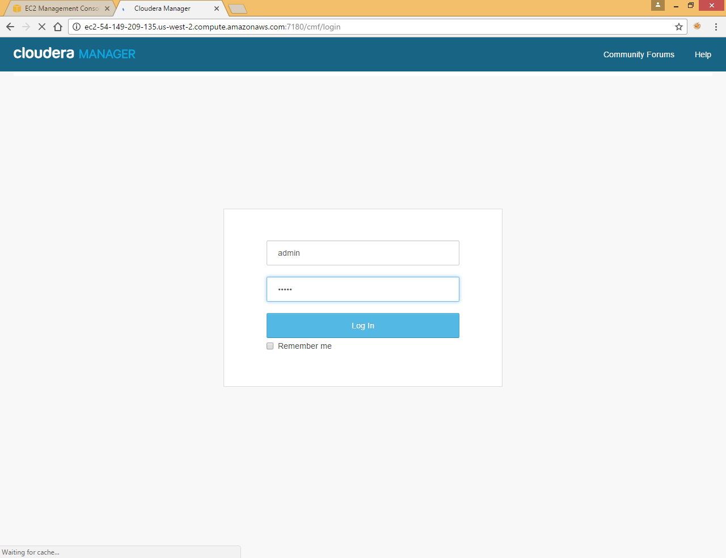

Use admin admin as user name and password

## Initializing and starting up Services

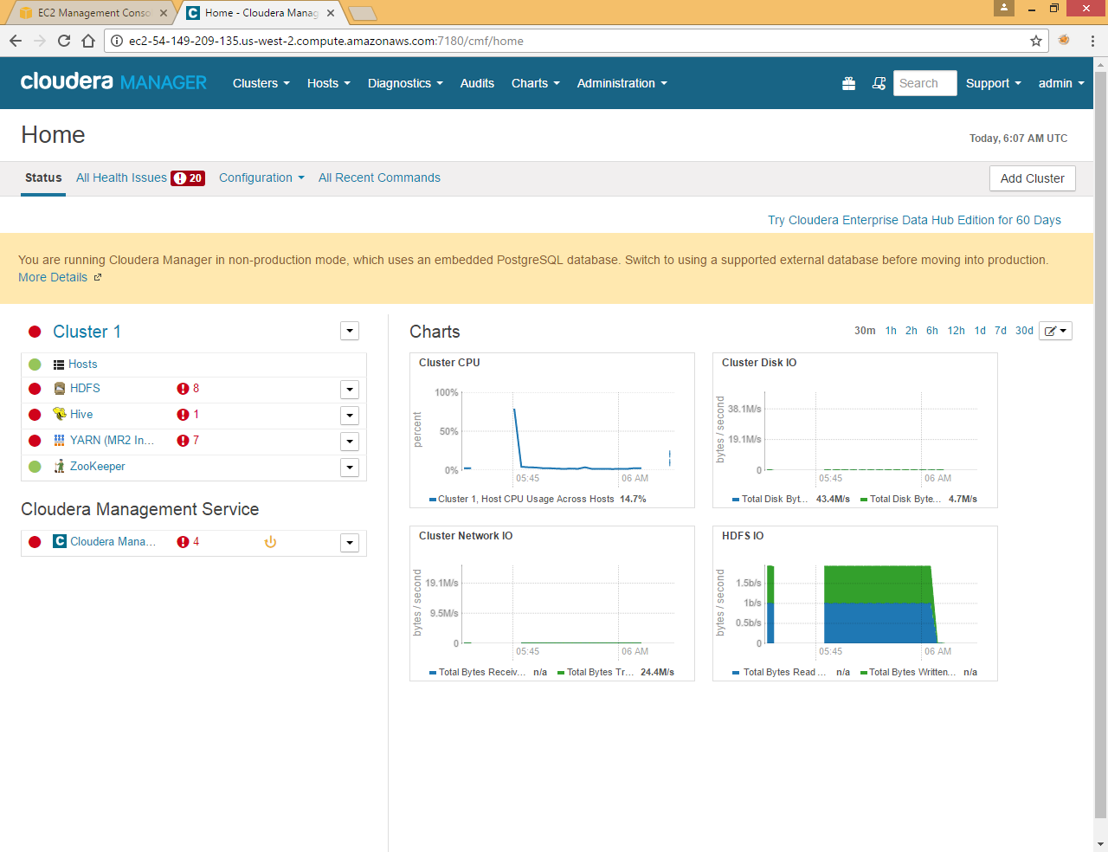

Here all services are in red state as these are pointing to the old machine (if machine is running these services will be in red state)

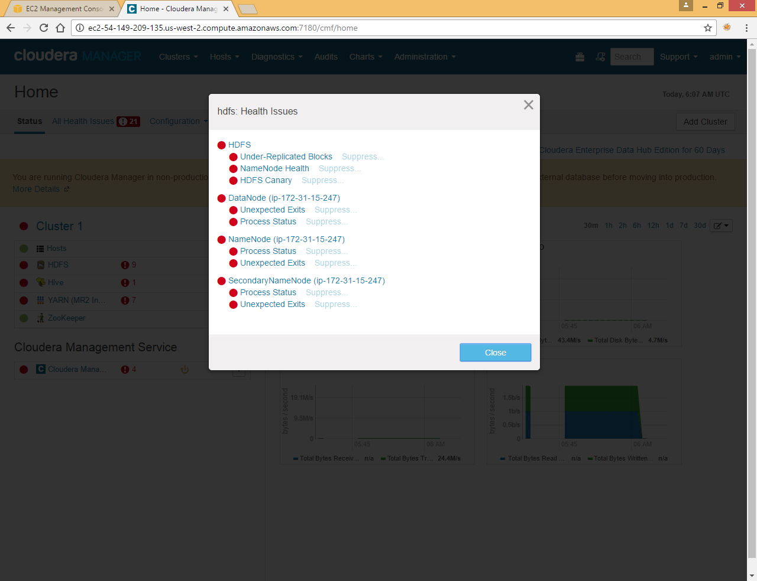

If we click on any issue we can check that these service still pointing to old Private IP

Stop all services one by one

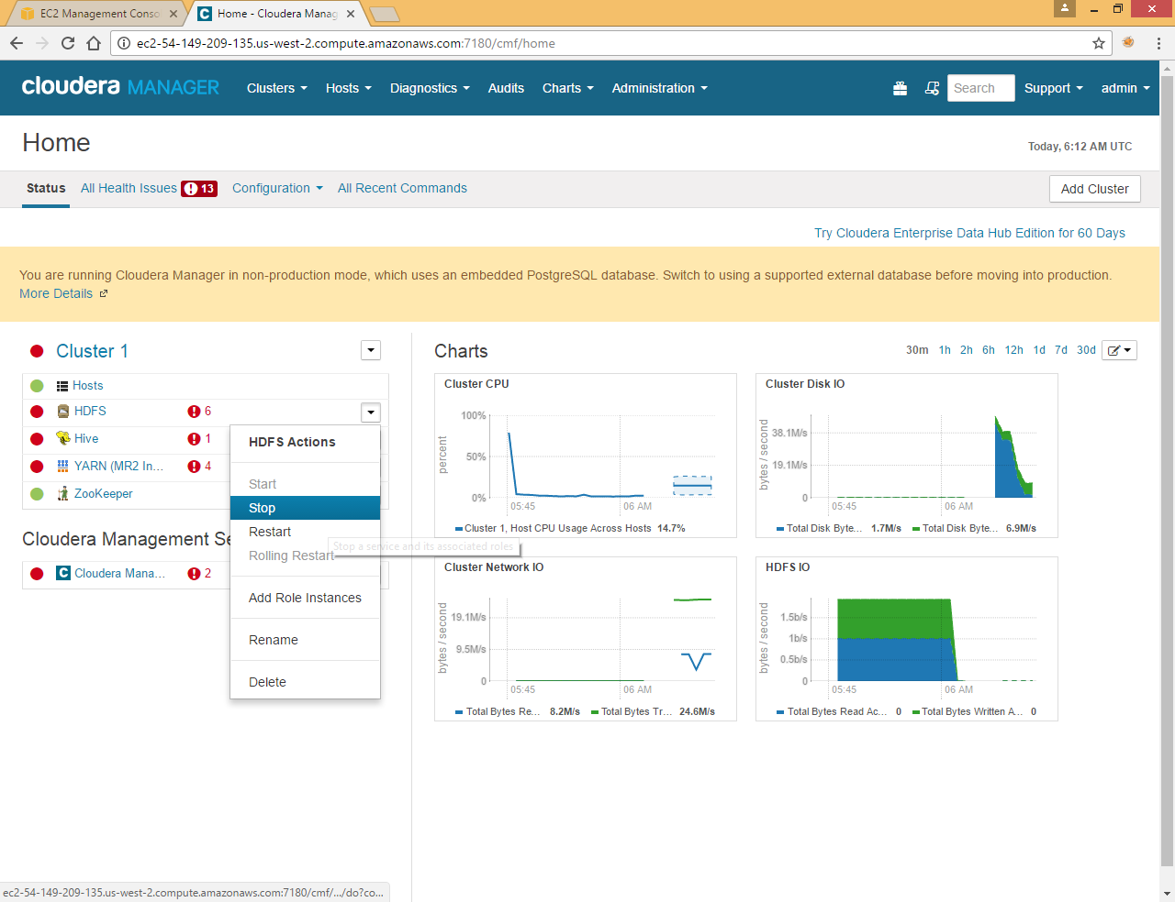

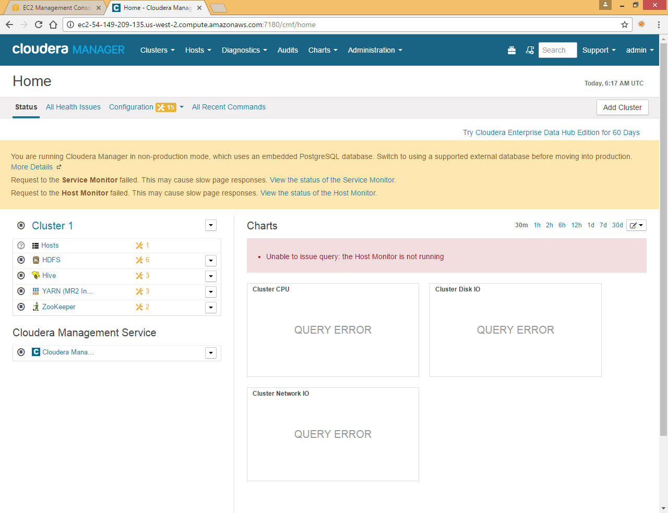

Now from terminal issue below two commands

|  |
| --- |
| sudo service cloudera-scm-server stop  sudo service cloudera-scm-agent stop |

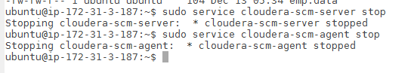

Now go to /etc/cloudera-scm-agent and update config.ini file

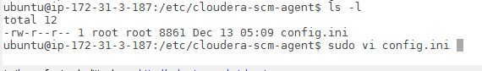

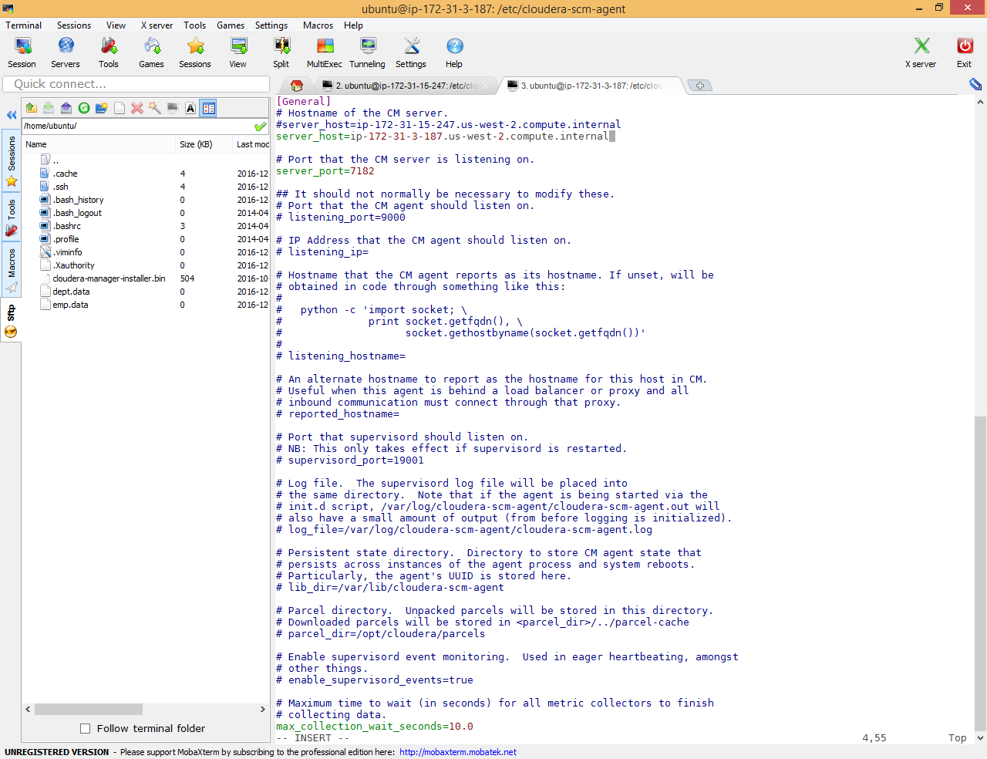

Update new Private DNS and save the file

(Note: you can find new private DNS from EC2 Instance)

Now start Cloudera services using below commands

|  |
| --- |
| sudo service cloudera-scm-server start  sudo service cloudera-scm-agent start |

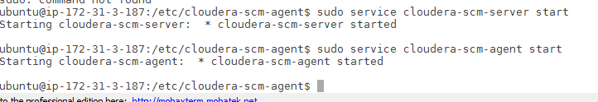

Now open Cloudera web console again

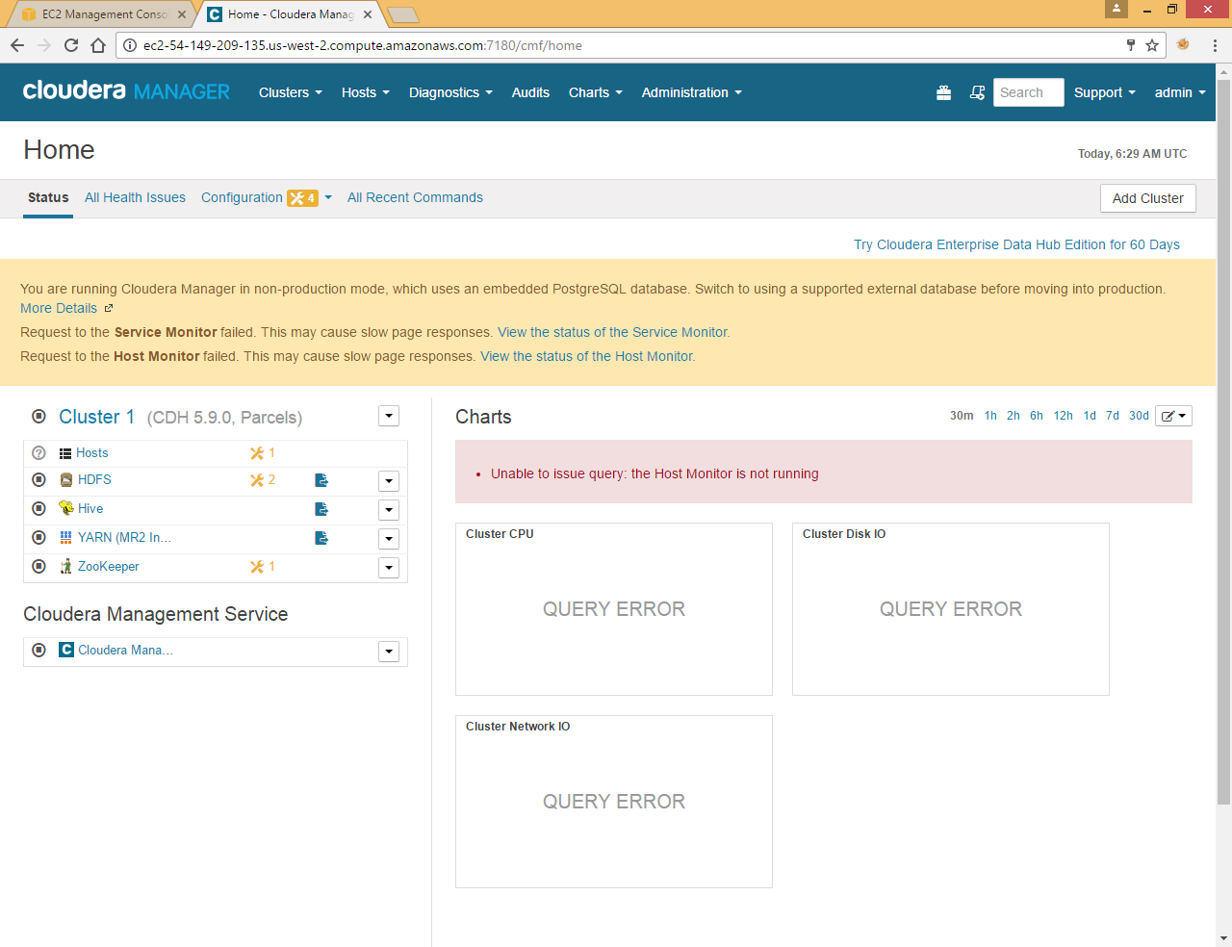

Here you will see  icon Click on that to restart stale services

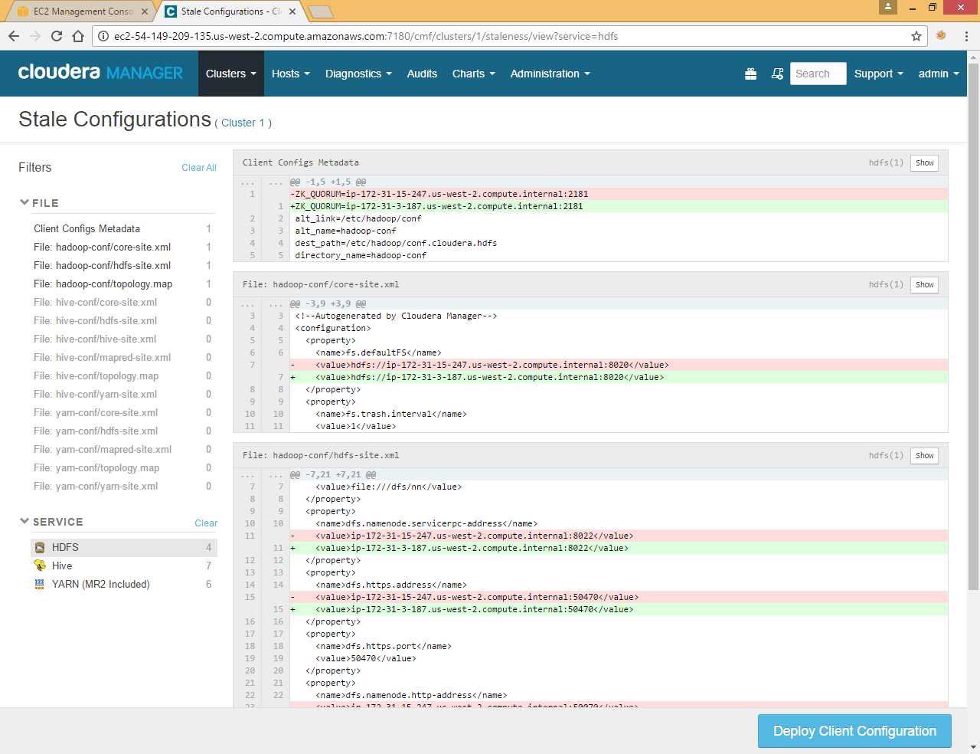

Click on Deploy Client Configuration

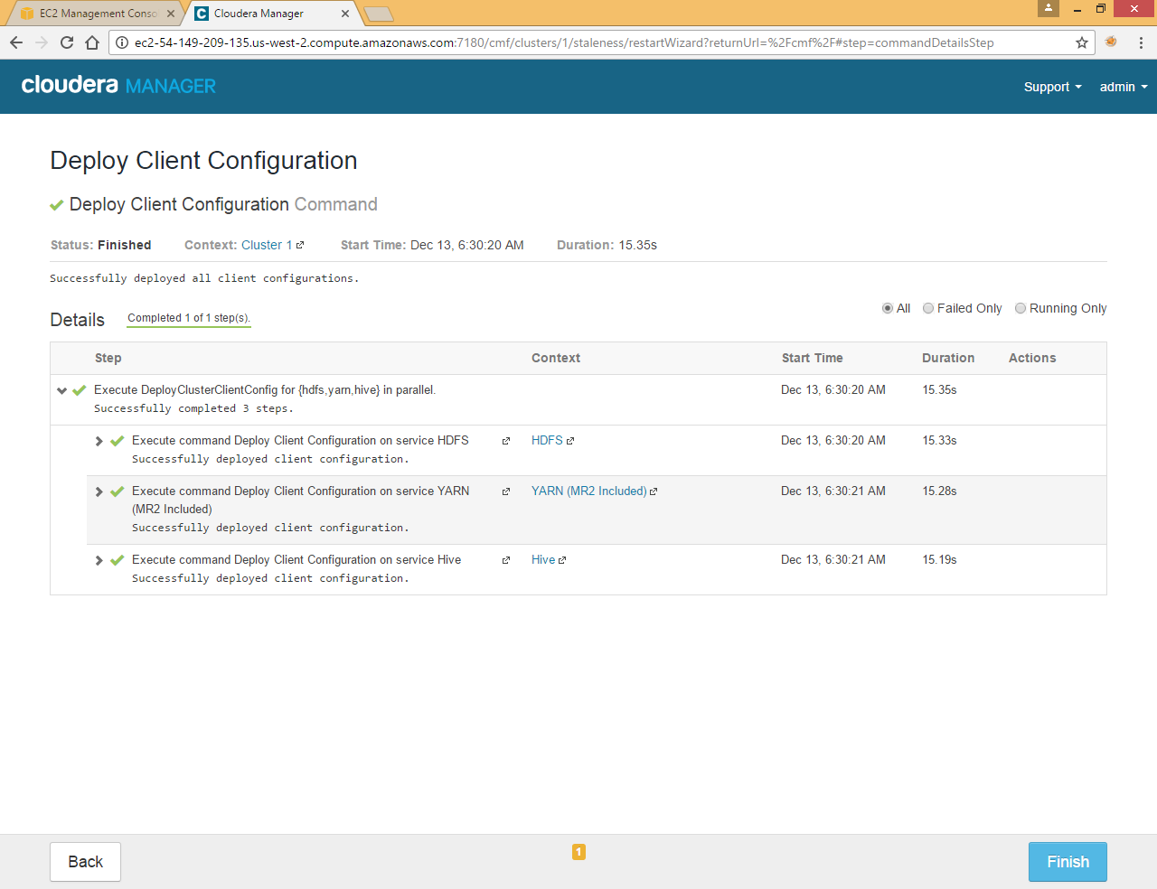

Now start Cloudera Management Service

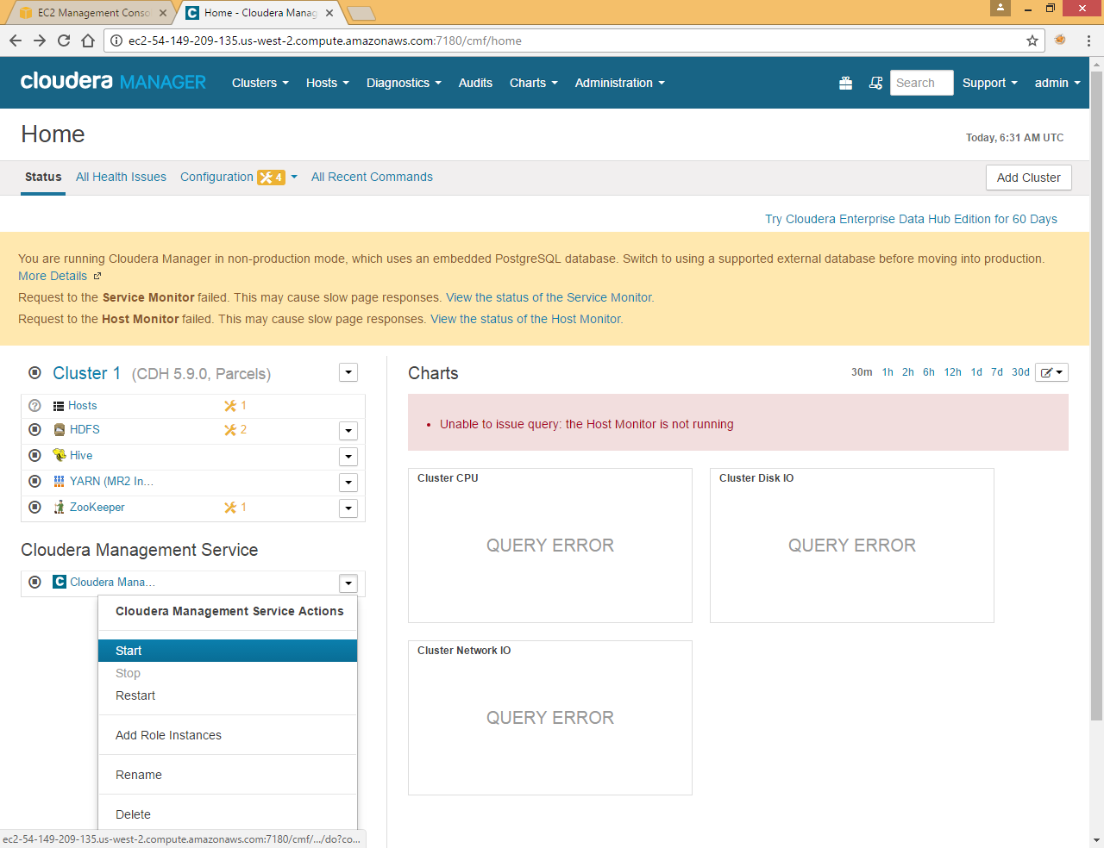

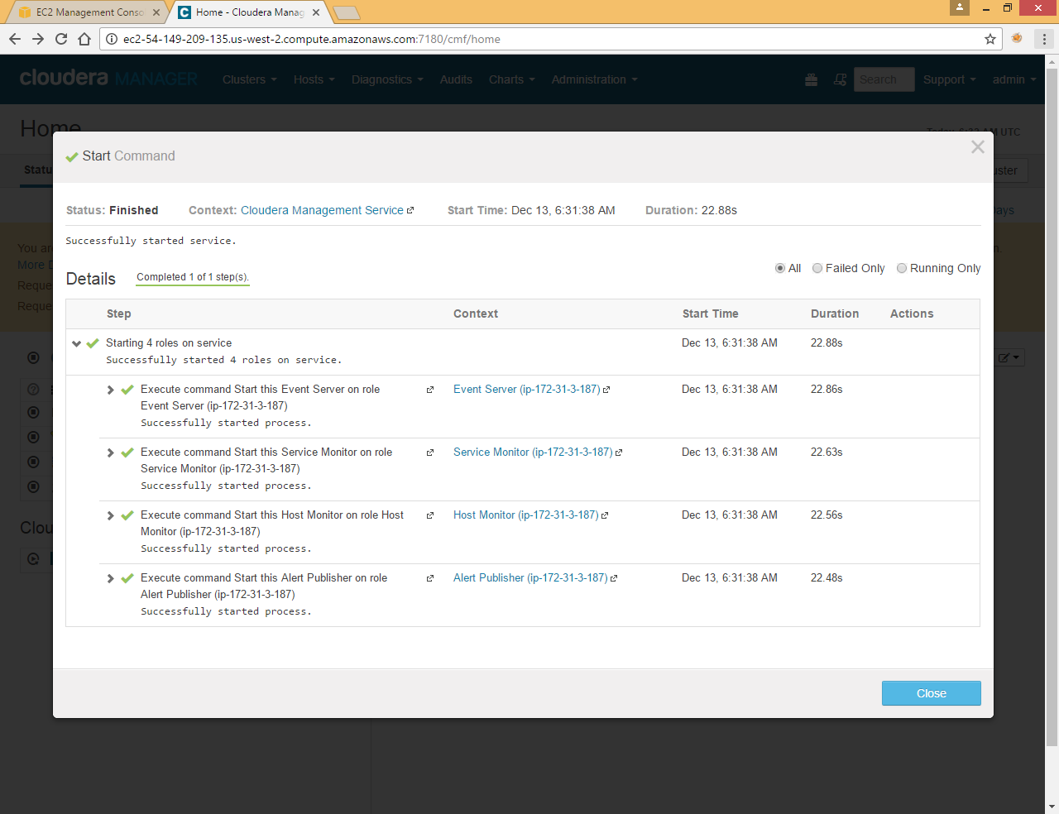

Now you can see that it is pointing to new private IP

Now Start all services one by one

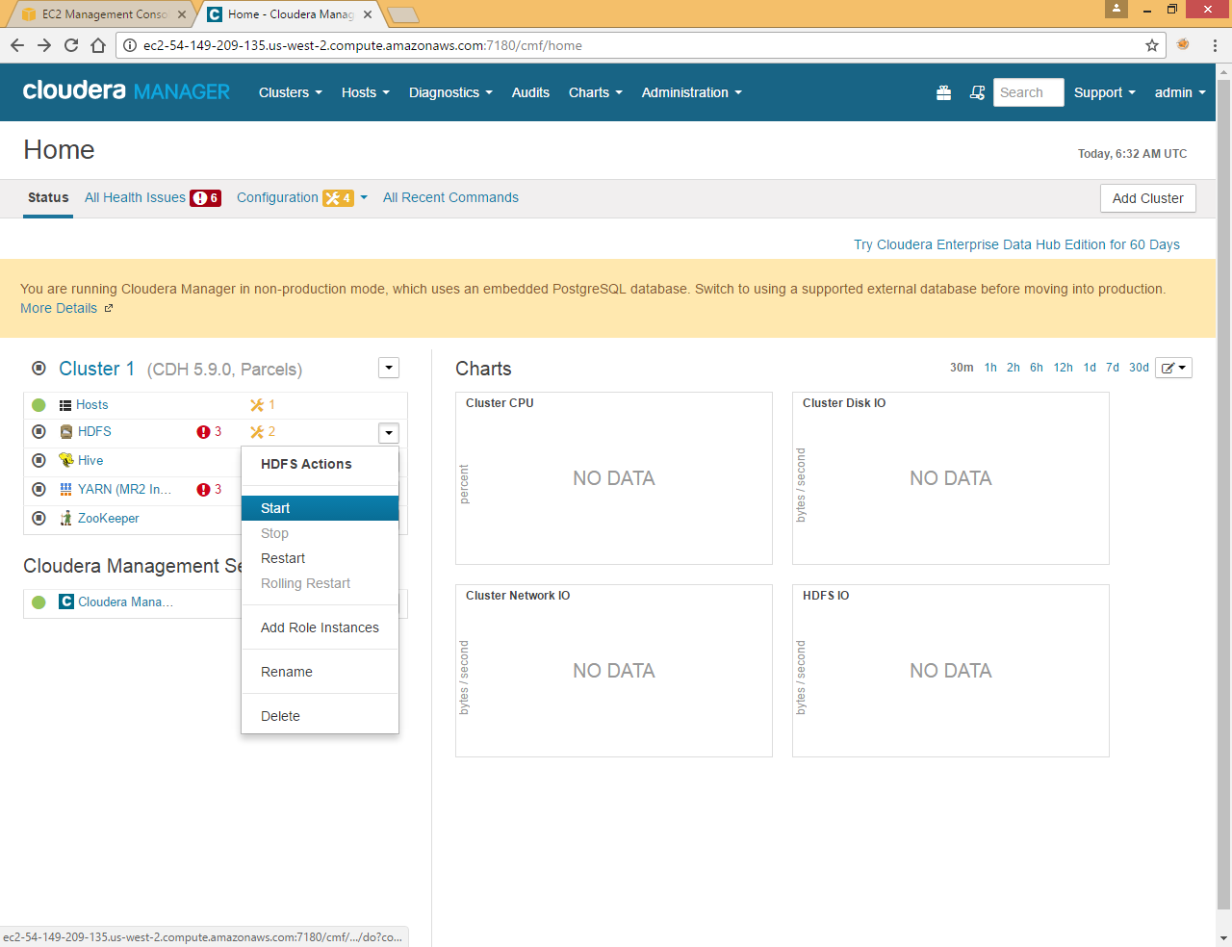

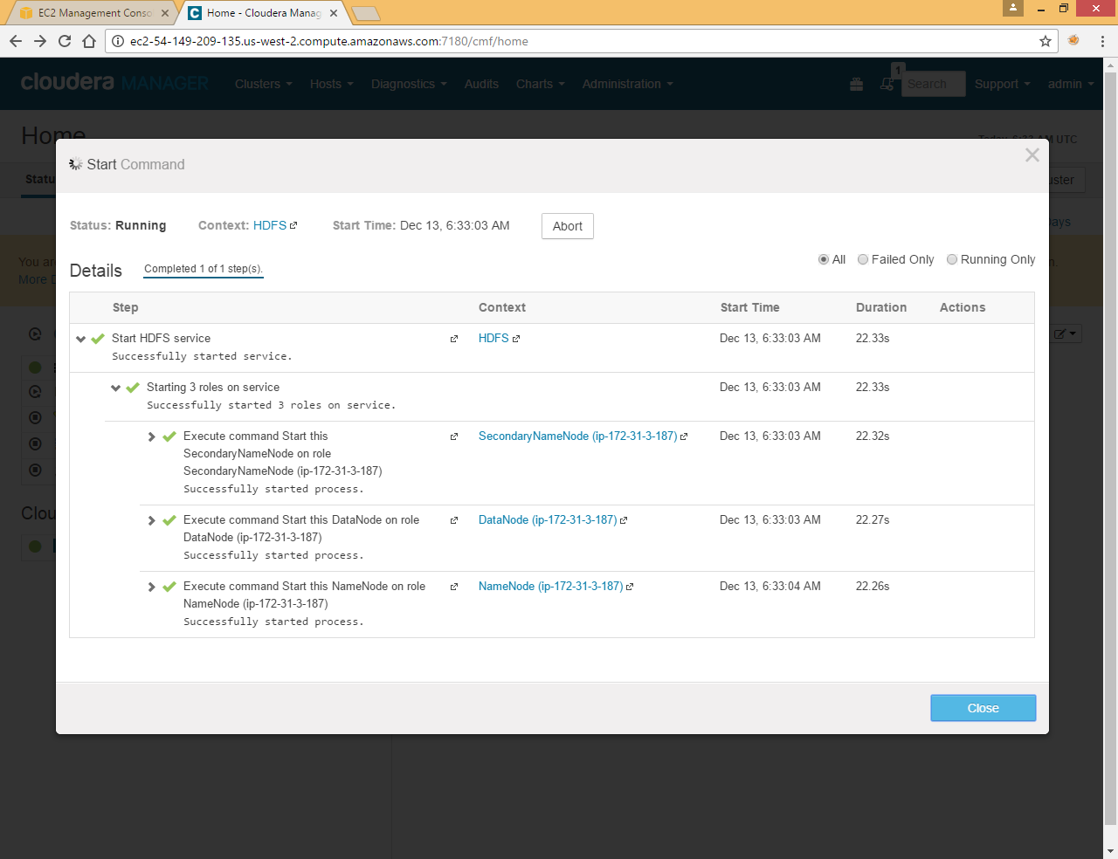

All services now pointing to new Private IP

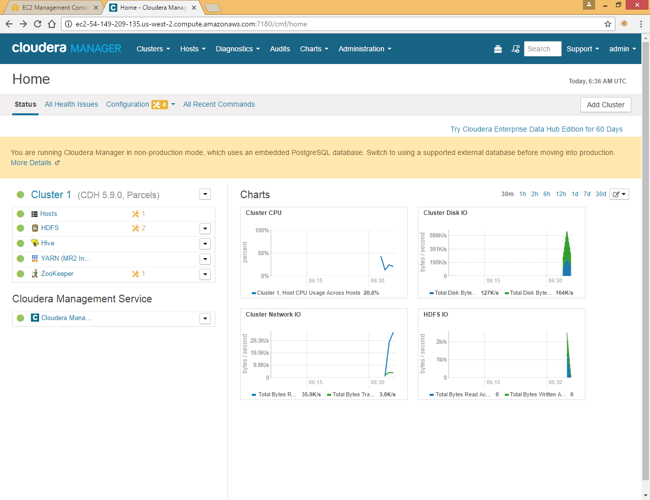

Here hive still pointing to old Metastore Database so first we need to update it.

Go to hive >> Configuration in Cloudera UI

Search **Hive Metastore Database Host**

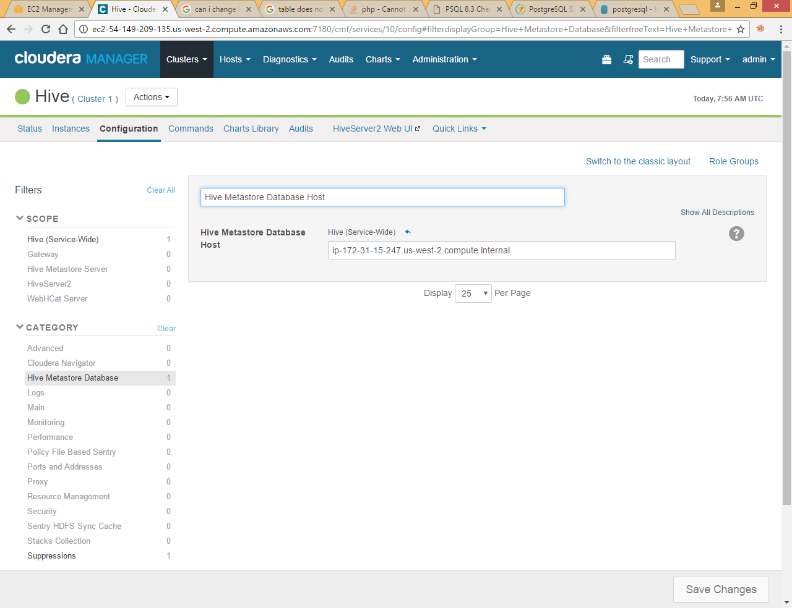

Here we need to update it with new Private DNS

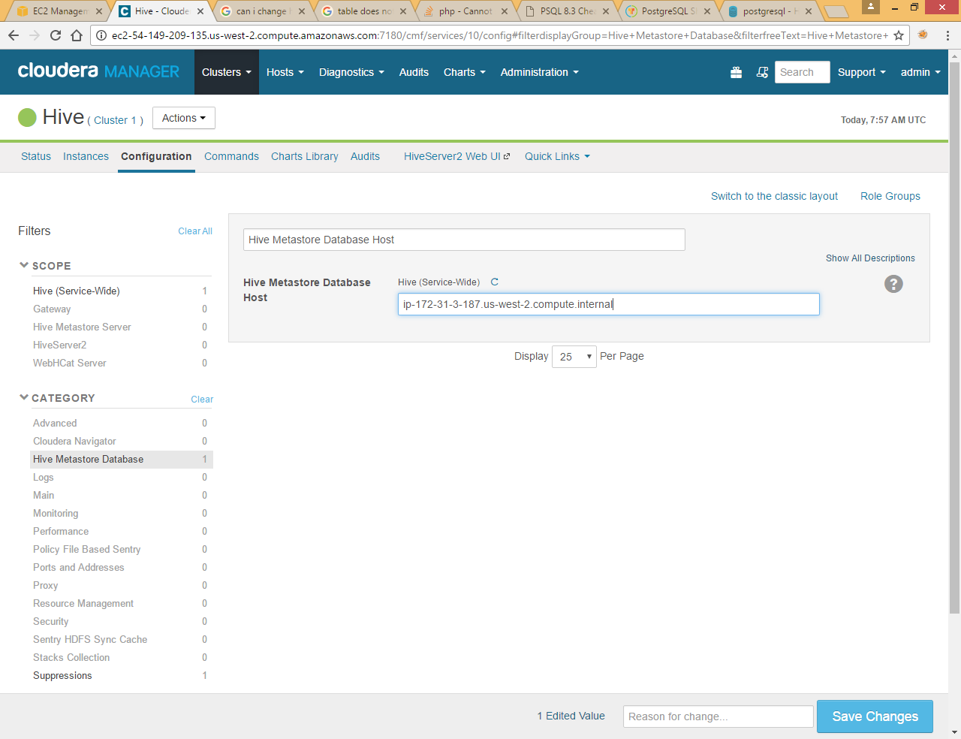

Click Save Changes

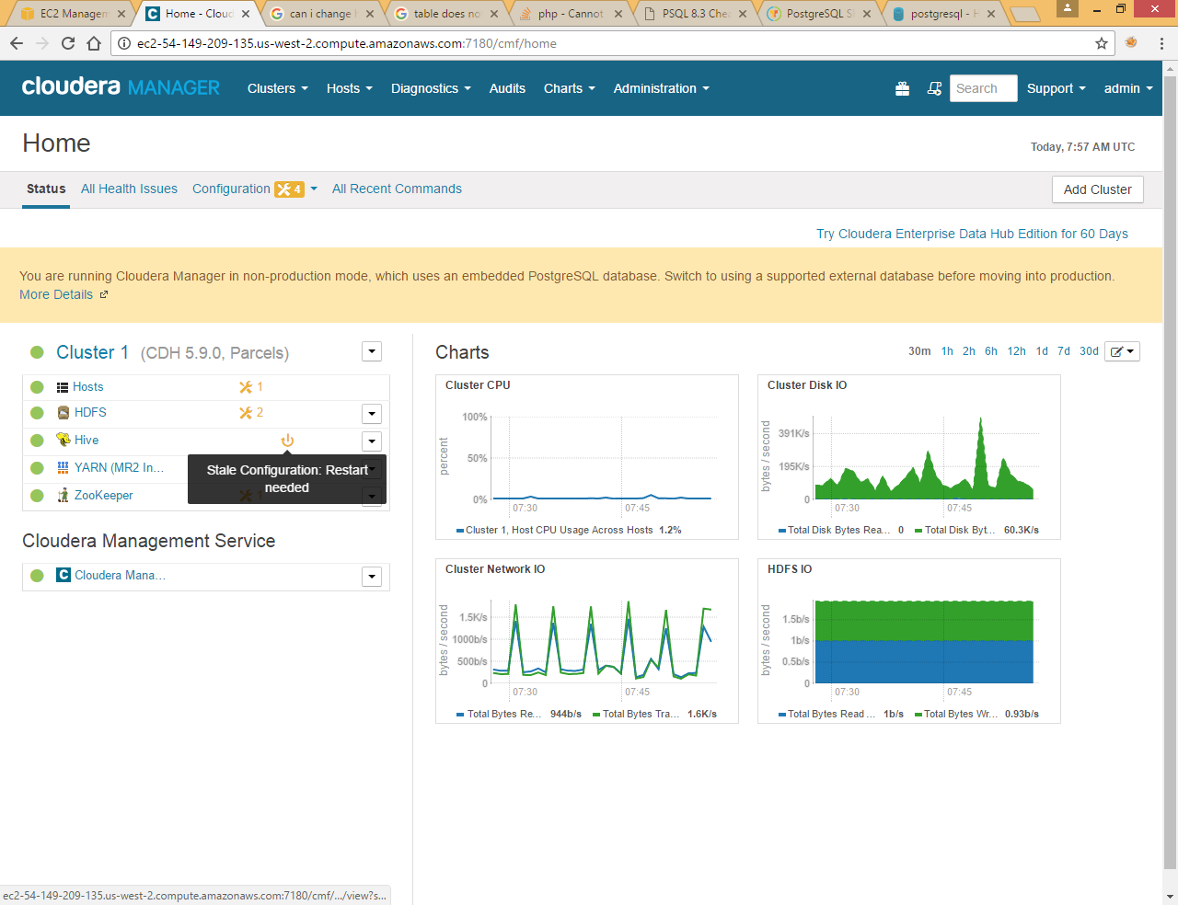

Restart stale service

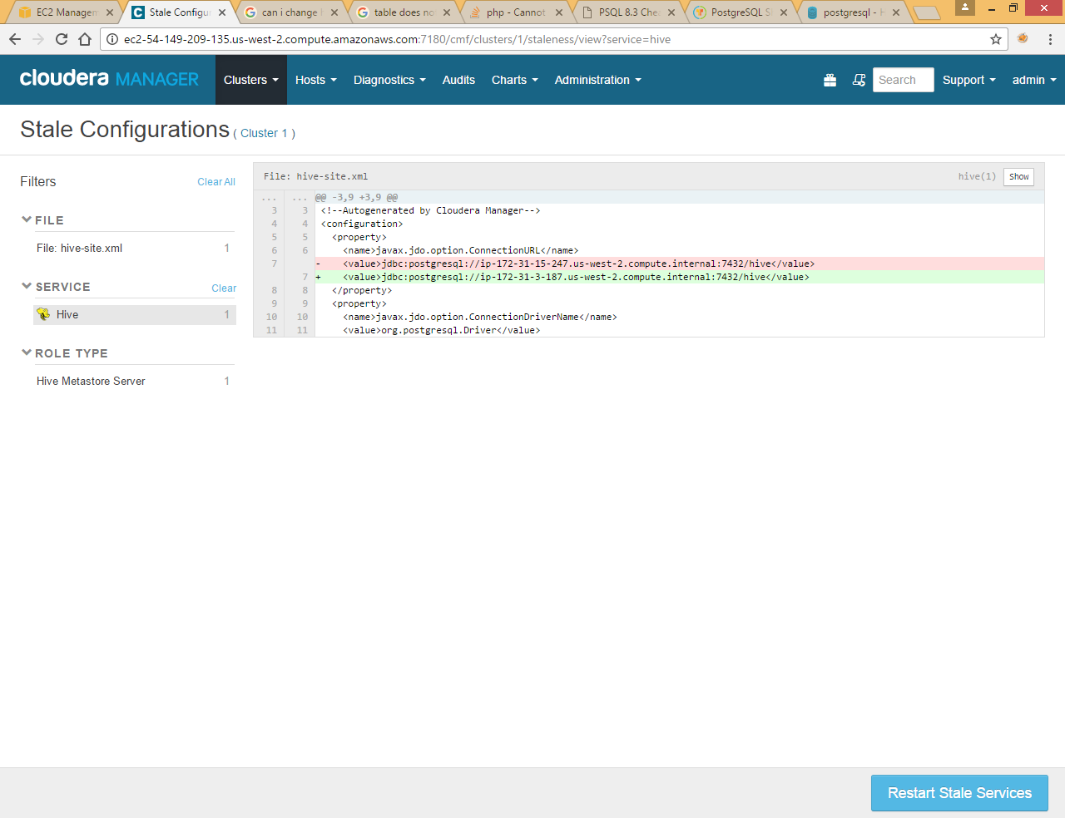

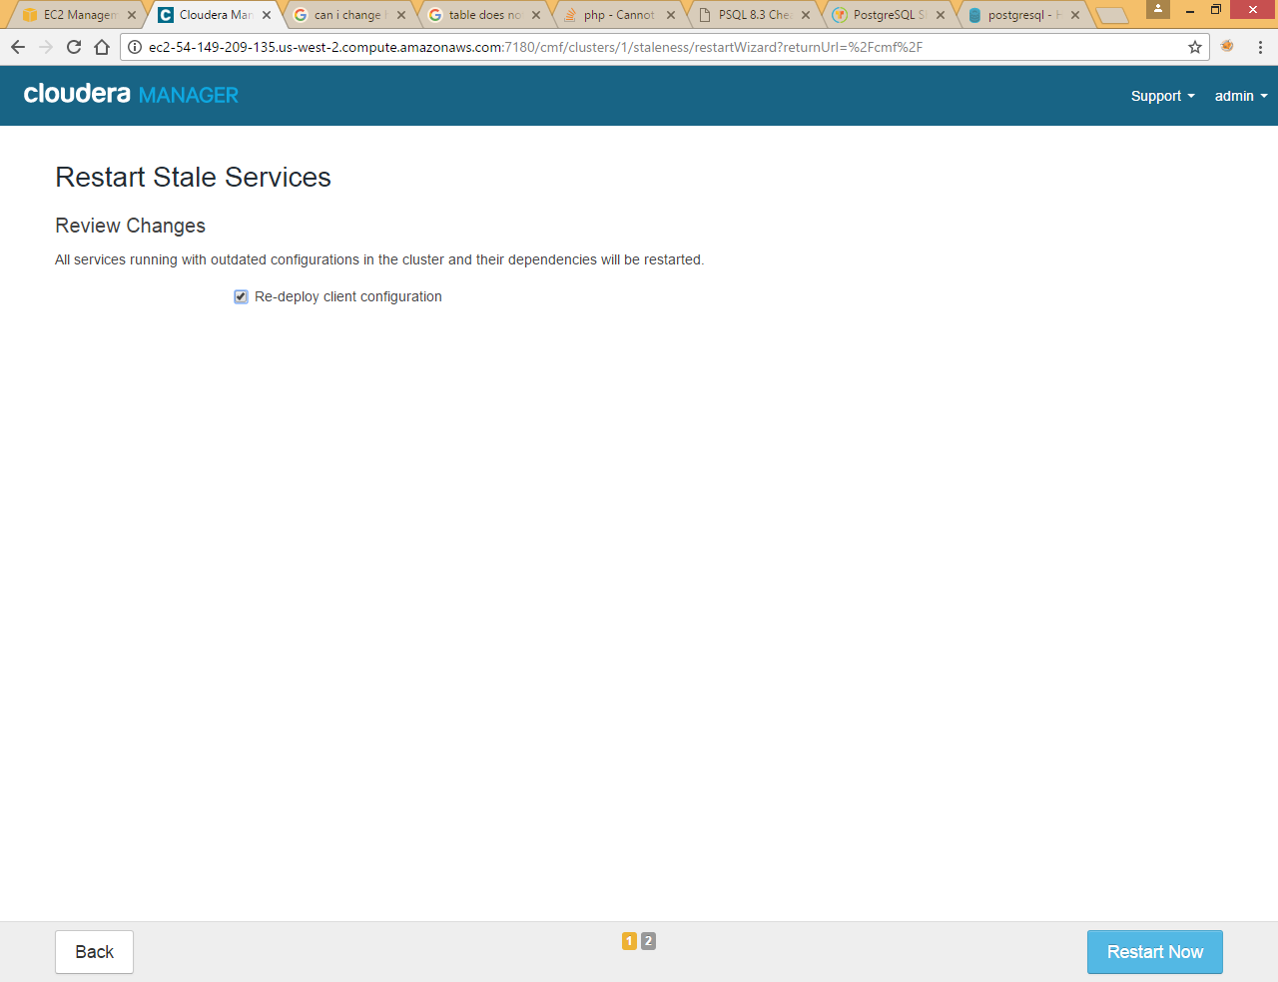

Now if you want to access emp table from hive shell you will get below exception

|  |
| --- |
| hive> select * from emp;  FAILED: SemanticException Unable to determine if hdfs://ip-172-31-15-247.us-west-2.compute.internal:8020/user/hive/warehouse/emp is encrypted: java.lang.IllegalArgumentException: Wrong FS: hdfs://ip-172-31-15-247.us-west-2.compute.internal:8020/user/hive/warehouse/emp, expected: hdfs://ip-172-31-3-187.us-west-2.compute.internal:8020  hive> |

This is because metastore db store some location specific information in some of the table like SDS and BDS

You can check it by login to metstore DB (postgres in our case)

Login to postgres using below command

|  |
| --- |
| psql -U hive -p 7432 -h localhost -d hive  hive=> select * from "SDS";    hive=> select * from "BDS";    \q to exit from command |

You can see Both SDS and BDS tables are pointing to old hdfs location

Hive provided metatool to update this location on all the tables and Cloudera has given web link to update this location.

So now stop hive service first

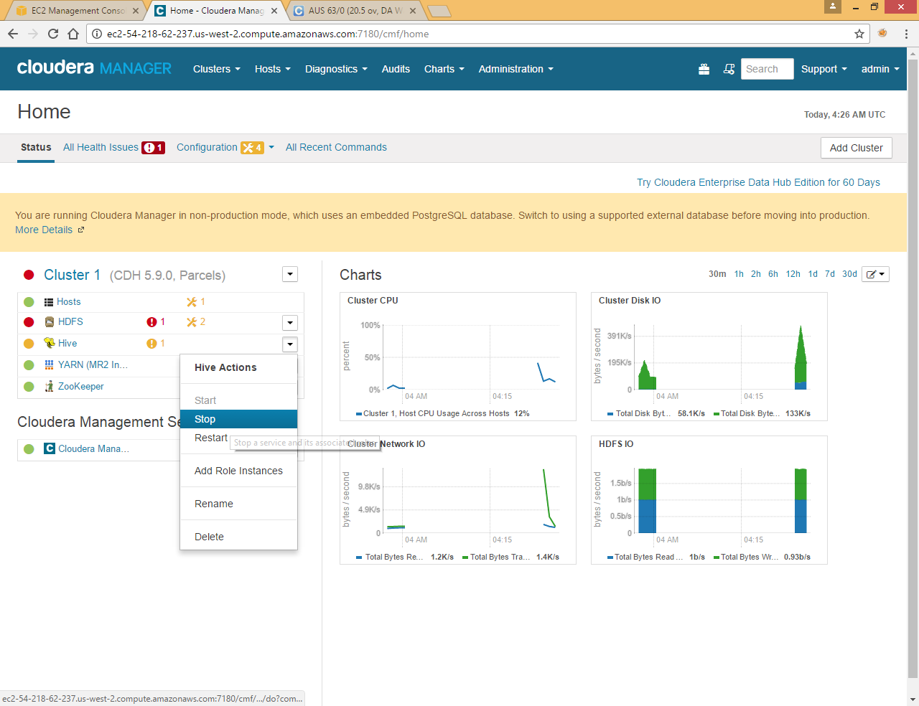

Now go to Hive >> Action >> Update Hive Metastore NameNodes

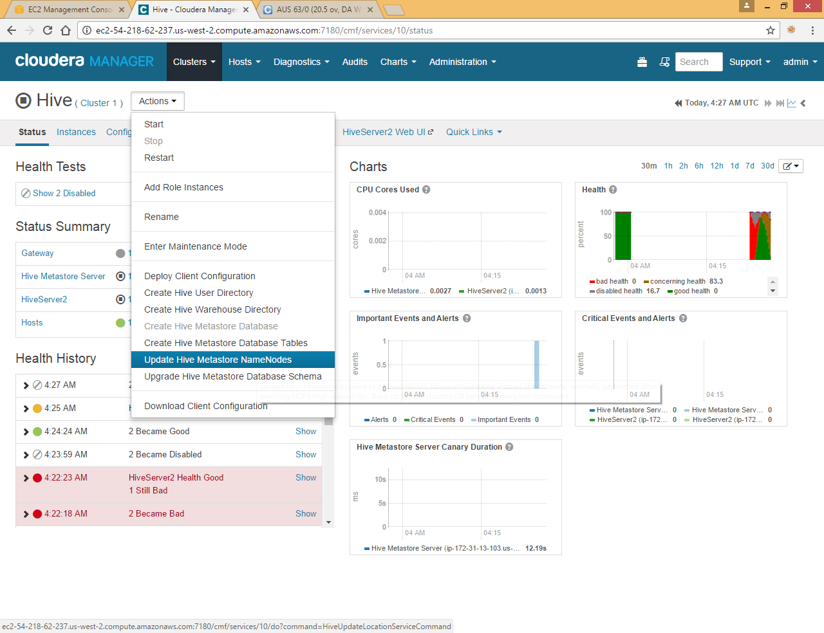

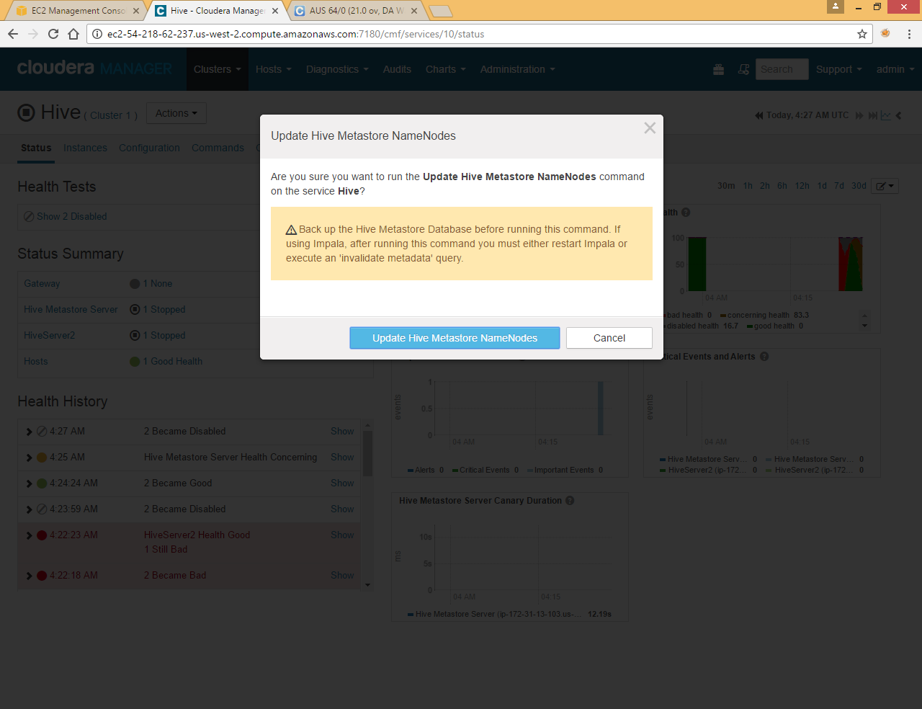

Click Update

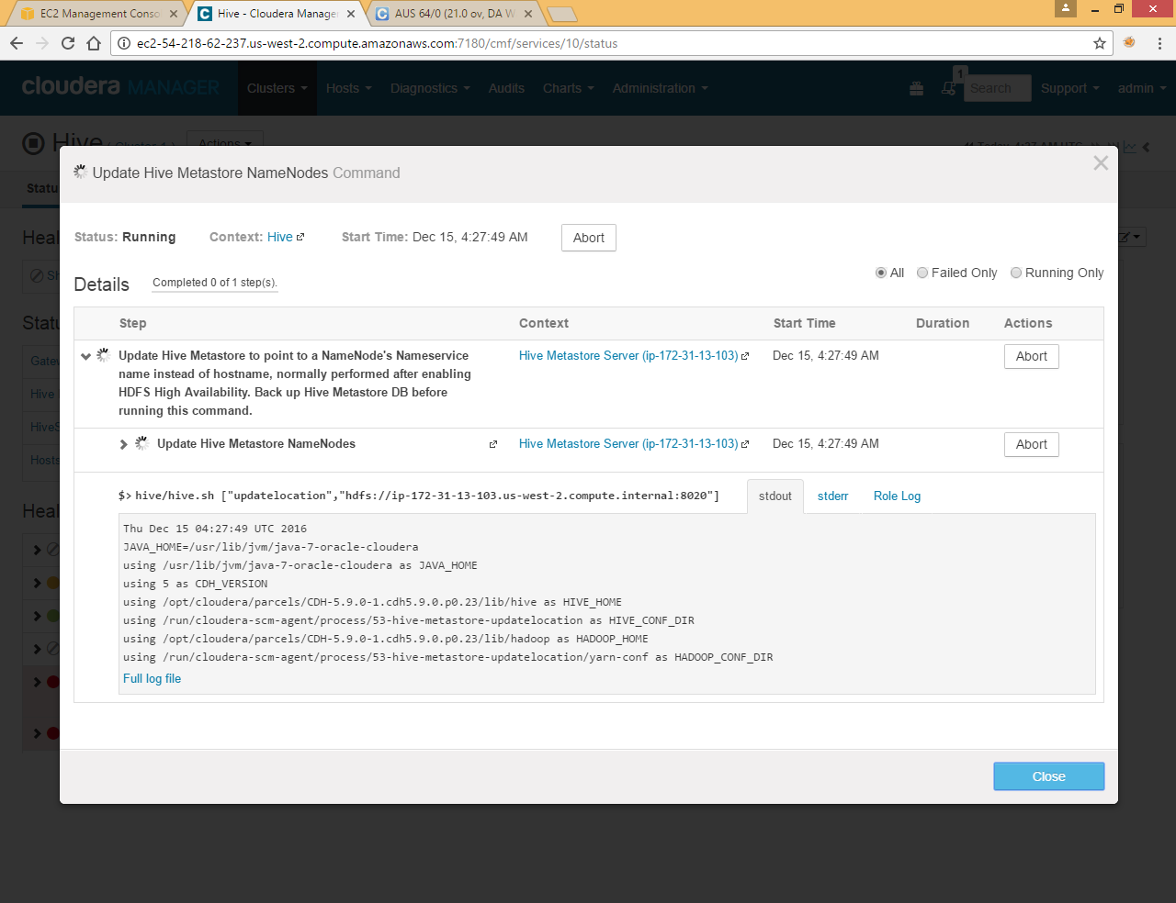

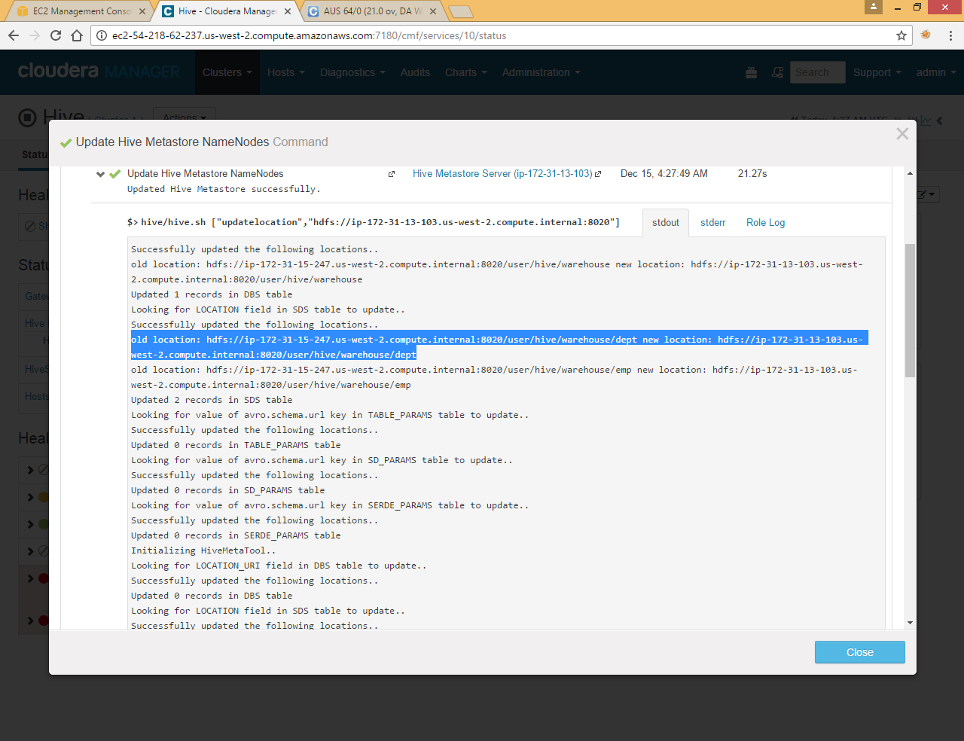

Here you can see it is updating from old IP to new IP and updating table like SDS and BDS

Now again you can check the SDS and BDS tables in postgres

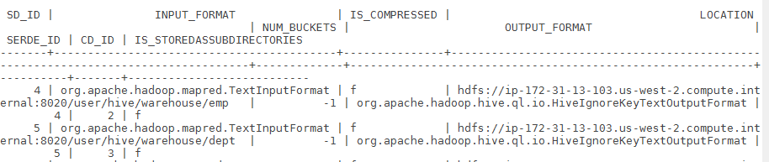

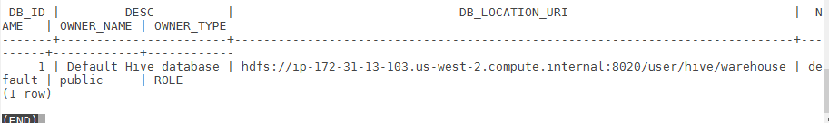

Now you can see it is pointing to new IP

Now Start hive services again

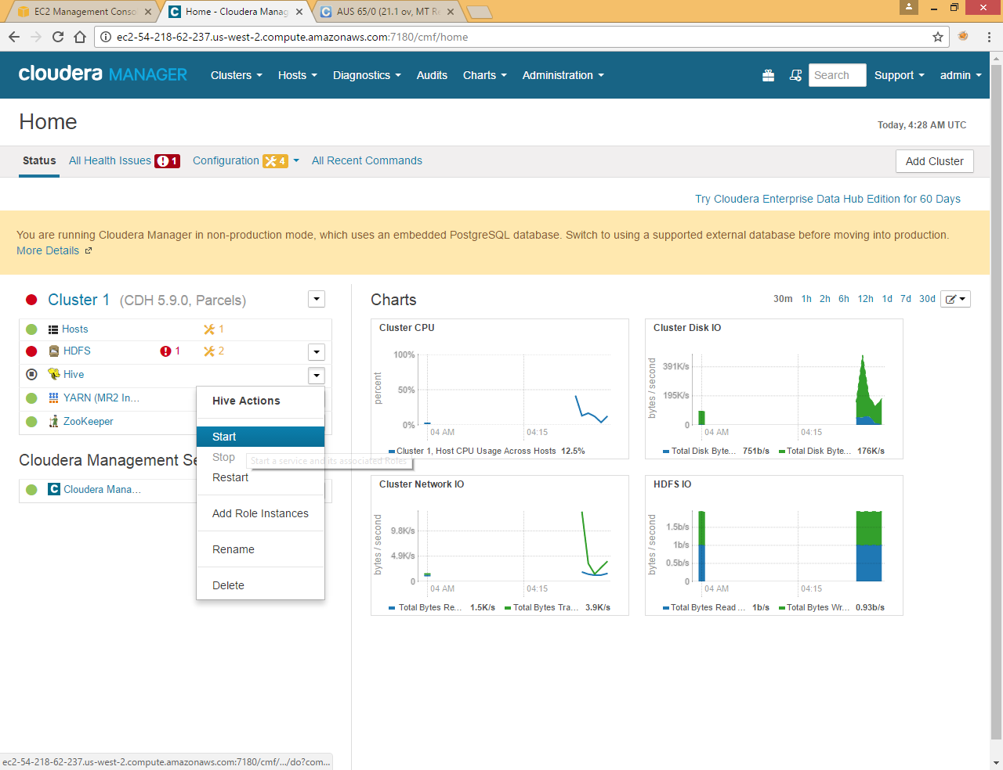

Now you can access emp and dept file from hive shell

|  |
| --- |
| hive> select * from emp;  OK  1 Raju 2  2 Nimish 1  3 Ruma 2  4 Subrata 1  5 Gargi 2  6 Siddharth 2  7 Anil 3  8 Ashis 3  9 Palas 2  10 Mr X 5  Time taken: 0.281 seconds, Fetched: 10 row(s)  hive> select * from dept;  OK  1 Sales  2 Marketing  3 HR  4 Engineer  5 Finance |

Now all your services are up and running fine

